Luray – Page County Chamber of Commerce
18 Campbell Street, Luray, VA 22835 - Tel: 540-743-3915 - Fax: 540-743-3944
www.VisitLurayPage.com

For Immediate Release Contact: 540-743-3915
June 22, 2022 events@luraypage.com

Town of Shenandoah Museum Grand Opening & Ribbon Cutting

Shenandoah, VA – The Luray-Page County Chamber of Commerce had the honor of joining the Town of Shenandoah to celebrate the grand opening of their new Town of Shenandoah Museum.

“It’s great to see the history of community being kept alive. The Town of Shenandoah has been working to not only give locals and visitors another place to enjoy, but a way to keep teaching people about their history as a part of the Norfolk Western, now Norfolk Southern railroad. We’re lucky to have people in the community that value the past, and we’re excited to have another place to celebrate it.”, said Regina Hilliard, President of the Luray-Page County Chamber of Commerce.

The Town of Shenandoah Museum has been in the works for over 5 years and is located near the railhead on First Street. The museum will feature railroad itesm, Shenandoah related mility items, town history, and even an eclectic variety of other items like the seating chart for the 1950s U.S. House of Representatives. The building also doubles as our Welcome Center for tourist information. “The purpose of the Shenandoah Museum is to feature a progressive minded small town with a planned future while maintain our historic artifacts, located where the legendary Shenandoah River meets the gorgeous Blue Ridge Mountains” said Town Clerk Lora Jenkins.

During the ribbon cutting ceremony, we were honored to be joined by Shenandoah Town Mayor Clinton Lucas, Jr., Councilman Mike Lowe, Councilman Russell Comer, Councilman Lynn Fox, Town Manager Jaunita Roudabush, Town Clerk Lora Jenks, President of the Luray-Page County Chamber of Commerce Regina Hilliard, Social Media & Marketing Assistant for the Luray-Page County Chamber of Commerce Edison Emmons, and members of the community.

The Town of Shenandoah Museum is located at 507 First Street, Shenandoah. Their hours are Monday-Saturday from 10:00 AM-5:00 PM, they will be closed for lunch each day from 12:00-1:00 PM. For more information on their new museum, be sure to visit their Facebook page at www.facebook.com/profile.php?id=100039607879698 , call (540) 652-8164, or email them at jroudabush@townofshenandoah.com.

For more details on the ribbon-cutting, contact the Luray-Page County Chamber of Commerce at events@luraypage.com.
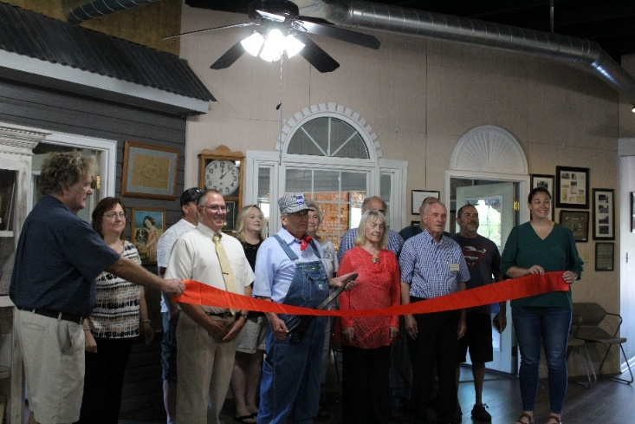
To see more pictures from the the Town of Shenandoah Museum Ribbon Cutting, visit our Facebook page.

