**Luray – Page County Chamber of Commerce**



18 Campbell Street, Luray, VA 22835 - Tel: 540-743-3915 - Fax: 540-743-3944

www.VisitLurayPage.com



**For Immediate Release Contact: 540-743-3915**

**May 30, 2022** [**events@luraypage.com**](mailto:events@luraypage.com)

**Shenandoah Caverns 100th Anniversary Ribbon Cutting**

**Quicksburg, VA** – The Luray-Page County Chamber of Commerce had the honor of joining the Shenandoah County Chamber of Commerce to celebrate the 100th Anniversary of Shenandoah Caverns.

“We were honored to be a part of this momentus anniversary and to get to partner with other areas and businesses for such occasions. While Shenandoah Caverns may not be in Page County, we are still grateful to get to promote and work with a business that has been serving the community and visitors for so long. We are excited to continue these partnerships and see where the future takes them”, said Regina Hilliard, President of the Luray-Page County Chamber of Commerce.

Shenandoah Caverns has been providing a unique experience for locals and visitors for the last 100 years. From their interesting and educational caverns tours to their America on Parade museum, which holds classic and beautiful parade floats, everyone who visits them leaves with a new view on what the Earth can create. Shenandoah Cavners not only has been around for 100 years, but it is also a family owned business, making them a true gem for our local business communities.

During the ribbon cutting ceremony, we were honored to join members of the Shenandoah County Chamber of Commerce as well as others from the community. In attendance was Owner Kathy Kelly, Vice President of Shenandoah Caverns Joe Proctor, President of the Shenandaoh County Chamber of Commerce Sharon Baroncelli, Ambassadors of the Shenandoah County Chamber of Commerce, Director of Tourism and Economic Development in Shenandoah County Jenna French, Shenandoah County Economic and Tourism Development Coordiantor Brenda Black, Congressman Ben Cline, Luray Town Councilwoman Stephanie Lillard, President of the Luray-Page County Chamber of Commerce Regina Hilliard, Social Media & Marketing Assistant for the Luray-Page County Chamber of Commerce Edison Emmons, and Chamber Ambassador Amanda Petty.

Shenandoah Cavners is located at 261 Caverns Road, Quicksburg. Their hours of operation are Monday-Sunday, 9:00 am-4:00 pm. For more on all of the everything they have to offer, be sure to visit their Facebook page at <https://www.facebook.com/shenandoahcaverns>, call (540) 477-3115, or email them at [americancelebration@gmail.com](mailto:americancelebration@gmail.com). For more details on the ribbon-cutting, contact the Luray-Page County Chamber of Commerce at [events@luraypage.com](mailto:events@luraypage.com).

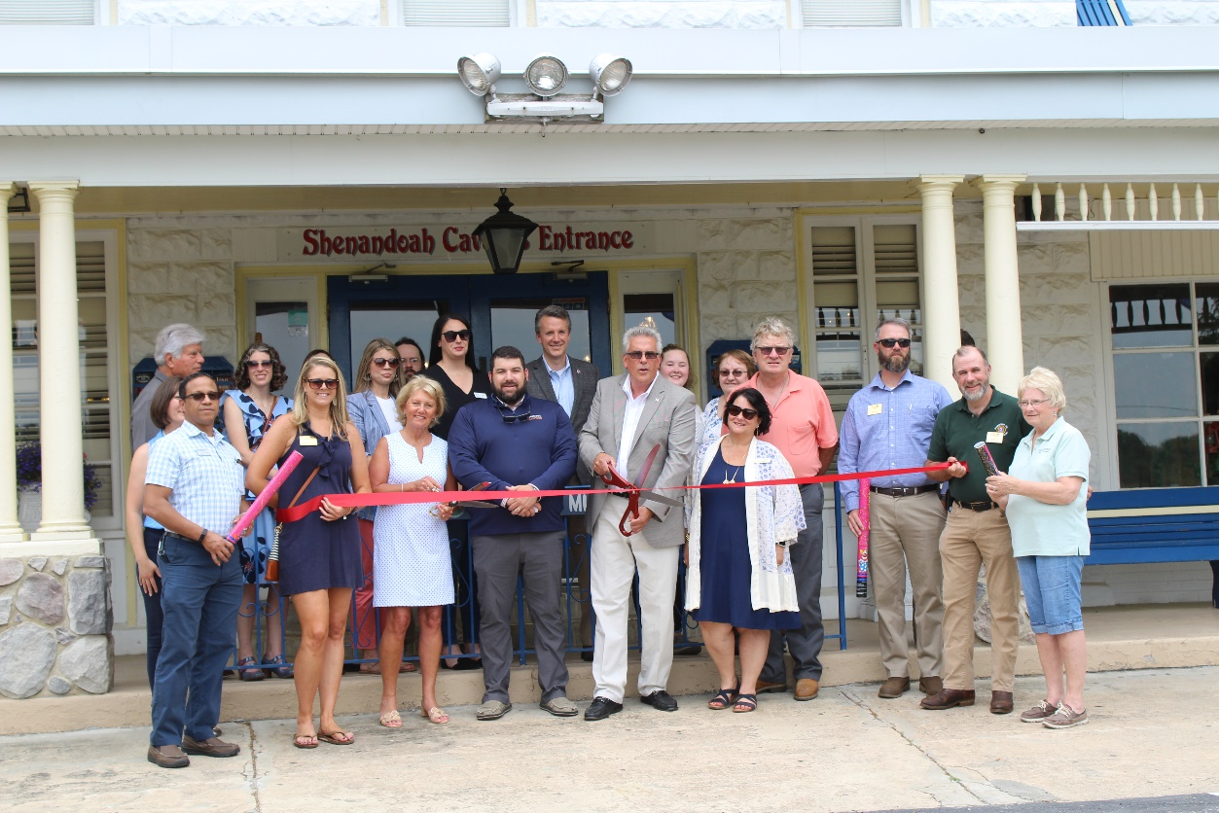

To see more pictures from the Hawksbill Brewing Company 5th Anniversary Ribbon Cutting, visit our [Facebook page](https://www.facebook.com/media/set/?set=a.315136313990798&type=3).