Staff  Gina Hilliard, President  Edison Emmons,  Communications and Marketing Coordinator  Clancey Arnold,  Membership Development and Engagement  Laurie Newcomer  Chamber & Tourism Assistant  Board of Directors  Executive Officers:  Travis Clark, Chair  Valley Health Page Memorial Hospital  Amy Judd, Vice Chair  Laurel Ridge Community College  DezaRae Beers, Secretary  Yogi Bear's Jellystone Park  Miranda Cave, Treasurer  Blue Ridge Bank  Bill Huffman, Chair of the Tourism Division  Luray Caverns  Board Members:  David Reed - Reed & Reed, P.C. Attorneys & Counsellors at Law  Megan Gordan - Page Alliance for Community Action  Michael Darrow– Delaware North at SNP  Mitch Lovinger – Appexnetwork Physical Therapy  Sable Ponn – Funkhouser Real Estate Group  Tony Villa – Madeline Farms  Follow Us on Social Media  Facebook  LurayPageCountyChamber  Instagram  LurayPageCountyChamber  Twitter  PageCoChamber  YouTube  LurayPageCountyChamber | Ambassadors  Clancey Arnold, Chair – Luray-Page County Chamber of Commerce  Sable Ponn, Vice-Chair – Sable Ponn, Funkhouser Real Estate Group  Jackie Moe – Heart Felt Events of Luray  Marlise Lee - Cameo Galleries  Zory Glaser – Patron  Tourism Council  Attractions:  Bill Huffman, Chair – Luray Caverns  Lodging:  Nancy Sottosanti, Treasurer – Shenandoah River Outfitters  DezaRae Beer – Yogi Bear Jellystone Park  Jim Sims – The Mimslyn Inn  Restaurants:  Helen Morton – Delaware North  Chuck Arnaud - Main Street Bakery and Catering  Services:  Chris Jenkins – Faithbrooke Barn and Vineyards  CeCe Castle, Secretary – Brookside Restaurant
 | 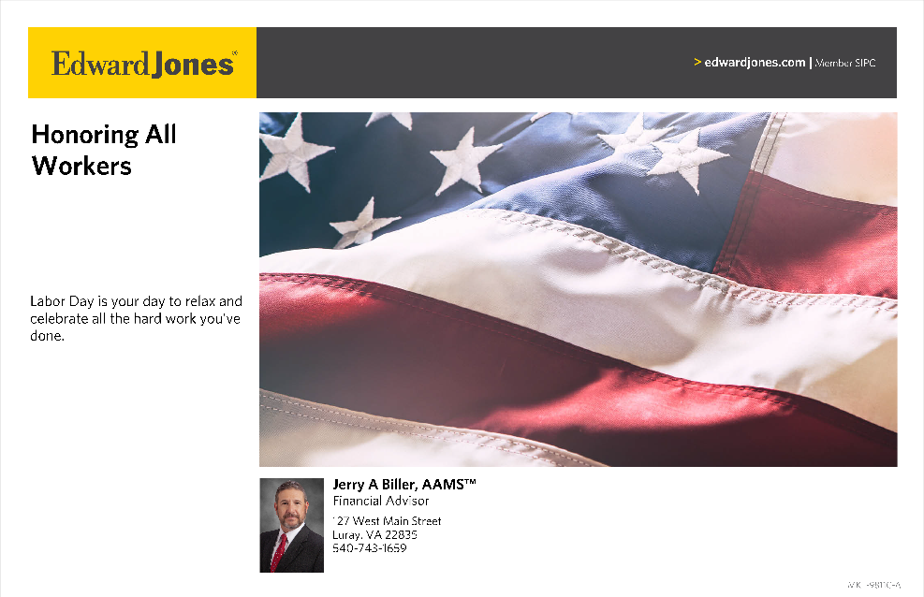

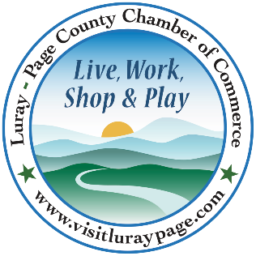

Luray-Page County Chamber of Commerce & Visitor Center
18 Campbell Street, Luray, VA 22835
Phone: (540) 743-3915 • Fax: (540) 743-3944
www.visitluraypage.com

September 2023 Newsletter

The Luray-Page County Chamber of Commerce's mission is to serve our members by promoting and supporting business and tourism throughout Page County. The Luray-Page County Chamber of Commerce's vision is to be the organization where our business community turns for leadership and resources.

Chamber Events

Thursday, September 14th, 2:00-3:00 PM
Business Seminar – 5 Do’s and Don’ts of Facebook
Join Janet Michael from Java Media for a FREE seminar “Five Facebook Do's and Don'ts” on Thursday, September 14, 2023, at 2pm in the chamber board room. Janet will offer tips for managing your business Facebook page that include your settings, content creation & timing of posts. You’ll get ideas & suggestions for creating content and increasing engagement. Open discussion to exchange ideas will follow the presentation. The seminar is free and chamber membership is not required to attend. Space is limited, so registration is required. Register via email to: janet@javamediamarketing.com or edison.emmons@luraypage.com.

Friday, September 15th, 10:00 AM
Good As New to U Grand Opening & Ribbon Cutting
Join us on Friday, September 15th at 10:00 AM, to celebrate the grand opening of Good As New to U, 23 East Luray Shopping Center, Luray. We’ll be cutting the ribbon at 10:00 AM to welcome Cristy McCoy. Good As New to U provides items such as jewelry, clothing, books, toys, small furniture, kitchen wares, tools, and household items at a fair and low price. RSVP by Thursday, September 14th by calling (540) 743-3915 or emailing events@luraypage.com.

Tuesday, September 19th, 12:00-12:30 PM
Tourism Tuesday Radio Show – Main Street Flavors
Tydel Wilson, owner of Main Street Flavors, is joining Edison Emmons to share information on his ice cream store. Listen in to The River 95.3 or https://thevalleytoday.libsyn.com/ to learn about the sweet treats he offers. To be a future guest on the Tourism Tuesday Radio Show, contact Edison at edison.emmons@luraypage.com.

Thursday, September 21st, 5:30-7:00 PM
Business After Hours – Main St. Flavors
Join us on Thursday, September 21st, from 5:30-7:00 PM Main Street Flavors, 40 East Main Street, Luray, for this month’s Business After Hours. This will be a great chance to network with other Chamber members, enjoy delicious food, and check out another great local business. All members who attend are entered into the drawing for great door prizes. You’ll also be able to enjoy tasty refreshments and door prizes. This event is designed for Chamber members to meet and build relationships with other local business members. It is time to get together and enjoy each other’s company. Bring business cards for networking and to be entered in door prize raffles. If you would like to attend, please RSVP to events@luraypage.com or (540) 743-3915 by Monday, September 18th.

Tuesday, September 26th, 11:30 AM-1:00 PM
Women in Business Lunch – Choices-Council on Domestic Violence
Join us on Tuesday, September 26th, from 11:30 AM-1:00 PM, at The Valley Cork, 55 East Main Street, Luray, for this month’s Women in Business Lunch. Shirley Sheets and Nancy May of Choices-Council on Domestic Violence will be joining us to talk about Setting Boundaries. Lunch will be provided by The Valley Cork and will be $15 for Chamber Members, or $20 for Potential Members. Please RSVP to events@luraypage.com or (540) 743-3915 by Friday, September 22nd.
Chamber Announcements

Any advertising inserted and printed in this newsletter and the content of those inserts and print ads are not sponsored or endorsed by the Luray-Page County Chamber of Commerce & Visitor Center.

RSVP to Events - When RSVP’ing for an event, please make sure to call our office at (540) 743-3915 or email your name, business, and event you’re planning on attending to events@luraypage.com. After coming up with our monthly events, we create Facebook event pages. While we appreciate everyone interacting and sharing our event pages, we will no longer accept them as the RSVP for our events. To properly invoice for each person attending, and to keep track of everyone that is planning on attending, we need confirmation via phone or email if you are attending our events.

Attending Events - Have employees that want to attend our Chamber events? Our events are open to all Chamber Members and their employees. Whether they want to network at Business After Hours or come to Women in Business, Lunch ‘N Learn or Business Seminar, we welcome any of your employees that would like to attend.

In The Loop – Our In the Loop is a weekly email that is sent to our members, as well as members of the community. You don’t have to be the primary rep on file with us to receive this weekly email, though. If any members have employees that want to keep up with what is going on in Luray-Page County each week, email their contact information to Edison at edison.emmons@luraypage.com to be placed on the mailing list.

Refer a New Member – Get $50.00 off your next membership renewal fee when you refer someone for their Chamber membership. The new member must identify you as their referral when filling out their member application. New members must not have held a Chamber membership with us within the last three years.

Member to Member Discount Program – This program is strictly between Chamber members. We encourage members to do business with other Chamber members. As an incentive, many local businesses offer discounts to Chamber members. Take advantage of these great opportunities and say “thank you” for supporting the Luray-Page County Chamber of Commerce. If you are interested in updating your discount or offering a new discount, contact Edison at edison.emmons@luraypage.com or (540) 743-3915.

Job Postings – Do you struggle to get your “Help Wanted” needs out to the public? We can help! Our benefits include the ability for you to advertise your job availabilities for free on our website. You can also place job listings in the “Hiring” section of In the Loop. We want to help you find employees, so contact Edison at edison.emmons@luraypage.com to add your job opportunities to our list.

Press Releases – Does your business have news that you want to get out to the public? If you have press releases that you want displayed on our website, email them to Edison at edison.emmons@luraypage.com. Edison will put them on the “Member News” page on website and can share them in our In the Loop email, as well.

Flyers - We’re sure you’ve seen all the flyers that are in our monthly newsletters. Our members have the option of inserting flyers with information on programs, events, and other important things their businesses or organizations are doing each month. When you receive our newsletters, make sure to take a second to look over the flyers so that you’ll know what’s going on in our community. Make sure that you hang them up in your window, make copies for your office, put them up in your employee breakrooms, or even scan them in and email them to your employees. This is a great way to not only help promote the business community, but to let your employees and customers know about what’s going on right here in their own backyards each month.

Advertising in Our Newsletter

The Luray-Page Chamber of Commerce is offering all members the opportunity to advertise your events in our newsletter. The newsletter will be sent out to our 400+ members in addition to state and local government officials. If you are interested in advertising, there are three main options:
- You design and print your 8 ½” x 11” flyers and bring them to us to stuff in this newsletter. We handle the stuffing and mailing and all you pay is $25.00.
- You can design a small advertisement that will be included in the body of the newsletter itself. All ads will be in black and white, ½ page ads are $20.00, ¼ page ads are $15.00, and 1/8-page ads are $10.00; availability is a first-come-first serve basis. Call Edison at the Chamber, 540-743-3915 for sizing availability.
The deadline for inserting information varies each month. Edison sends an email to our members at the beginning of each month with the deadline date, as well as a reminder the week before the inserts is due. If you use Luray Copy Service for printing, we will pick them up for you. We are happy to pick up any printing for the newsletter when we pick our newsletters up. Contact Edison at edison.emmons@luraypage.com if you want to advertise either with information inserts or for taking an ad out in the newsletter.

Confirming Your Information

If you haven't checked your business listing on our website recently, now is the time to do so. We want to make sure we have the most updated information on our Chamber Membership Directory and in our system. Head over to our Directory page (https://www.visitluraypage.com/chamber/directory/) and make sure the info we have is correct. If you find anything that is not correct or has changed, please email any updates to Edison at Edison.emmons@lurayapge.com. To make it easier, below is a checklist of info to confirm:
Business Name, Primary Phone, Primary Fax, Primary Email, Physical Address, Mailing Address, Website Link, Social Media links (Facebook, Instagram, Twitter, You Tube), Primary Rep., Primary Rep Phone Number, Primary Rep Email, 50-word description about your business, Hours of Operation, Updated photos (Each member gets 5 pictures on our website)
New Members Spotlight

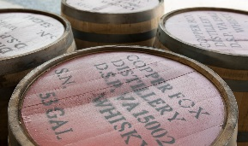
Copper Fox Distillery, located at 9 River Lane, Sperryville, opened in 2005, with the distinction of being the first US distillery, since the repeal of Prohibition, to boast a traditional malt floor and kiln. Owner and Master Distiller, Rick Wasmund, interned at Scotland’s Bowmore Distillery, where he learned the traditional art of floor malting barley. Upon Rick’s return from Scotland, he opened Copper Fox Distillery in a converted cider mill. The mill, constructed in 1936, originally produced apple juice and apple products, and interestingly the building is once again a “juice plant”, with a continued emphasis on local apples. The distillery’s combination of innovation and tradition produces a whisky that is truly unique. Handcrafted with original ideas and locally sourced ingredients, each barrel starts from scratch with hand-malted barley. The innovation begins in the kiln, where instead of peat, local fruitwoods are used to gently smoke and dry the grain. Copper Fox Distillery is the only distillery in the world to mature their whisky with toasted Applewood. This process enhances the flavor of the smoky malt, resulting in a complex and singular flavor experience. Copper Fox distillery believes its hand crafted, award winning American single malt whisky and rye whisky, are rich, full flavored products, distinctive, original and unlike any other. Tours are offered for guests to journey firsthand through the steps used in perfecting the world class spirits crafted right here in Virginia. For a fee, guests also have the opportunity to sample spirits with tastings and cocktails. For more information, visit https://www.copperfoxdistillery.com/ or https://www.facebook.com/copperfoxdistillery/ or contact (540)987-8554.

