Luray – Page County Chamber of Commerce
18 Campbell Street, Luray, VA 22835 - Tel: 540-743-3915 - Fax: 540-743-3944
www.VisitLurayPage.com

For Immediate Release Contact: 540-743-3915
April 19, 2022 events@luraypage.com

Mend My Mobile Grand Opening & Ribbon Cutting

Luray, VA – The Luray-Page County Chamber of Commerce had the honor of celebrating the 125th anniversary of Schewels Home with a special ribbon cutting at Schewels Home, 1460 US Highway 211 West, Suite C, Luray.

“Our business community is lucky to have a business such as Schewels Home. Not only do they offer an option for furniture shopping that keeps people local, but they are a great example for our other businesses. We look forward to watching them to grow in our community,” said Gina Hilliard, president of the Luray-Page County Chamber of Commerce.

Schewels Home opened their Luray branch in 1941 on West Main Street. As they continued to grow, they needed a bigger space, so in 2000 they moved to their current location, on 211 West. Larry Taylor, manager of the Luray store for the past five years, said Schewels is a “wonderful company to work for” that truly considers “the employee’s and the customer’s well being.” Tammy Good-Ware, the Luray store’s credit manager for the past 32 years, echoed that sentiment.

Yesterday, we welcomed members of the community to join us in celebrating this momentus anniversary. In attendance were Luray Town Councilman Jerry Shiro, Danielle Babb with the town of Luray, Sheriff Chad Cubbage, Luray-Page County Chamber of Commerce board member Sable Ponn, Schewels Home CEO Marc Schewel, and other members of the Schewls Home team.

For more on all of the services that they offer make sure to visit http://www.schewels.com or their facebook page at https://www.facebook.com/Schewels-Home-Luray-1716169271755822/, call (540) 743-5154, or email them at luray.mgr@schewel.com, For more details on the ribbon-cutting, contact the Luray-Page County Chamber of Commerce at events@luraypage.com.

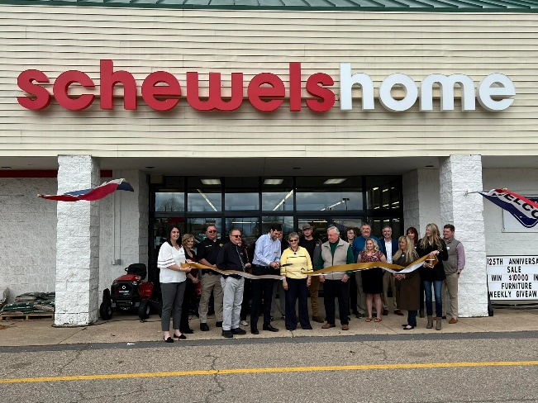

To see more pictures from the Schewels Home 125th Anniversary Ribbon Cutting, you can visit our Facebook page.

