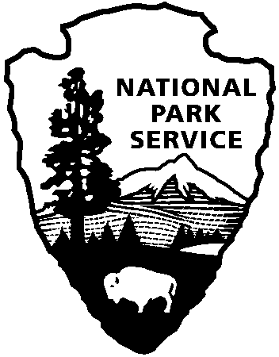
Office of the Superintendent
3655 U.S. Highway 211 East
Luray, VA 22835
Karl Rand (540) 999-3500 x3284
Karl_rand@nps.gov
FOR IMMEDIATE RELEASE
April 12, 2022
Shenandoah National Park News Release

National Park Service
U.S. Department of the Interior

Shenandoah National Park announces
Wildflower Weekend events

LURAY, VA - Spring wildflowers and nature art will be celebrated during Shenandoah National Park's 35th annual Wildflower Weekend, May 14-15, 2022. Guided hikes and programs will focus on the diversity and importance of not only hundreds of species of flowering plants that are protected by the park, but other seasonal changes as well.

Special features this year include a botanical art workshop led by watercolor artist Betty Gatewood, as well as a wildflower photography workshop led by Ann and Rob Simpson. No art experience is necessary, and all materials will be provided. There will also be a presentation by Shenandoah’s current Artist-in Residence, Jillian Sico.

All programs are free. No reservations are needed. However, there is a $30 entrance fee to the park (good for seven days). Adults and children are welcome on all Wildflower Weekend programs. For more information about spring in Shenandoah and the complete Wildflower Weekend schedule of programs, visit our website at https://www.nps.gov/shen/planyourvisit/spring.htm. There will also be regularly scheduled weekend Ranger programs at both visitor centers at mile 4.6 and mile 51.

For those who cannot attend in person, Shenandoah’s virtual wildflower walks from 2021 are on the Park’s YouTube channel at https://www.youtube.com/user/ShenandoahNPS.

Wildflower Weekend is supported by the Shenandoah National Park Association and the Artist-in-Residence program is supported by the Shenandoah National Park Trust.

Photos to support this Press Release can be downloaded at
https://www.flickr.com/photos/snpphotos/albums/72177720298061128
All are public domain; please credit NPS.

- www.nps.gov/shen -

About the National Park Service: Since 1916, the National Park Service has been entrusted with the care of America’s more than 400 national parks. With the help of volunteers and partners, we safeguard these special places and share their stories with millions of people every year. Learn more at www.nps.gov.

Follow ShenandoahNPS on
EXPERIENCE YOUR AMERICA™
The National Park Service cares for special places saved by the American people so that all may experience our heritage.

