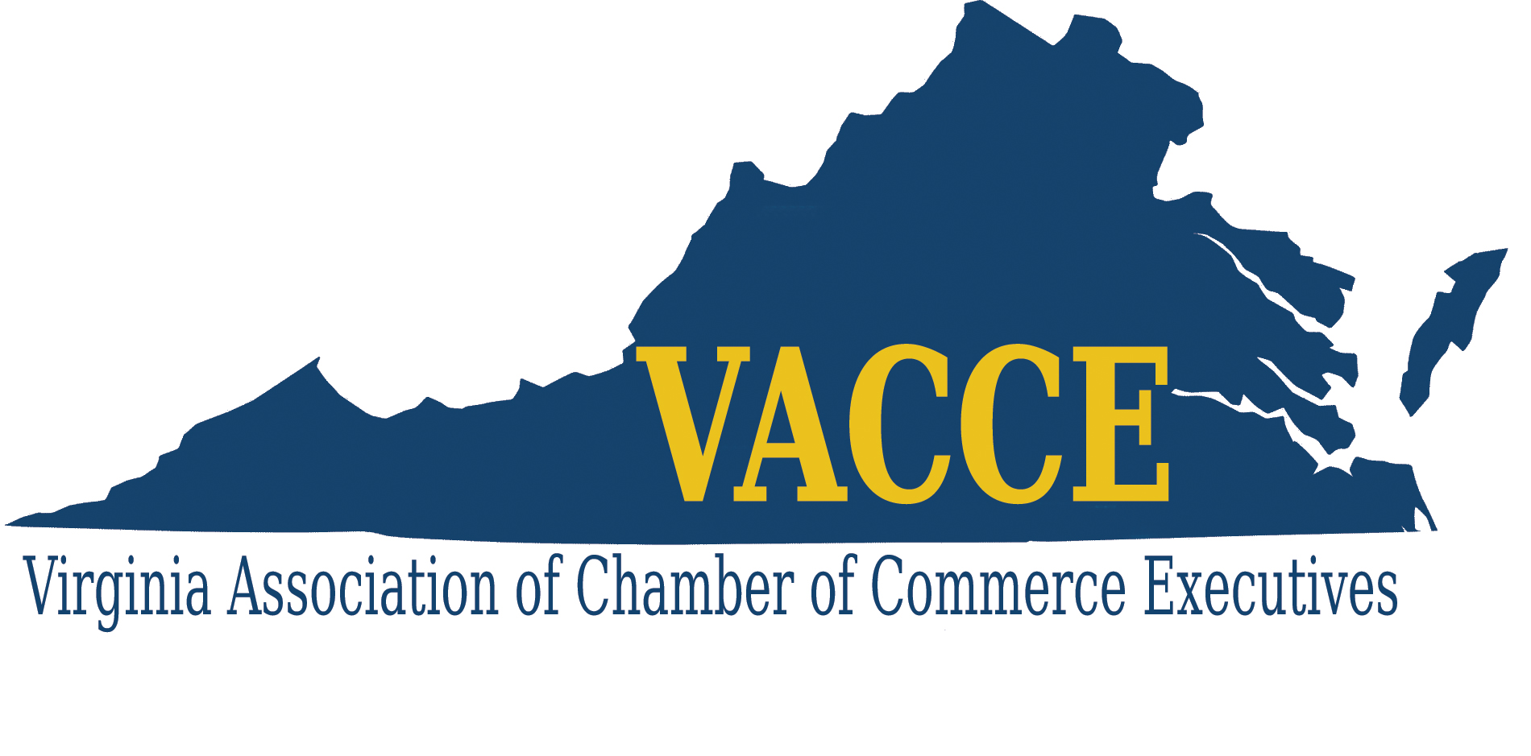

March 4, 2022 Contact: Tiffany Fulmer Ott
For Immediate Release tfulmer@tlfexecutiveservices.com
404-312-0524

VIRGINIA ASSOCIATION OF CHAMBER OF COMMERCE EXECUTIVES PRESENTS SERVICE AWARDS FOR 2022

The Virginia Association of Chamber of Commerce Executives (VACCE) recognized its 2022 Service Award recipients during their Staff Development Conference held today at the Hotel 24 South in Staunton, VA. The Service Awards recognize those members in Virginia who have achieved significant years of service in the chamber of commerce industry.

VACCE presents a certificate of service for each five-year increment of service. Service includes a combination of executive and/or staff employment time in all chambers of commerce.

We are proud to recognize the following professionals for their years of service to the chamber of commerce industry:
5 Years of Service
Carlie Floyd – Harrisonburg-Rockingham Chamber of Commerce
Cassie Bate Hurley – Arlington Chamber of Commerce

10 Years of Service
Heath Barret – Lynchburg Regional Business Alliance
Andrea Copeland – Charlottesville Regional Chamber of Commerce
Regina Hilliard – Luray-Page County Chamber of Commerce
15 Years of Service
Kate Bates – Arlington Chamber of Commerce

20 Years of Service
Joyce Waugh – Roanoke Regional Chamber of Commerce

25 Years of Service
Rob Anderson – ChamberRVA
Laverne Brown – Lynchburg Regional Business Alliance
James Carroll, III – Hampton Roads Chamber of Commerce

35 Years of Service
Teresa Beale – Franklin-Southampton Area Chamber of Commerce
Sylvia Haines – Hampton Roads Chamber of Commerce

VACCE congratulates each of these professionals for their service to the chamber of commerce industry!

VACCE is an alliance of chamber professionals representing all chambers of commerce from localities throughout the state. The Association provides a forum and partnership for integrating the work of local chambers of commerce in order to contribute to the growth and development of their local communities and the Commonwealth.

###

