Staff  Gina Hilliard, President  Edison Emmons,  Communications and Marketing Coordinator  Clancey Arnold,  Membership Development and Engagement  Laurie Newcomer  Chamber & Tourism Assistant  Board of Directors  Executive Officers:  Travis Clark, Chair  Valley Health Page Memorial Hospital  Amy Judd, Vice Chair  Laurel Ridge Community College  DezaRae Beers, Secretary  Yogi Bear's Jellystone Park  Miranda Cave, Treasurer  Blue Ridge Bank  Bill Huffman, Chair of the Tourism Division  Luray Caverns  Board Members:  David Reed - Reed & Reed, P.C. Attorneys & Counsellors at Law  Megan Gordan - Page Alliance for Community Action  Michael Darrow– Delaware North at SNP  Mitch Lovinger – Appexnetwork Physical Therapy  Sable Ponn – Funkhouser Real Estate Group  Follow Us on Social Media  Facebook  LurayPageCountyChamber  Instagram  LurayPageCountyChamber  Twitter  PageCoChamber  YouTube  LurayPageCountyChamber | Ambassadors  Clancey Arnold, Chair – Luray-Page County Chamber of Commerce  Sable Ponn, Vice-Chair – Sable Ponn, Funkhouser Real Estate Group  Jackie Moe – Heart Felt Events of Luray  Marlise Lee - Cameo Galleries  Zory Glaser – Patron  Tourism Council  Attractions:  Bill Huffman, Chair – Luray Caverns  Lodging:  Nancy Sottosanti, Treasurer – Shenandoah River Outfitters  DezaRae Beer – Yogi Bear Jellystone Park  Jim Sims – The Mimslyn Inn  Restaurants:  Helen Morton – Delaware North  Chuck Arnaud - Main Street Bakery and Catering  Services:  Chris Jenkins – Faithbrooke Barn and Vineyards  CeCe Castle, Secretary – Brookside Restaurant

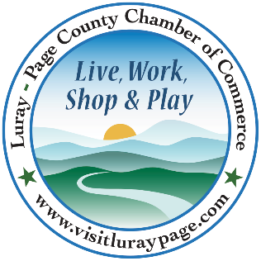

Luray-Page County Chamber of Commerce & Visitor Center
18 Campbell Street, Luray, VA 22835
Phone: (540) 743-3915 • Fax: (540) 743-3944
www.visitluraypage.com

October 2023 Newsletter

The Luray-Page County Chamber of Commerce's mission is to serve our members by promoting and supporting business and tourism throughout Page County. The Luray-Page County Chamber of Commerce's vision is to be the organization where our business community turns for leadership and resources.

Chamber Events

Thursday, October 5th, 10:00 AM
Pretty on Y’all Grand Opening & Ribbon Cutting
Join us on October 5th at 10:00 AM to celebrate the grand opening of Pretty on Y’all, 58 West Main Street, Luray. We’ll be cutting the ribbon at 10:00 AM to welcome the owners to the Page County Business Community. This is a great chance to meet the owners and check out all the crafts that they’ll be offering. If you’re interested in attending, RSVP by Wednesday, October 4th, to events@luraypage.com or (540) 743-3915.

Wednesday, October 11th, 9:00 AM
1st Annual Chamber Golf Classic
Golfers from Page County and the surrounding areas will surely anticipate our 1st Annual Chamber Golf Classic. Our newest annual event is an excellent way to showcase your company, meet new business prospects, and entertain top clients while relaxing on one of the area’s finest golf courses - all while enjoying a day of relaxation on one of the area’s finest golf courses with breathtakingly beautiful views of the Shenandoah Valley. You can find out more about the event by visiting https://www.facebook.com/events/1029247701409638.

Wednesday, October 11th, 12:00-12:30 PM
Valley Business Today Radio Show – Page One
Justin Horn, Director for Page One, is joining Edison Emmons to share information on Page One, a local Non-Profit that helps those in need throughout Page County. Listen in to The River 95.3 or https://thevalleytoday.libsyn.com/ to learn about Page One. To be a future guest on the Valley Business Today Radio Show, contact Edison at edison.emmons@luraypage.com.

Thursday, October 12th, 11:30 AM-1:00 PM
Lunch ‘N Learn – Spotted Lantern Fly
Join us on Thursday, October 12th, from 11:30 AM-1:00 PM at Luray-Page County Chamber of Commerce, 18 Campbell Street, Luray. Joanne Royaltey, Consumer Horticulture and Invasive Species Program Associate for the Virginia Cooperative Extension, will be joining us to talk about Spotted Lantern Fly, an invasive species that has become more prominent in our area, putting our agricultural businesses at risk. Joanne will be talking about the species, the dangers they cause, and what to do if you should find them where you live or work. Lunch is being provided by Main Street Bakery and Catering and will be $15 for Chamber Members and $20 for Potential Members. RSVP by Friday, October 6th to events@luraypage.com or (540) 743-3915.

Tuesday, October 17th, 10:00 AM
The Chop House Bistro Grand Opening & Ribbon Cutting
Join us on Tuesday, October 17th, at 10:00 AM, to celebrate the grand opening of The Chop House Bistro, 132 East Main Street, Luray. We’ll be cutting the ribbon at 10:00 AM to welcome them to the Page County Business Community. The Chop House Bistro is downtown Luray’s newest restaurant, that will be open 7 days a week for lunch and dinner and Brunch on Sunday’s. They will start serving lunch every day at 11:00 AM, and will seat their last table for dinner at 8:30 PM. Please RSVP to events@luraypage.com or (540) 743-3915 by Monday, October 16th.

Tuesday, October 17th, 12:00-12:30 PM
Tourism Tuesday Radio Show – Pretty on Y’all
Catalina Cencich, Co-Owner of Pretty on Y’all, is joining Edison Emmons to share information on this neat crafting studio. Listen in to The River 95.3 or https://thevalleytoday.libsyn.com/ to learn about Pretty on Y’all and everything they have to offer. To be a future guest on the Tourism Tuesday Radio Show, contact Edison at edison.emmons@luraypage.com.

Wednesday, October 18th, 8:00-9:30 AM
Chamber Membership Orientation
Make Sure You are Getting the MOST Out of Your Chamber Membership! If you are a new member, long-time member, or even future members, find out how to get the most out of a Chamber membership. We will walk you through all the basics, in-depth review of membership benefits, how to get involved, our events, how to sponsor events, give you an opportunity to meet Chamber members, and provide you with coffee and breakfast pastries. Come have your membership questions answered, talk about your business and network with other new members. Hosed at the Chamber/Visitor Center boardroom, 18 Campbell Street, Luray. RSVP to events@luraypage.com or (540) 743-3915 by Monday, October 16th to save your seat.

Thursday, October 19th, 4:45-5:15 PM
Annual Tourism Division Meeting will be held in the Luray-Page County Chamber of Commerce Board Room. Our main item of business will be the election of the 2023-24 Tourism Council. Nomination considerations should be forwarded to Gina Hilliard at the Chamber Office by Friday, October 6th. In case of necessary absences, proxies are allowed. Please provide a signed proxy statement to any member in good standing to be presented to the Secretary at the meeting or to Gina at the Chamber by Wednesday, October 18th.

Thursday, October 19th, 5:30-7:00 PM
Business After Hours – Luray-Page County Chamber of Commerce
Join us on Thursday, October 19th, from 5:30-7:00 PM for Business After Hours at the Luray-Page County Chamber of Commerce. Along with our Co-Host, Luray Downtown Initiative, this event is designed for Chamber members to meet and build relationships with other local business members. Come and enjoy an evening of networking, food and drinks from Heartfelt Events of Luray and smores by the firepit. It is time to get together and enjoy each other’s company. You will have the opportunity to introduce yourself to other members, exchange business cards, make new business contacts, win door prizes, and enjoy refreshments. If you’re interested in attending, RSVP to RSVP to events@luraypage.com or (540) 743-3915 by Tuesday, October 17th.

Thursday, October 19th, 6:30-7:00 PM
Annual Chamber Business Meeting will be held in the Luray-Page County Chamber of Commerce. Our main item of business will be the election of the 2023-24 Chamber Board of Directors and changes in the By-Laws. Board of Directors nomination considerations should be forwarded to Gina Hilliard at the Chamber Office by Friday, October 13th.

Wednesday, October 25th, 5:30-7:00 PM
Women in Business - EmpowerHer: Hair and Makeup Tutorial
Join us for "EmpowerHer: Elevate Your Professional Image," on Wednesday, October 25th, from 5:30-7:00 PM, at The Valley Cork, 55 East Main Street, Luray. Lydia Sites of Lydia J. Designs will be featuring exclusive hair and makeup tutorials to enhance your confidence and presentation in the corporate world. You’ll gain practical knowledge and hands-on experience in styling your hair and applying makeup for a professional setting, enhance your confidence and self-assurance by refining your personal grooming skills, and connect with like-minded women and mentors in the business community, fostering a supportive and empowering network. If you are a Chamber Member and would like to attend, it will cost $15 and $20 for Potential Chamber members. Cost will include 2 drinks and charcuterie board samples. For those interested in joining us, please RSVP to events@luraypage.com or by calling (540) 743-3915 by Monday, October 23rd.

New Members Spotlight

John F. Lanier CLU CHFC - Mutual of Omaha Investor Services Inc. & Financial Advisor
John F. Lanier CLU CHFC - Mutual of Omaha Investor Services Inc. & Financial Advisor, Charlottesville. John started his Financial Services career at MetLife in Baltimore in 1994. He owned his own business in Maryland in the transportation sector. John graduated from the University of Baltimore with a BS in Accounting. In 1999, John moved to Stanley. Following his move, he served as a Board Member, Vice President, and later President for the Luray-Page County Chamber of Commerce during the 2000s. Through Mutual of Omaha, John is now able to offer life insurance, health insurance, long-term care insurance, Medicare supplements, Critical Illness policies, annuities, financial planning and investment services.

You can learn more about his offerings by visiting https://agents.mutualofomaha.com/agents/va/charlottesville/johnlanier, emailing john.lanier@mutualofomaha.com, or calling (434) 288-1203.

Log Cabin in Blue
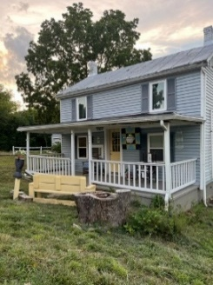
Log Cabin in Blue, 392 Hamburg Road, Luray, is a new lodging facility in Luray-Page County. Owner Nancy Brubaker opened Log Cabin in Blue to visitors during the first month of August of this year. Nancy took much consideration and care when remodeling this house. It was originally her grandfather’s home until he sold it to tenants in the 1960s. Over the last couple decades, the property changed hands. Then about four years ago the couple died that owned it and Nancy was able to purchase the home. The house needed extensive updates, and when they tore the walls down, they found hand cut logs on one side of the house and solid oak boards on the other side. Nancy had a historian come and look at the house and found out that it dated back to being built in 1864, with the new side being added in 1913. After restoring the house, Nancy decided she wanted to share the history of the house with visitors.

You can learn about the history, see the beautiful renovations, and book your stay by emailing nanbrub@yahoo.com or calling (540) 742-2575.

Pretty on Y’all
Pretty on Y’all, 58 West Main Street, Luray, is a new crafting studio in downtown Luray. Opening their doors in late summer of 2023, owners Andrea Cencich and her daughter Catalina had visited the area many times before during the last five years and wanted to help people appreciate the Arts and Culture movements in Luray-Page County. Andrea and Catalina originally hale from Pittsburg, PA, where they did a lot of service work through art events at churches and schools, but this was their first time running a studio. When they first opened, they were happy to give back to the community by offering free events for kids. After seeing their success, they started offering low priced crafting sessions that reflected the same idea. When you walk into Pretty on Y’all, you’ll find tons of discounted yarn that Andera had collected throughout the years. There are also pieces for sale that were made with different yarns. They offer the space for typical crafting sessions, as well as parties and private events. They have supplies for tons of different crafts, including jewelry making.

You can check out more about them at https://prettyonyall.net/, prettyonyall@gmail.com, or (540) 274-4105.

Member Spotlight
Culligan Water
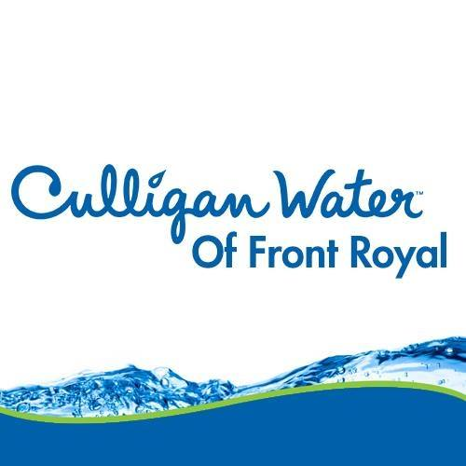
Culligan Water, Front Royal, offers a variety of options for water treatments and supply. The Culligan Company was founded in 1936 to help offer clean drinking water options. The Front Royal office services people and businesses throughout the Shenandoah Valley and is backed by one of America’s most trusted brands with more than 80 years of water treatment experience. Their agents offer water treatment, water filtration, and bottled and drinking water for businesses and homes. They also work with local non-profit organizations through sponsorships, as well.

You can learn more about them by visiting http://www.culliganfr.com, emailing gkeats@culliganfr.com, or calling (540) 635-4915.

