Staff  Gina Hilliard, President  Edison Emmons, Social Media & Marketing Assistant  Clancey Arnold, Membership Development &  Investment Administrator  Courtney Stoneberger, Chamber & Tourism Assistant  Mary Dykes, Chamber & Tourism Assistant  Board of Directors  Executive Officers:  Chris Jenkins, Chair  Faithbrooke Barn and Vineyards  Travis Clark, Vice-Chair  Valley Health Page Memorial Hospital  DezaRae Beers, Secretary  Yogi Bear's Jellystone Park  Miranda Cave, Treasurer  Blue Ridge Bank  Bill Huffman, Chair of the Tourism Division  Luray Caverns  Board Members:  Mitch Lovinger – Appexnetwork Physical Therapy  Amy Judd – Laurel Ridge Community College  Sable Ponn – Funkhouser Real Estate Group  Pam Wightman – Delaware North at SNP  Megan Newberry - Andersen Corporation  David Thomas - Valley Star Farm  Mark Dofflemyer – Pioneer Bank  Tony Villa – Madeline Farms  Follow Us on Social Media  Facebook  LurayPageCountyChamber  VisitLurayPageVA  Instagram  LurayPageCountyChamber  VisitLurayPageVA  Twitter  VisitLurayPage  You Tube  LurayPageCountyChamber  VisitLurayPageVA | Ambassadors  Clancey Arnold, Chair – Luray-Page County Chamber of Commerce  Sable Ponn, Vice-Chair – Sable Ponn, Funkhouser Real Estate Group  Amanda Petty – Amanda Petty Homes with Re/Max Gateway  Zory Glaser – Cardinal Cottage Vacation Cabin Rental  Nancy Boyer – Page County Public Forum  Christine Caldwell – Andersen Corporation  Tourism Council  Restaurants:  Helen Morton – Delaware North  Romeo Pugliese - Mamma Mia Italian Restaurant  Lodging:  Nancy Sottosanti, Treasurer – Shenandoah River Outfitters  DezaRae Beer – Yogi Bear Jellystone Park  Jim Sims – The Mimslyn Inn  Attractions:  Bill Schumacher, Vice-Chair – Fort Valley Ranch  Bill Huffman, Chair – Luray Caverns  Services:  Chris Jenkins – Faithbrooke Barn and Vineyards  CeCe Castle, Secretary – Brookside Restaurant
 | 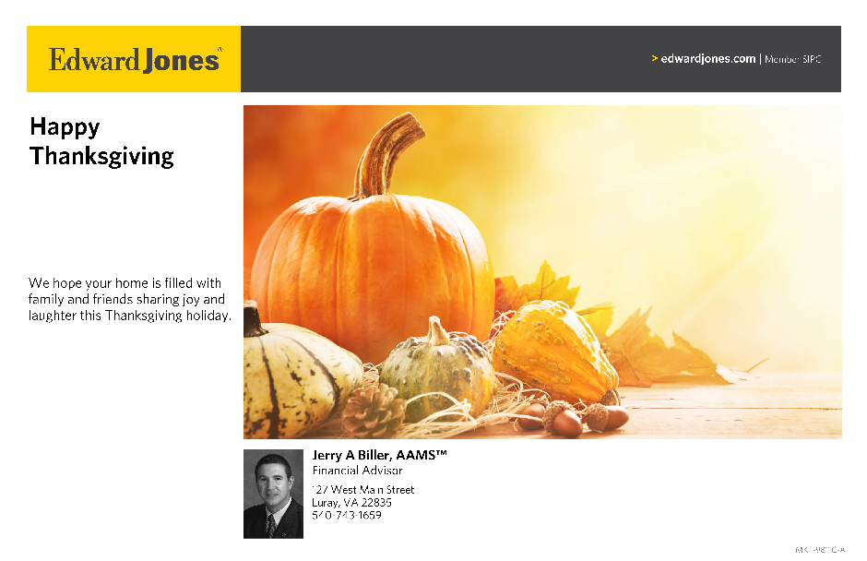

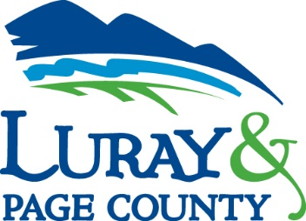
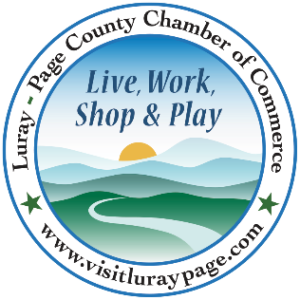

Luray-Page County Chamber of Commerce & Visitor Center
18 Campbell Street, Luray, VA 22835
Phone: (540) 743-3915 • Fax: (540) 743-3944
www.visitluraypage.com

November 2022 Newsletter

The Luray-Page County Chamber of Commerce's mission is to serve our members by promoting and supporting business and tourism throughout Page County. The Luray-Page County Chamber of Commerce's vision is to be the organization where our business community turns for leadership and resources.

Chamber Events

Wednesday, November 2nd, 11:30 AM-1:00 PM
Non-Profit Council
Our mission is to promote the sustainability and growth of the nonprofit organizations and strengthen their role in our community by helping nonprofits collaborate and communicate their mission, value, and engagement opportunities to Page County’s business community. This committee provides non-profits an opportunity for information-sharing, trouble-shooting community-wide issues, identifying common solutions and grant opportunities, networking, educational presentations, training, and speakers, sharing of resources, and advocacy. We will meet every other month on the first Wednesday. Join us on Wednesday, November 2nd, at 11:30 AM-1:00 PM at Laurel Ridge Community College, 200 College Drive. Lunch will be catered by Main Street Bakery and Catering for $15 for Chamber member and $20 for potential chamber member. RSVP by Monday, October 31st, at (540) 743-3915 or events@luraypage.com.

Saturday, November 5th, 2:00 PM
Andrew Jackson School Ribbon Cutting
Join us on Saturday, November 5th at 2:00 PM to celebrate the opening of the Andrew Jackson School Museum. We’ll be cutting the ribbon at 2:00 PM and will be joined by members of the community that attended the school when it was open. Afterwards, everyone is invited to stick around and learn about this historic school. If you plan on attending, please RSVP by Friday, November 4th to events@luraypage.com or (540) 743-3915.

Thursday, November 17th, 5:30-7:00 PM
Business After Hours – Broad Porch Coffee
Join us on Thursday, November 17th, from 5:30-7:00 PM for Business After Hours at Broad Porch Coffee, 20 West Main Street, Luray. Broad Porch Coffee will be providing a great networking opportunity, tasty refreshments, and some great door prizes. This event is designed for Chamber members to meet and build relationships with other local business members. It is time to get together and enjoy each other’s company. You will have the opportunity to introduce yourself to other members, exchange business cards, make new business contacts, win door prizes, and enjoy refreshments. If you plan on joining us, please RSVP to events@luraypage.com or (540) 743-3915 by Wednesday, November 16th.

Tuesday, November 22nd, 5:30-7:00 PM
Women in Business – Mixology at The Valley Cork
Join us on Tuesday, November 22nd at 5:30 PM at The Valley Cork, 55 East Main Street, Luray for a special Mixology class. We’ll be joined by the owner of The Valley Cork, Lynette Shenk, to learn how to make some holiday cocktails. While you learn about making this fun and tasty drink, you can enjoy light refreshments, as well. The cost for this class will be $15 for Chamber Members and $20 for potential members. Please RSVP to events@luraypage.com or (540) 743-3915 by Friday, November 18th.

Tuesday, November 29th, 12:30-1:00 PM
Tourism Tuesday Radio Show – 7th Annual Chamber Holiday Festival
Tourism Tuesday Radio Show: Chamber Holiday Festival. Gina Hilliard, president of the Luray-Page County Chamber of Commerce, is joining Edison Emmons to share information on this year’s Chamber Holiday Festival event. Listen in to the River 95.3 or https://theriver953.com/podcasts/the-valley-today/ to learn about the kid’s crafts, cookies, hot cocoa, pictures with Santa, local craft vendors, and other fun Holiday activities we’ll be featuring. To be a future guest on the Tourism Tuesday Radio Show, contact Edison at edison.emmouns@luraypage.com.

Saturday, November 26th – Sunday, December 18th
Shop Small for the Holidays
Page County Shops for the Holidays. Kick off your holiday season on Saturday, November 26th by shopping locally at all the wonderful shops located throughout Page County. Shop Small for the Holidays! From November 26th through December 18th shop small at local shops and restaurants for a chance to win a $500 shopping spree! When you shop or dine local, send a picture of your receipt by email to events@lurayapage.com, or drop it off in person at 18 Campbell Street, Luray, to be entered into our $500 shopping spree. For each receipt you bring or send to us, you will receive one entry, even if it’s for an online order. Just make sure your entry has your name, phone number, and copy of receipt. Receipts are due to by December 18th, at 5:00 PM, and the drawing will take place Live on our Facebook on Monday, December 19th. For more information visit @LurayPageChamber on Facebook or contact the Chamber at events@luraypage.com or 540-743-3915.

Chamber Announcements

Any advertising inserted and printed in this newsletter and the content of those inserts and print ads are not sponsored or endorsed by the Luray-Page County Chamber of Commerce & Visitor Center.

Member Spotlight

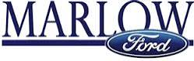
Marlow Ford
Marlow Ford, 1021 US Highway 211 West, Luray, is a local Ford dealership. Opening their doors in 1990, Marlow Ford of Luray has been a trusted dealership in the Shenandoah Valley for over two decades. They offer their clients expert sales, competitive financing, and superior parts and services. Their lot holds a complete line of new Fords, along with a vast selection of pre-owned and commercial vehicles for you to choose from. As a part of the Marlow Automotive Group, they follow the mission of customer satisfaction by offering affordable and friendly services.
You can learn more about their lot and their services by visiting https://www.marlowford.com/, emailing sales@marlowford.com, or by calling (540) 743-5128.

New Member Spotlight

Blue Shepherd Spirits
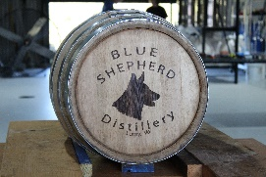
Blue Shepherd Spirits, 622 West Main Street, Luray, is a local nano-distillery in Luray. Blue Shepherd is owned and operated by Alex Colby and his wife Sarah Ellis, Blue Shepherd offers rum, gin, and vodka that they distil right on the property. Alex is a full-time fire fighter and paramedic, and was formerly an Army medic. The original plan wasn’t to start his distillery business until he retired, but after losing his uncle to a second heart attack, he thought why wait? Blue Shepherd Spirits is named after Alex’s Blue German Shepherd Bruce. Blue Shepherds are pretty rare, so they thought it would be fitting to pay homage to Bruce. Bruce is a rescue that had some behavior issues with strangers, but is extremely loveable if you’re part of his pack. Blue Shepherd recently opened their doors in an old car garage on West Main Street. They specialize in small batch artesian spirits. They offer a variety of seasonal and permanent cocktails, as well as bottles of the liquor they sell. You can learn more at http://blueshepherdspirits.com/, alex@blueshepherdspirits.com, or (540) 316-0056.

Greatful Cookies
Greatful Cookies, Luray, is a local custom cookie business. Greatful Cookies is run by Whitney Dinges and has been offering custom sugar cookies to customers since 2015. They got their start when Whitney’s mom wanted to make cute sugar cookies for her wedding, which then led to a fun and tasty hobby. In 2020, Whitney joined in the business with her mom and officially took over in 2021. After taking over, Greatful Cookies officially became a licensed business. Whitney is a full-time Elementary School Counselor by day and bakes their delicious cookies at night. When you order cookies through Greatful Cookies, you get custom, one of a kind sugar cookies. They offer a variety of flavors, their most popular being vanilla, chocolate, lemon, and snickerdoodle. Each batch of cookies takes several days to finish and are a true labor of love. They not only bake up custom orders for corporate events, birthdays, weddings, and more, but you can also find them at a variety of events throughout the Holiday season.
You can check them out at https://www.facebook.com/greatfulcookies, greatfulcookies@gmail.com, or (540) 860-1188.

Shenandoah Valley Black Heritage Project
Shenandoah Valley Black Heritage Project, Harrisonburg, is a local non-profit organization that works to educate communities in the Shenandoah Valley about African American history. The SVBH was established in February of 2013. They opened their center of operations at 425 Hill Street in Harrisonburg in 2018. They offer a space for meetings, research, and resources for those interested in African American history of the Shenandoah Valley. The group is a result of several individuals and groups coming together that wanted to shed light on the history of African Americans in our communities. The group seeks to learn about history that is kept out of history books, to share the research and findings they come across, and to illuminate history through cultural programs. This truly grass roots organization has continued to grow and share their research and always welcome new volunteers. They work with local historians, teachers, artists, and descendants to help uncover and share this vital part of history. You can learn more about their mission by visiting http://www.valleyblackheritage.org, emailing robinlyttle@valleyblackheritage.org, or calling (410) 206-1814.

Sudboss Garage, LLC
Sudboss Garage, LLC, 161 Brady Road, Stanley, is a local car detailing garage. Owned and operated by David Nealis, Sudboss Garage started as a side weekend job about 10 years ago when David would detail his friends and family’s cars on the weekends. As good reviews started spreading, David was able to make this fun weekend job a full-time career. Sudboss Garage has officially been open for a little over a year. The team prides themselves on offering high quality products to help keep your car looking fresh and running great. The garage is master certified with Fireball USA, which gives customers comfort knowing that they are highly trained individuals and are very good at what they do. They detail vehicles to help preserve customers hefty investments and to protect them against potential harm by daily driven elements. We also install electronic accessories, lighting and off-road components. We can also protect the frame and undercarriage of vehicles as well with our new anti-corrosive clear coat. You can learn more by visiting http://www.sudbossgarage.com, emailing sudboss1@yahoo.com, or calling (540) 435-3155.

