Luray – Page County Chamber of Commerce
18 Campbell Street, Luray, VA 22835 - Tel: 540-743-3915 - Fax: 540-743-3944
www.VisitLurayPage.com

For Immediate Release Contact: 540-743-3915
March 17, 2022 events@luraypage.com

Mend My Mobile Grand Opening & Ribbon Cutting

Luray, VA – The Luray-Page County Chamber of Commerce had the honor of celebrating the grand opening and ribbon cutting of Mend My Mobile, 1416 US Highway 211 West, Luray, on Wednesday, March 16, 2022, at 10:30 AM.”

“We love to see new businesses opening in Page County”, said Gina Hilliard, president of the Luray-Page County Chamber of Commerce. “Mend My Mobile brings a much needed service to our community. Businesses like Mend My Mobile keeps people and revenue in Page County by giving them the option to not have to drive to another county to receive these services.”

Mend My Mobile opened their doors in September of 2021. Owned and operated by Jeremy Seal, he has over 20 years experience working in the communications industry. In spring of 2021, Jeremy became certified in mobile phone repair. He can repair a wide variety of phones models, specializing in cracked Screens and batteries replacements using high quality replacement parts. We talked to Jeremy about becoming part of the Page County business community, he said “Phones have become expensive, our goal is to help our local community keep their investment running smoothly.” His office hours are Monday-Friday 10:00 AM-6:00 PM and Saturday 10:00 AM-4:00 PM.

Yesterday, we welcomed members of the community to join us in welcoming this new business to town. In attendance were Board of Supervisor’s Allen Louderback, Mayor of Luray Jerry Dofflemyer, Town Manager Steve Burke, Sheriff Chad Cubbage, Chief of the Luray Police Department Bow Cook, Sable Ponn, Chamber Board of Directors, as well as an Ambassador, and Amanda Petty, who is also an Ambassador.

For more on all of the services that they offer make sure to visit https://mendmymobile.godaddysites.com/?fbclid=IwAR3L5svtdDhhUsRvS7XFWjWnV91VSp9fJZ_Zge3wWSrYj1Z_Bm32VlqT-iM or their facebook page at https://www.facebook.com/mendmymobilephone/, call (540) 669-5993, or email them at support@mendmymobilephone.com, For more details on the ribbon-cutting, contact the Luray-Page County Chamber of Commerce at events@luraypage.com.
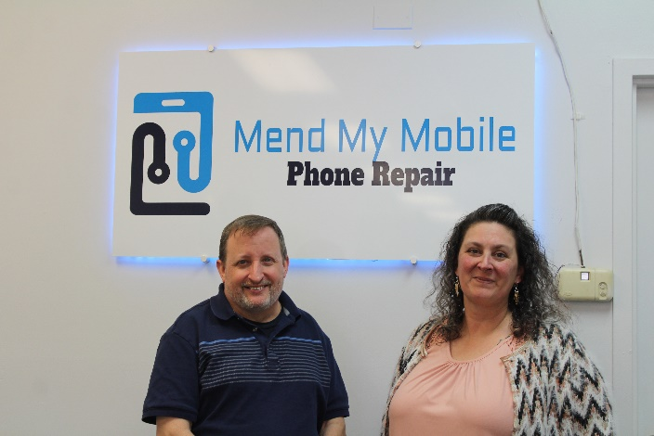
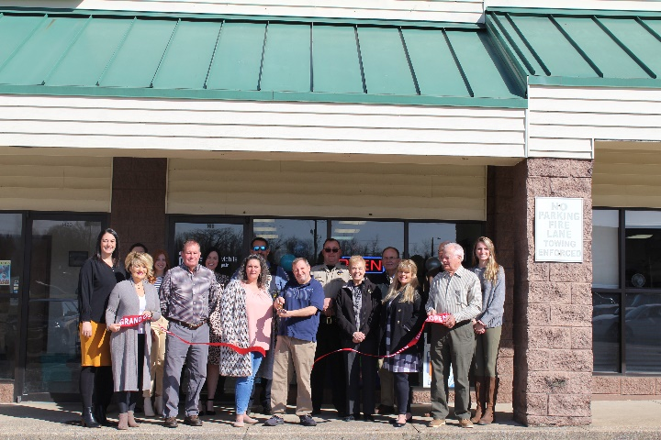

To see more pictures from the Mend My Mobile Grand Opening & Ribbon Cutting, you can visit our Facebook page.

