Staff  Gina Hilliard, President  Edison Emmons,  Communications and Marketing Coordinator  Clancey Arnold,  Membership Development and Engagement  Mary Dykes, Chamber & Tourism Assistant  Courtney Stoneberger, Chamber & Tourism Assistant  Board of Directors  Executive Officers:  Travis Clark, Chair  Valley Health Page Memorial Hospital  Amy Judd, Vice Chair  Laurel Ridge Community College  DezaRae Beers, Secretary  Yogi Bear's Jellystone Park  Miranda Cave, Treasurer  Blue Ridge Bank  Bill Huffman, Chair of the Tourism Division  Luray Caverns  Board Members:  David Reed - Reed & Reed, P.C. Attorneys & Counsellors at Law  Ian Rudolph – Rudy’s Diner  Megan Gordan - Page Alliance for Community Action  Michael Darrow– Delaware North at SNP  Mitch Lovinger – Appexnetwork Physical Therapy  Sable Ponn – Funkhouser Real Estate Group  Tony Villa – Madeline Farms  Follow Us on Social Media  Facebook  LurayPageCountyChamber  VisitLurayPageVA  Instagram  LurayPageCountyChamber  VisitLurayPageVA  Twitter  VisitLurayPage  You Tube  LurayPageCountyChamber  VisitLurayPageVA | Ambassadors  Clancey Arnold, Chair – Luray-Page County Chamber of Commerce  Sable Ponn, Vice-Chair – Sable Ponn, Funkhouser Real Estate Group  Amanda Petty – Amanda Petty Homes with Re/Max Gateway  Christine Caldwell – Luray Downtown Initiative  Marlise Lee - Cameo Galleries  Zory Glaser – Patron  Tourism Council  Attractions:  Bill Huffman, Chair – Luray Caverns  Lodging:  Nancy Sottosanti, Treasurer – Shenandoah River Outfitters  DezaRae Beer – Yogi Bear Jellystone Park  Jim Sims – The Mimslyn Inn  Restaurants:  Helen Morton – Delaware North  Romeo Pugliese - Mamma Mia Italian Restaurant  Services:  Chris Jenkins – Faithbrooke Barn and Vineyards  CeCe Castle, Secretary – Brookside Restaurant
 | 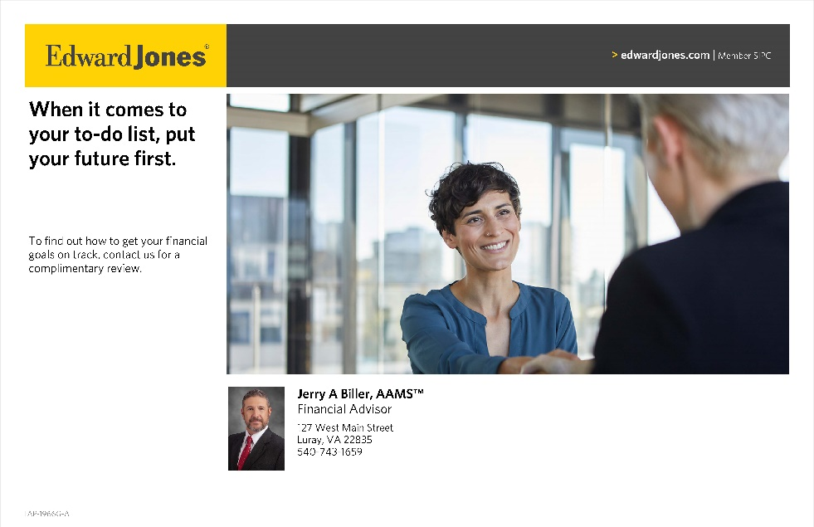

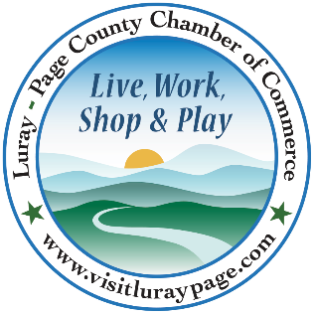

Luray-Page County Chamber of Commerce & Visitor Center
18 Campbell Street, Luray, VA 22835
Phone: (540) 743-3915 • Fax: (540) 743-3944
www.visitluraypage.com

May 2023 Newsletter

The Luray-Page County Chamber of Commerce's mission is to serve our members by promoting and supporting business and tourism throughout Page County. The Luray-Page County Chamber of Commerce's vision is to be the organization where our business community turns for leadership and resources.

Chamber Events

Thursday, May 11th, 2:00-3:00 PM
Business Seminar – Creating with Canva
Join Janet Michael from Java Media for a FREE webinar “Creating with Canva” on Thursday, May 11, 2023, from 2–3 PM via Zoom. Janet will give an overview for using templates to create social media posts & flyers, plus other uses/reasons to add Canva to your marketing toolkit. Attendance is free but registration is REQUIRED.
Register here: https://link.edgepilot.com/s/d1bde06f/mvid0uhAEEm2Fbf0hRaPZQ?u=https://bit.ly/40fc2rB. This webinar is in partnership with the Luray/Page County Chamber of Commerce. Chamber membership is not required to attend.
Janet Michael is the owner of Java Media, a social media and marketing firm, with over 25 years of experience developing successful marketing & advertising campaigns. Java Media provides social media training and workshops for small business owners as well as social media management, oversight & evaluation services. She produces podcasts for small business owners, non-profits, and local leaders. Janet also hosts a daily award-winning talk show, The Valley Today, on local radio station, The River 95.3FM.

Tuesday, May 16th, 12:00-12:30 PM
Tourism Tuesday Radio Show – Main Street Bakery and Catering
Chef Chuck Arnaud, owner of Main Street Bakery and Catering, is joining Edison Emmons to share information on his restaurant catering business in downtown Luray. Listen in to The River 95.3 or https://theriver953.com/podcasts/the-valley-today/ to learn about all the local flavors he has to offer. To be a future guest on the Tourism Tuesday Radio Show, contact Edison at edison.emmons@luraypage.com.

Tuesday, May 16th, 3:30-4:30 PM
Education/Realtor Partnership Meeting
Join us on Tuesday, May 16th to learn more about the Page County Public School System. Antonia M. Fox, Ed.D., Superintendent of Page County Public Schools wants to invite you to come and want to help you better understand and sell our area and our Page County Public Schools. Our goal is to inform local real estate agents to understand more about the advantages of our local school system. Come meet with our staff so we can share with you all the wonderful experiences the students can have during their time here in Page County. It is important that our local agents know how to great our schools are. Please RSVP by Friday, May 12th to 540-743-3915 or events@luraypage.com.

Thursday, May 18th, 5:30-7:00 PM
Business After Hours – Page Valley Agricultural & Industrial Fair
Join us on Thursday, May 18th, from 5:30-7:00 PM, for this month’s Business After Hours at the Page Valley Fair Grounds, 15 Fairlane Drive, Luray. You’ll get to enjoy delicious refreshments and a signature drink, as well as being entered in for drawings for great door prizes for local businesses, including passes to this year’s Fair. The festivities will take place in the Commercial Building. Parking will be inside the first gate. This event is designed for Chamber members to meet and build relationships with other local business members. It is time to get together and enjoy each other’s company. Bring business cards for networking and to be entered in door prize raffles. If you would like to attend, please RSVP to events@luraypage.com or (540) 743-3915 by Tuesday, May 16th.

Tuesday, May 23rd, 5:30-7:00 PM
Women in Business – Celebrating Women’s Health Month
Grab your mom, sisters, co-workers, or best girlfriends and join us on Tuesday, May 23rd, from 5:30-7:00 PM at Laurel Ridge Community College, 200 College Drive room 208-209, for a fun evening in a beautiful setting, celebrating women’s health with Valley Health Page Memorial Hospital, Boost Your Brilliance, Integrated Bodyworks, and other Community Partners. Women’s health care month is observed annually in May. This is also an annual observance engineered by the US. Department of Health and Human Services Office on Women’s Health. The goal of the holiday is to empower women in such a way that they can make health a priority. It also equips women with the knowledge to help other women on their journeys to improve themselves. With the efforts of individuals and healthcare workers, every woman can live a healthy and happy life. For this event, the cost is $15 for Chamber Members and $20 for Potential Members. Everyone in attendance will enjoy delicious appetizers, desserts, drinks and learn about the importance of keeping up with routine health screenings. Everyone in attendance will be able to get their blood pressure checked and BMI. We will have a guest speaker provide tips on healthy recipes and stress management. If you would like to attend, please RSVP to events@luraypage.com or (540) 743-3915 by Monday, May 22nd.

Thursday, June 8th, 5:00 PM
97th Annual Banquet & Awards – Hawaiian Luau
97th Annual Banquet & Awards will be a Hawaiian Luau themed celebration of the Luray-Page County Chamber of Commerce & Visitor Center’s 97th year in the Page County business community. This year's Annual Banquet & Awards will be held at Brenwood Lake Weddings, 245 Log Cabin Drive, Stanley, with a cocktail hour, silent auction, catered meal, and awards. We’re excited to share this celebration time with all our amazing members. Tickets will be $75.00. We will share plenty of photos afterward.

Chamber Announcements

Any advertising inserted and printed in this newsletter and the content of those inserts and print ads are not sponsored or endorsed by the Luray-Page County Chamber of Commerce & Visitor Center.

We have a variety of events throughout the year. While some of them are free, we do host events that we require an RSVP for. Our Lunch N’ Learn’s, Women in Business, Annual Banquet, and other events that we require an RSVP for are ones where we must charge for food that is provided. RSVPing for these events is how we can let our hosts know how much food to prepare. If you RSVP to an event, but do not let us know before the RSVP date that you will not be able to attend, we will still have to charge for your spot, as our hosts and caterers will have already purchased and prepared the food for the events.

When RSVP’ing for an event, please make sure to call our office at (540) 743-3915 or email your name, business, and event you’re planning on attending to events@luraypage.com. After coming up with our monthly events, we create Facebook event pages. While we appreciate everyone interacting and sharing our event pages, we will no longer accept them as the RSVP for our events. To properly invoice for each person attending, and to keep track of everyone that is planning on attending, we need confirmation via phone or email if you are attending our events.

We’re sure you’ve seen all the flyers that are in our monthly newsletters. Our members have the option of inserting flyers with information on programs, events, and other important things their businesses or organizations are doing each month. When you receive our newsletters, make sure to take a second to look over the flyers so that you’ll know what’s going on in our community. Make sure that you hang them up in your window, make copies for your office, put them up in your employee breakrooms, or even scan them in and email them to your employees. This is a great way to not only help promote the business community, but to let your employees and customers know about what’s going on right here in their own backyards each month.
Member Spotlight

Beahm’s Chapel Cemetery
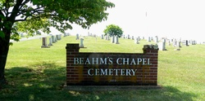
Beahm’s Chapel Cemetery, 1224 US Hwy 211 East, Luray, is a local, historic cemetery. Located in the shadows of the Blue Ridge Mountains, Beahm’s Chapel Cemetery was organized in 1914 and was originally just 5 acres of land. Today, the cemetery consists of approximately 35 acres. They have approximately 15,000 sites that have been surveyed, with 7,700 still available. Of the graves that taken, 400 are veterans that served our country. The cemetery got its name from the small chapel located adjacent to the cemetery. In addition to traditional burial sites, they also have a Columbarium with single or double niches for individuals who have been cremated.

To learn more about this historic cemetery, or to make donations, you can visit http://www.beahmschapelcemetery.com, email beahmschapelcemetery@centurylink.net, or call (540) 743-6407.

New Members Spotlight

EXP Realty – Lisa Merkel
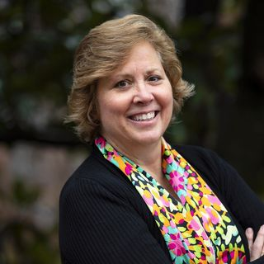
EXP Realty – Lisa Merkel, Luray, is a licensed real estate agent servicing various areas in the state of Virginia. Lisa has been active in the real estate industry since 2019 but has been a licensed realtor in Virginia and Washington D.C. for the past 3 years. After retiring from a long career in management consulting, her and her husband decided to start a residential redevelopment company that was based around their love of renovating older homes. Lisa became an active realtor to help sell their renovated properties. Being a realtor allows Lisa to utilize key strengths like integrity, client service, strategy, and negotiation to find win-win solutions in solving clients real estate needs. Lisa loves working with all types of clients, from buyers to sellers to investors. In addition to work with people form the Page County community, she also has worked with individuals and families from around the world who are interested in finding their own special place in Western Virginia and in Page County. Currently, Lisa works with eXp Realty, which is the fastest growing brokerage in the world. Lisa also is a sponsor for a new online community that helps all the members of our community connect and learn about other local businesses.

You can learn more about Lisa by visiting http://lisamerkel.exprealty.com, emailing lisa.merkel@exprealty.com, or calling (703) 708-4711.

American Cancer Society – Page County Relay for Life
American Cancer Society - Page County Relay for Life, Page County, is a local branch of the American Cancer Society. The American Cancer Society was founded in 1913 in an effort to raise awareness about cancer and to support research efforts. When the organization was founded, cancer meant near-certain death. Seeing the fear and denial that doctors and patients were faced with, the founders of the organization were able to pull together other colleagues in. These individuals who were part of the original group took on the momentous task of writing articles for popular magazines and professional journals, publishing Campaign Notes, creating a monthly bulletin of cancer information, and recruited doctors throughout the country to help educate the public. Now, the American Cancer Society is the leading cancer-fighting organization with a vision of ending cancer as we know it, for everyone. They are the only organization that is working to improve the lives of people with cancer and their families through advocacy, research, and patient support, to ensure everyone has an opportunity to prevent, detect, treat, and survive cancer. The Page County Relay for Life branch helps to bring these resources and information to the Page County community. They also host the annual Relay for Life walk and hold other fund-raising events throughout the year to help support the overarching organization.

You can learn more by visiting http://relayforlife.org/pageva, emailing pagerelay18@gmail.com, or calling (540) 669-7112.

