Staff:  Gina Hilliard, President  Edie Emmons, Social Media & Marketing Assistant  Clancey Arnold, Membership Development &  Investment Administrator  Courtney Stoneberger, Chamber & Tourism Assistant  Board of Directors:  Executive Officers:  Chris Jenkins, Chair – Faithbrooke Barn and Vineyards  Mark Dofflemyer, Vice-Chair – Pioneer Bank  DezaRae Beers, Secretary – Yogi Bear's Jellystone Park  Miranda Cave, Treasurer – Blue Ridge Bank  Mark Leach, Past Chair of the Board – Patron  John Shaffer, Chair of the Tourism Division –  Luray Caverns  Board Members:  Travis Clark – Valley Health Page Memorial Hospital  Mitch Lovinger – Appexnetwork Physical Therapy  Kim Blosser – Lord Fairfax Community College  Bart Patton - Patton Gunsmith Works  Tanya Jones – Red Zinnia Consulting  David Thomas - Valley Star Farm  Darryl Haley – Patron  Volunteers:  Jerry Griffin  Follow Us on Social Media  Facebook  LurayPageCountyChamber  VisitLurayPageVA  CabinCapitalofVirginia  Instagram  LurayPageCountyChamber  VisitLurayPageVA  Twitter  VisitLurayPage  You Tube  LurayPageCountyChamber  VisitLurayPageVA | Ambassadors:  Clancey Arnold, Chair – Luray-Page County Chamber of Commerce  & Visitor Center  Helen Phillips-Cockrell – Co-Chair - Certified Health and Wellness Coach, Optimal Health Solutions  Sable Ponn – Sable Ponn, Funkhouser Real Estate Group  Zory Glaser – Cardinal Cottage Vacation Cabin Rental  Garnett Brockman – Page County Farm Bureau Federation/Insurance  Nancy Boyer – Page County Public Forum  Dave Bull – Patron  Tourism Council:  Restaurants:  CeCe Castle, Secretary – Brookside Restaurant  Romeo Pugliese - Mamma Mia Italian Restaurant  Lodging:  Nancy Sottosanti, Treasurer – Shenandoah River Outfitters  John Shaffer, Chairman – Luray Caverns Motels  Jim Sims – The Mimslyn Inn  Attractions:  Bill Schumacher, Vice-Chairman – Fort Valley Ranch  Sue Ishak – Wisteria Farm and Vineyard  Services:  Helen Morton – Delaware North  Chris Jenkins – Faithbrooke Barn and Vineyards  Liz Lewis – County of Page  Sally Hurlbert – Shenandoah National Park

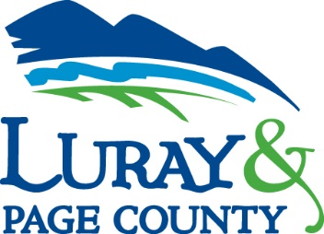
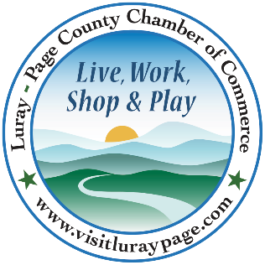

Luray-Page County Chamber of Commerce & Visitor Center
18 Campbell Street, Luray, VA 22835
Phone: (540) 743-3915 • Fax: (540) 743-3944
www.visitluraypage.com

March 2021 Newsletter

The Luray-Page County Chamber of Commerce's mission is to serve our members by promoting and supporting business and tourism throughout Page County. The Luray-Page County Chamber of Commerce's vision is to be the organization where our business community turns for leadership and resources.

Chamber Events

Wednesday, March 3rd, 11:30 AM-1:00 PM
Virtual 411 Orientation. New Chamber members from December, January, and February are invited to join our Virtual 411 Orientation. Our 411 Orientation offers an in-depth review of membership benefits, gives a chance to have your membership questions answered, talk about your business, and network with other new members. RSVP to events@luraypage.com by Tuesday, March 2nd. Register in advance for this webinar: https://us02web.zoom.us/webinar/register/WN_SMX6iMKER8OgY8nUBXIi1Q. After registering, you will receive a confirmation email containing information about joining the webinar.
Thursday, March 11th, 11:30 AM-1:00 PM
Virtual Lunch N' Learn. Sharon Booker, manager of H&R Block, along with Senior Tax Advisor Laurie McKenzie, will join us for this month's Lunch N' Learn. Deduction, Credits, & COVID: 2020 Tax returns. Answering your questions about individual and business tax returns. Register in advance for this webinar: https://us02web.zoom.us/webinar/register/WN_s_B2JzIGT5eCQXkNqqHFoQ. After registering, you will receive a confirmation email containing information about joining the webinar.
Sunday, March 14th-20th
Page County Restaurant Week. Page County area restaurants and local foodies join together to celebrate the Third Annual Page County Restaurant Week. Participating restaurants will feature specials and menu favorites, and some new and unique choices. Want to win a gift certificate to a restaurant in Page County? Follow these rules: Eat at your favorite restaurant in Page County starting Friday, February 19th-March 13th, email a copy of your receipt, or guest check to events@luraypage.com to be entered into a gift certificate on us! Prizes will be gift certificates to restaurants with the most receipts received. Restrictions apply. For more information, visit www.dineoutpagecountyva.com, or contact (540) 743-3915 or events@luraypage.com.
Tuesday, March 17th, 12:00-12:30 PM
Tourism Tuesday Radio Show: Copper Fox Distillery. Cheryl Targos, with Copper Fox Distillery, is joining Edie Emmons to share information on their Distillery. Listen in to the River 95.3 or https://theriver953.com/podcasts/the-valley-today/ to hear about Copper Fox Distillery and all they have to offer. To be a future guest on the Tourism Tuesday Radio Show, contact Edie Emmons at edie.emmons@luraypage.com.

New Member Highlights

Nesbitt Realty
Nesbitt Realty, 1451 Belle Haven Road Suite 222, Alexandria, is a family-run estate brokerage serving the Shenandoah Valley and Northern Virginia. After years of being a leading member of a dotcom technology team, Will Nesbitt bought the office of retiring broker, River Towers in New Alexandria. What became Nesbitt Realty, Will began to build a web-based hub of real estate information to provide buyers, sellers, renters, and landlords an easy and user-friendly way to exchange information. Once they established their web-based hub, business took off, and they added some more family to the team, allowing them to help more customers. In 2020, Will and his wife Julie returned to the Valley they grew up in, purchased a home in Luray, Va, and expanded their service area to the Shenandoah Valley. For the past 35 years, Nesbitt Realty has helped buyers, sellers, renters, and landlords achieve their real estate goals. Nearly half of Nesbitt Realty's income is from property management. To learn more, visit their website, https://nesbittrealty.com/, send an email to will@nesbittontheweb.com, or call (703) 765-0300.

Studio 31.13
Studio 31.13, 12 East Main Street, Luray, is Luray's newest crafting studio. Opening this year, Studio 31.13 will allow the community to participate in craft projects, workshops, kits, and parties. In summer 2020, Christine Caldwell, who developed Studio 31.13, had the opportunity to transition out of a successful Human Resources career. Considering herself a crafter, she got the idea for a studio where others could learn techniques and skills to do crafts.
Christine started developing a business plan and vision for Studio 31.13 in November 2020 and working to open as soon as possible. The studio will be a crafting studio boutique that offers upscale, trendy, and unique craft projects, kits, workshops, and parties for all ages. With various experiences and crafts offered, they will help all who attend design and execute masterpieces while encouraging and celebrating creative freedom. To learn more about Studio 31.13, visit https://www.facebook.com/luraystudio3113/, email luraystudio31.13@gmail.com, or call (828) 577-0313.

Help Us Welcome Our New Members
Nesbitt Realty  Will Nesbitt  1451 Belle Haven Road Suite 222 Alexandria, VA  (703) 765-0300  will@nesbittontheweb.com | Studio 31.13  Christine Caldwell  12 East Main Street  Luray, VA  (828) 577-0313  luraystudio31.13@gmail.com

Member Spotlight

Castle Vineyards
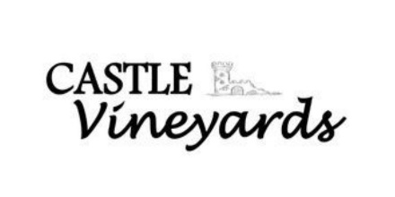
Castle Vineyards, 2150 Mims Road, Luray, is a local vineyard that offers various wines from Barren Ridge Vineyards in Fishersville, VA. Castle Vineyard is a joint effort of Jeremy McCoy and his uncle, R. Steven Davis. Opening its doors in 2017, Castle has made a fun, laid-back environment for locals and visitors alike. With an option for indoor and outdoor seating, there is no shortage of areas to sit and enjoy the wine and entertainment they offer. Aside from wine tastings, they also provide the chance to hold special events on their property and accommodate 45 people. While they are catered more to adults, they have fun and games for the whole family to enjoy. For more information, visit their website, https://castlevineyardsva.com/, email info@castlevineyardsva.com, or call (571) 283-7150.

* Do your part to slow the spread of the coronavirus and follow all CDC guidelines. Please continue to sanitize/wash hands and social distance. Please remember to bring and wear a face mask at all our in-person meetings and events.

*If you haven't already signed up for or gotten your COVID-19 vaccine yet, visit the Virginia Department of Health's new vaccine registration website. Getting both shots of the COVID-19 vaccine will help to slow the spread and is the best way to make sure that you keep yourself and others safe. You can register for your vaccine by visiting https://vaccinate.virginia.gov/.

* Any advertising inserted and printed in this newsletter and the content of those inserts and print ads are not sponsored or endorsed by the Luray-Page County Chamber of Commerce. *

