Staff  Gina Hilliard, President  Edison Emmons,  Communications and Marketing Coordinator  Clancey Arnold,  Membership Development and Engagement  Mary Dykes, Chamber & Tourism Assistant  Courtney Stoneberger, Chamber & Tourism Assistant  Board of Directors  Executive Officers:  Travis Clark, Chair  Valley Health Page Memorial Hospital  Amy Judd, Vice Chair  Laurel Ridge Community College  DezaRae Beers, Secretary  Yogi Bear's Jellystone Park  Miranda Cave, Treasurer  Blue Ridge Bank  Bill Huffman, Chair of the Tourism Division  Luray Caverns  Board Members:  David Reed - Reed & Reed, P.C. Attorneys & Counsellors at Law  Mitch Lovinger – Appexnetwork Physical Therapy  Sable Ponn – Funkhouser Real Estate Group  Megan Newberry - Andersen Corporation  Megan Gordan - Page Alliance for Community Action  Michael Darrow– Delaware North at SNP  Tony Villa – Madeline Farms  Ian Rudolph – Rudy’s Diner  Follow Us on Social Media  Facebook  LurayPageCountyChamber  VisitLurayPageVA  Instagram  LurayPageCountyChamber  VisitLurayPageVA  Twitter  VisitLurayPage  You Tube  LurayPageCountyChamber  VisitLurayPageVA | Ambassadors  Clancey Arnold, Chair – Luray-Page County Chamber of Commerce  Sable Ponn, Vice-Chair – Sable Ponn, Funkhouser Real Estate Group  Amanda Petty – Amanda Petty Homes with Re/Max Gateway  Zory Glaser – Cardinal Cottage Vacation Cabin Rental  Nancy Boyer – Page County Public Forum  Christine Caldwell – Andersen Corporation  Marlise Lee - Cameo Galleries  Tourism Council  Attractions:  Bill Huffman, Chair – Luray Caverns  Bill Schumacher, Vice-Chair – Fort Valley Ranch  Lodging:  Nancy Sottosanti, Treasurer – Shenandoah River Outfitters  DezaRae Beer – Yogi Bear Jellystone Park  Jim Sims – The Mimslyn Inn  Restaurants:  Helen Morton – Delaware North  Romeo Pugliese - Mamma Mia Italian Restaurant  Services:  Chris Jenkins – Faithbrooke Barn and Vineyards  CeCe Castle, Secretary – Brookside Restaurant
 | 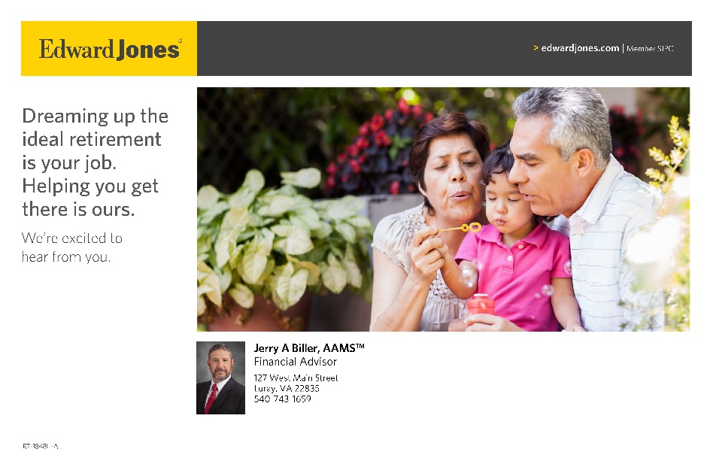

Luray-Page County Chamber of Commerce & Visitor Center
18 Campbell Street, Luray, VA 22835
Phone: (540) 743-3915 • Fax: (540) 743-3944
www.visitluraypage.com

March 2023 Newsletter

The Luray-Page County Chamber of Commerce's mission is to serve our members by promoting and supporting business and tourism throughout Page County. The Luray-Page County Chamber of Commerce's vision is to be the organization where our business community turns for leadership and resources.

Chamber Events

Wednesday, March 8th, 10:00 AM-4:00 PM
Job Fair & Workshop
Join us on Wednesday, March 8th, from 10:00 AM-4:00 PM, for our annual Job Fair and Workshop, hosted at Laurel Ridge Community College, 200 College Drive, Luray. This event is sponsored by Syntelligent Analytic Solutions, LLC and the Chamber’s partners are Laurel Ridge Community College, Page County Public Schools, Page County Economic Development & tourism, Virginia Employment Commission, Virginia Career Works and Qualified Staffing. Looking for work or wanting to make a career change? Let us help you! Whether you’re interested in working for a startup or a large organization, or if you just need a refresher on how to build an eye-catching resume, we invite you to come out and join us for our job fair and workshop. You will have the opportunity to get help with job search assistance, resume building and review, application help, and get a chance to interact with 25+ companies and score a job for you. Bring multiple cover letters and resumes along with you.

If you are a business that is looking for new employees, we invite you to set up a table for this year’s job fair. Attended by students from LHS, PCHS, Mt. Carmel, & LRCC, as well as the community, you will have the opportunity to meet potential employees. If you are interested in setting up a table, please contact Clancey at Clancey.arnold@luraypage.com or (540) 743-3915.

Thursday, March 9th, 2:00-3:00 PM
Business Seminar – Creating Content
Join Janet Michael from Java Media for a FREE webinar “Creating Your Content” on Thursday, March 9, 2023, from 2:00– 3:00 PM via Zoom. The webinar is free, but registration is required. Janet will give an overview of the different types of content and what works best on which platforms. She will offer tips, ideas, and suggestions to create content for your specific business. Attendance is free but registration is REQUIRED. Register here: https://link.edgepilot.com/s/98c82b3c/E2xV77inh0KIRs-SpmUEZg?u=http://bit.ly/3KgEQeX. This webinar is in partnership with the Luray/Page County Chamber of Commerce. Chamber membership is recommended but not required to attend.

Janet Michael is the owner of Java Media, a social media and marketing firm, with over 20 years of experience developing successful marketing & advertising campaigns. Java Media provides social media training and workshops for small business owners as well as social media management, oversight & evaluation services. She produces podcasts for small business owners, non-profits, and local leaders. Janet also hosts a daily award-winning talk show, The Valley Today, on local radio station, The River 95.3FM.

Sunday, March 12th-Saturday, March 18th
Page County Restaurant Week
From March 12th - 18th is the perfect time to eat local in Page County. Page County is filled with lots of various restaurants that offer a variety of foods. Food is something everyone can connect over. Whether you like juicy burgers, cheesy nachos, a good cup of coffee, or something sweet, Page County has plenty of food for you to enjoy. With a variety of flavors to savor, we know you won’t be disappointed. During the week, make sure to check out the specials that our local restaurants are offering. When you eat local during this week, make sure to email your receipts to events@luraypage.com or drop them off at 18 Campbell Street, Luray, by Sunday, March 19th by 5:00 pm. to be entered into a drawing for a $250 Dining Spree to various restaurants in Page County. The Dining Spree is sponsored by Page County Economic Development & Tourism and the winner will be picked on Monday, March 20th. The Chamber’s partners are Page County Economic Development & Tourism, Luray Downtown Initiative, Town of Luray, Town of Stanley & Town of Shenandoah.

To stay up to date on all the specials being offered that week by participating restaurants, check out our website, https://www.visitluraypage.com/chamber/chamber-events/page-county-restaurant-week/ or Facebook page, https://www.facebook.com/luraypagecountychamber.

If you would like to participate in the Page County Restaurant Week, please contact Mary at mary.dykes@luraypage.com to get signed up and we will promote your restaurant and specials.

Thursday, March 16th, 5:30-7:00 PM
Business After Hours – American Legion Post #22
Join us on Thursday, March 16th, from 5:30-7:00 PM, for Business After Hours at American Legion Post #22, 106 Zerkel Street, Luray. This event is designed for Chamber members to meet and build relationships with other local business members in a relaxed atmosphere. It is time to get together and enjoy each other’s company while learning more about the American Legion Post #22 and what they have to offer. You’ll also be able to enjoy tasty refreshments. All members who attend is entered into the drawing for great door prizes, so bring business cards for networking and to be entered in the door prize raffles. If you would like to attend, please RSVP to events@luraypage.com or (540) 743-3915 by Tuesday, March 14th.

Tuesday, March 21st, 12:00-12:30 PM
Tourism Tuesday Radio Show – Broad Porch Coffee Company
Ryann Hodson, Co-Owner of Broad Porch Coffee Company, is joining Edison Emmons to share information on this neat little coffee shop. Listen in to The River 95.3 or https://theriver953.com/podcasts/the-valley-today/ to learn about what Broad Porch Coffee offers. To be a future guest on the Tourism Tuesday Radio Show, contact Edison at edison.emmons@luraypage.com.

Thursday, March 23rd, 10:30 AM
Poppy’s Barber Shop Grand Opening & Ribbon Cutting
Join us on Thursday, March 23rd at 10:30 AM to celebrate the grand opening of Poppy’s Barber Shop, 302 West Main Street. Come and celebrate with us as we hold a special ribbon cutting ceremony to welcome Poppy’s Barber Shop to the Page County Business Community. After the ribbon is cut, stick around and learn about all the services that they offer. If you plan on attending, please RSVP to (540) 743-3915 or events@luraypage.com by Tuesday, March 21st.

Tuesday, March 28th, 11:30 AM-1:00 PM
Women in Business Lunch – Building Business Relationships
Join us on Tuesday, March 28th, from 11:30 AM-1:00 PM at The Valley Cork, 55 East Main Street, Luray, for our Women in Business Lunch. We’ll be featuring Nick Koger, Community Outreach Manager for the Shenandoah Community Capital Fund, who will be speaking on entrepreneurial support, funding, programs, and potential mentors for your business. The Shenandoah Community Capital Fund (SCCF) mission is to help people create options for themselves through access to capital and support by convening relationships among the Shenandoah Valley Ecosystem. Learn first-hand what it means to develop a business, complete a business program, and launch a product. Lunch will cost $15 for Chamber Members and $20 for Potential Members. If you wish to attend, please RSVP to events@luraypage.com or (540) 743-3915, by Friday, March 24th.

Member Spotlight

Burner’s Beef
Burner’s Beef, Luray, is a local cattle farm. Not only is Burner’s Beef a third-generation farm, but they were also the first to bring the Simmental breed of cows into the Shenandoah Valley in 1970. The farm is now run by Jared Burner, who has a bachelor’s degree in Animal and Poultry Science from Virginia Tech, as well as master’s degree in Agriculture Economics. Jared follows his family’s belief in health and quality of their cattle and really focuses on the genetics of their heard to produce top quality cattle. Burner’s Beef grows all the feed that their animals consume, making them a truly self-sufficient farm. Burner’s Beef offers their beef in almost any cut you could want, as well as partnering with various restaurants and shops throughout the Shenandoah Valley to provide high quality beef for their menus and shelves.
You can learn more about their products and practices by visiting https://www.burnersbeef.com/, calling (540) 421-1892, or emailing burnersbeef@gmail.com.

Chamber Announcements

Any advertising inserted and printed in this newsletter and the content of those inserts and print ads are not sponsored or endorsed by the Luray-Page County Chamber of Commerce & Visitor Center.
We have a variety of events throughout the year. While some of them are free, we do host events that we require an RSVP for. Our Lunch N’ Learn’s, Women in Business, Annual Banquet, and other events that we require an RSVP for are ones where we must charge for food that is provided. RSVPing for these events is how we can let our hosts know how much food to prepare. If you RSVP to an event, but do not let us know before the RSVP date that you will not be able to attend, we will still have to charge for your spot, as our hosts and caterers will have already purchased and prepared the food for the events.
When RSVP’ing for an event, please make sure to call our office at (540) 743-3915 or email your name, business, and event you’re planning on attending to events@luraypage.com. After coming up with our monthly events, we create Facebook event pages. While we appreciate everyone interacting and sharing our event pages, we will no longer accept them as the RSVP for our events. To properly invoice for each person attending, and to keep track of everyone that is planning on attending, we need confirmation via phone or email if you are attending our events.
We’re sure you’ve seen all the flyers that are in our monthly newsletters. Our members have the option of inserting flyers with information on programs, events, and other important things their businesses or organizations are doing each month. When you receive our newsletters, make sure to take a second to look over the flyers so that you’ll know what’s going on in our community. Make sure that you hang them up in your window, make copies for your office, put them up in your employee breakrooms, or even scan them in and email them to your employees. This is a great way to not only help promote the business community, but to let your employees and customers know about what’s going on right here in their own backyards each month.
New Member Spotlight

Drastic Tek, LLC
Drastic Tek, LLC, Luray, is a local website development and hosting business. Owned and operated by Mike Kreider, Drastic Tek has been in operation for 4 months. Originally, Mike was offering his services in a freelance capacity. As he navigated his freelance business, he developed a fulfilling enjoyment in helping small businesses compete on the internet by improving their online presence. This new enjoyment also led to his skillset in Cloud Solutions Architecture, as well as Search Engine Optimization. Drastic Tek offers two services: website hosting and development. Mike works with clients to design and build their dream website and then will host it and keep it running smoothly on his cloud infrastructure. Mike and his fiancé moved from Northern Virginia a couples ago to have a slower way of life and fell in love with the area and the community.
To learn more about how Drastic Tek can help you, visit https://drastictek.com, email mike@drastictek.com, or call
(757) 617-6487.

Edward Jones – Anthony Craft

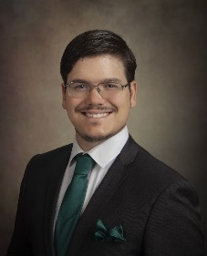
Edward Jones – Anthony Craft, 1456 US Highway 211 West, Suite B, Luray is a new financial advisor with Edward Jones in Luray. Anthony knew he wanted to be a financial advisor since he graduated Liberty High School. With years of sales experience, along with experience in the financial field he decided to launch his practice with the best company that would provide the highest level of support for him and his clients. Anthony has been working with Edward Jones for the past 5 years with Jerry Biller, but recently branched out into his own practice in Luray. Anthony, as well as all other Edward Jones financial advisors, provide guidance to help their clients retire with a nest egg that will last them through their retirement. He is able to help clients achieve this by helping them sell stocks, bonds, mutual funds, CDs, and even life insurance or long-term care insurance. Having lived and worked in the community for so long already, Anthony has been able to help the community he loves prepare for and navigate their retirement financially.
To set up a time to meet with Anthony, email anthony.craft@edwardjones.com or call (540) 742-7150.

Hawksbill Greenway Recreation Foundation
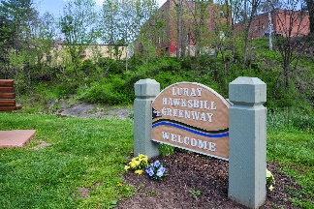
Hawksbill Greenway Recreation Foundation, Luray, is a local non-profit organization that works to promote community involvement in the continuing support of the Luray Hawksbill Greenway and Luray’s Park system. The organization helps to gather funding and place it where it’s most needed for enhancements and maintenance to keep the trail beautiful and healthy for our community. Their main goal is to support and enhance the town’s investment in its award-winning Hawksbill Greenway, as well as its 300-acre park system. They also support environmental education throughout the community and its schools. The Hawksbill Greenway Recreation Foundation is a 501 (c) (3) charitable corporation created to make it feasible for the community at large to make tax-exempt donations and to enable the Foundation to apply for grants. Specifically, they can accept funds, including private donations and grants, and manage them on behalf of the town of Luray. Their board is comprised of Bill Dudley, Ken Beyer, Margaret Stevenson, Jim Davis, Gladys McNemar, Rod Graves, and Chris Canaday.
To learn more about the organization and how you can help them, visit http://hawksbillgreenway.org, email hawksbillgreenway@gmail.com or call (540) 669-0318.

TMW Productions, LLC
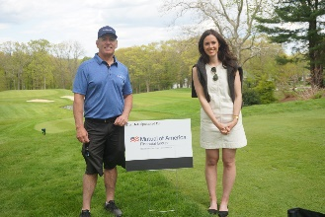
TMW Productions, LLC, Virginia, is an event planning business. TMW Productions got its original start supporting corporate and not-for-profit organizations in 2016. In July 2022, they branched out and started Weddings by TMW Productions, LLC, which supports weddings and other private events. Based in Rhode Island, they have been able to expand into 7 other states, including Virginia. Zach Whittenberger, owner and operator of TMW Productions has always wanted to start his own business and always seemed to find himself working in hospitality. Zach graduated from Johnson & Wales University with degrees in Restaurant Management, Food Service Management, and Event Management. This, along with helping the Rotarians plan events, he found his true calling as an event planner. TMW Productions is an event management company offering consulting services for corporate, not-for-profit organizations or individuals. They offer an a la carte task listing, that allows people to contract with us for the specific details they need assistance within their events, which range from sponsorship development to recruiting exhibitors for trade shows or food and beverage planning on menus and the research into venues and vendors. They also attend the day-of events to ensure the timeline, presentation and program is executed according to plan.
You can learn more by visiting http://www.tmwproductions.biz, emailing tarahw@tmwproductions.biz, or calling (401) 589-1321.

Watch & Warrant Restaurant
Watch & Warrant Restaurant, 2 East Main Street, Luray, is downtown Luray’s newest restaurant. The idea for Watch & Warrant was conceived in 2022 and brought to life in January 2023. Owners Kristofor Johnston and Chuck Cisneros are using their passion for delivering quality food and atmosphere to bring a new flair to downtown Luray. Kristofor and Chuck wanted to create an upscale restaurant that would offer residents and visitors in the Shenandoah Valley a memorable experience. When looking for a place to open their restaurant, they noticed the prime location and historical charm that 2 East Main Street offered. Located in historic downtown Luray, Watch & Warrant is a full-service restaurant and bar inspired by the exuberance of the Roaring 20s. Our menu offers an updated take on traditional American cuisine with an emphasis on infusing fresh and locally sourced foods and high quality ingredients. They offer a welcoming and comfortable atmosphere, whether you are looking to enjoy a meal or relax with a refreshing beverage.
You can find out more by visiting watchwarrant.com, by calling (540) 860-5476, or by emailing info@watchluray.com.

Dr. Zory Glaser
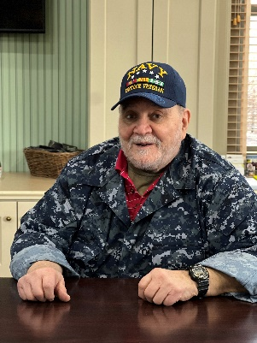
Dr. Zory Glaser is a local patron that has been working with the Luray-Page County Chamber of Commerce for 20 years. Zory got involved with the organization when there was a need for volunteer staff at the Chamber office. Zory would come in and volunteer for 4 hours on Saturdays and Sundays to help the Chamber office run efficiently. At the time, Zory was the owner and operator of Cardinal Cottage, his small cabin rental that was in the foothills of the Massanutten Mountain, near the Egypt Bend Community. Zory had been a Page County business Owner and part of the Chamber continuously since 2002. When the Chamber moved to its current location, Zory followed and became part of the Tourism Advisory Committee. Zory was in a unique position as one who owned and operated a tourism-related business within the County and was becoming more deeply involved in many of the tourism-related aspects within the Community, while still residing and working outside of Page County. Zory had been a Member with Cardinal Cottage until recently sold he sold the property. While no longer a Page County business owner, Zory feels strongly about maintaining my involvement with the Chamber, and with the business community, and have rejoined the Chamber as a “Patron”. Dr. Zory Glaser serves as Adjunct Associate Professor of Environmental and Occupational Medicine, in the Department of Environmental Health Engineering, School of Public Health, The Johns Hopkins University, Baltimore, MD. Additionally, he consults for the Hopkins Hospital/ Clinical Center, and lectures at the Hopkins School of Medicine, and the School of Nursing. Following a career in the U.S. Navy, Glaser served as a Commissioned Officer in the U.S. Public Health Service. His final PHS assignment was with the Center for Medical Devices and Radiological Health, U.S. Food and Drug Administration.

You can find out more by connecting via email at zglaser8@gmail.com.

