Staff:  Gina Hilliard, President  Clancey Arnold, Membership Development &  Investment Administrator  Edie Emmons, Social Media & Marketing Assistant  Courtney Stoneberger, Chamber & Tourism Assistant  Board of Directors:  Executive Officers:  Mark Leach, Chair of the Board – Delaware North  Mark Dofflemyer, Vice-Chair of the Board – Pioneer Bank  Stephanie Lillard, Secretary of the Board – Patron  Miranda Cave, Treasurer – Blue Ridge Bank  John Shaffer, Chair of the Tourism Division –  Luray Caverns  Board Members:  Steve Synnott – Syntelligent Analytic Solutions, LLC  Romeo Pugliese – Mamma Mia’s Italian Restaurant  Mitch Lovinger – Appexnetwork Physical Therapy  Chris Jenkins – Faithbrooke Barn and Vineyards  Kim Blosser – Lord Fairfax Community College  DezaRae Beers – Yogi Bear’s Jellystone Park  David Thomas - Valley Star Farm  Darryl Haley – Patron  Volunteers:  Jerry Griffin  Follow Us on Social Media  Facebook  LurayPageCountyChamber  VisitLurayPageVA  CabinCapitalofVirginia  Instagram  LurayPageCountyChamber  VisitLurayPageVA  Twitter  VisitLurayPage  You Tube  LurayPageCountyChamber  VisitLurayPageVA | Ambassadors:  Clancey Arnold, Chair – Luray-Page County Chamber of Commerce & Visitor Center  Helen Phillips-Cockrell – Co-Chair - Certified Health and Wellness Coach, Optimal Health Solutions  Sable Ponn – Sable Ponn, Funkhouser Real Estate Group  Zory Glaser – Cardinal Cottage Vacation Cabin Rental  Garnett Brockman – Page County Farm Bureau Federation/Insurance  Nancy Boyer – Page County Public Forum  Dave Bull – Patron  Tourism Council:  Restaurants:  CeCe Castle, Secretary – Brookside Restaurant  Romeo Pugliese - Mamma Mia Italian Restaurant  Lodging:  Nancy Sottosanti, Treasurer – Shenandoah River Outfitters  John Shaffer, Chairman – Luray Caverns Motels  Jim Sims – The Mimslyn Inn  Attractions:  Bill Schumacher, Vice-Chairman – Fort Valley Ranch  Sue Ishak – Wisteria Farm and Vineyard  Services:  Helen Morton – Delaware North  Chris Jenkins – Faithbrooke Barn and Vineyards  Liz Lewis – County of Page  Sally Hurlbert – Shenandoah National Park

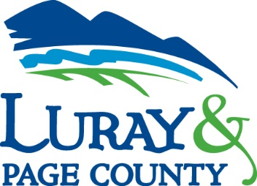
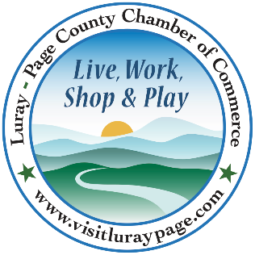

Luray-Page County Chamber of Commerce & Visitor Center
18 Campbell Street, Luray, VA 22835
Phone: (540) 743-3915 • Fax: (540) 743-3944
www.visitluraypage.com

January 2021 Newsletter

The Luray-Page County Chamber of Commerce’s mission is to serve our members by promoting and supporting business and tourism throughout Page County. The Luray-Page County Chamber of Commerce’s vision is to be the organization where our business community turns for leadership and resources.

Chamber Events

Tuesday, January 5, 9:00-10:30 AM
LeadShare. This is an active, structured program for providing and receiving business referrals. It is designed to assist Chamber members in expanding their business network through the Luray-Page County Chamber of Commerce. Join Helen Phillips-Cockrell, Certified and Wellness Coach with Optimal Solutions, and Clancey Arnold, Membership Development & Investment Coordinator, on the first Tuesday of every month and receive direct leads from other Chamber members. This month’s meeting will be held at Rudy’s Diner, 418 North Fifth Street, Shenandoah. No registration is required. Chamber Members are invited to attend whenever their schedule allows.

Thursday, January 7th, 14th, 21st, 28th, 10:00-11:00 AM
Chamber Coffee and Conversation. Join Chamber & Visitor Center President, Regina Hillard, along with her guest speakers. To find out information on guest speakers and the topics we are featuring, follow us on our Chamber Facebook page, www.facebook.com/luraypagecountychamber/. This virtual forum will be streamed virtually on Zoom or live on our Chamber Facebook page, allowing the choice of watching it live or recorded.

Tuesday, January 19th 12:00-12:30 PM
Tourism Tuesday Radio Show. Maureen Moss, owner of Moonshadows, is joining Edie Emmons to share information on their restaurant. Listen in to the River 95.3 or https://theriver953.com/podcasts/the-valley-today/ to hear about everything they offer at Stover Hall. To be a future guest on the Tourism Tuesday Radio Show, contact Edie Emmons at edie.emmons@luraypage.com.

*Do your part to slow the spread of the coronavirus and follow all CDC guidelines. Please continue to sanitize/wash hands and social distance. Please remember to bring and wear a face mask at all our in-person meetings and events.

* Any advertising inserted and/or printed in this newsletter as well as the content of those inserts and print ads, are not sponsored or endorsed by the Luray-Page County Chamber of Commerce. *

New Member Highlights

Fort Valley Ranch Campground
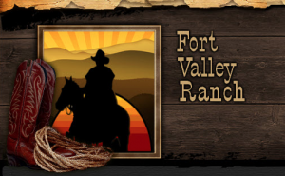
Fort Valley Ranch Campground, 299 South Fort Valley Road, Fort Valley, is the newest lodging option at Fort Valley Ranch. Owned by Anne Heck and her family, the ranch has added a campground, giving riders and visitors another option for lodging. With over 30 years of experience in the Hospitality business, they are excited to add something new, for all their guests to enjoy. To learn more or book your stay, you can visit https://www.fortvalleystable.com/, call (540) 933-6633, or send an email to fortvalleyranch@gmail.com.

Heartfelt Evets
Heartfelt Events, 418 East Main Street, is a wedding and event planning company. Co-owned by Jackie Moe and Noel Croushore, they have years of Hospitality and event planning experience under their belt. With experience behind them, they helped to small gatherings in Kuwait, for the US Embassy. Now, running Heartfelt Events in Luray, their years in event planning, food and beverage, and logistics has helped them adapt to throwing events from the biggest parties, to the most intimate of weddings. To find out more about all the offer, you can give them a call at (540) 333-9422, or send an email to jackie@heartfeltevents.net.

Grotto Vino
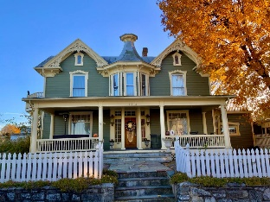
Grotto Vino, LLC, 138 East Main Street, Luray, is a revitalized Bed and Breakfast, that provides guests everything they hope to find in the beautiful Shenandoah Valley, while engaging the local community shared events. Recently purchased by Matthew Bement, a retired Marine, and his wife Janina, a for school counselor in Germany, they offer guests and locals a multitude of services. Along with lodging, they will also offer custom tours, private events, wine making classes and tastings, and much more. For more information, visit http://www.innoftheshendandoah.com, call (202) 805-1458, or send an email to matthew@grottovino.com

Page Theater
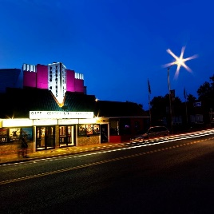
Page Theater, 33 East Main Street, Luray, is everyone’s favorite local move theater. Recently purchased by the Hoke family, the Pink Theater in the middle of town, plays current and classic movies, giving the community a variety of entertainment. Purchased and reopened in 2019, the Hoke purchased the theater to help keep an iconic business for Page County, and to help bring the magic of the movies, back to the community. Aside from movies, they also host private events and are always willing to give free tours, to anyone who requests one. To learn more, visit http://pagetheaters.com, call (540) 843-3722, or send an email to newpagetheater@gmail.com.

Shenandoah Investment Properties
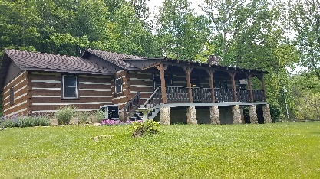
Shenandoah Investment Properties, 1173 Crooked Run Road, Shenandoah, is a short-term rental property, that sits on 33 private acres of land, near the Shenandoah River. What started as a real estate and management business in 2006, added on their rental property in 2019. 30 Acre Haven, which was built in 1987, is ending its first season with 5 Star Reviews. Bill Shuler, owner of Shenandoah Investment Properties, has been working with the community for over 35 years, and is still active in volunteering and serving with organizations that work to make our local community a better place. To learn more, you can call (540) 652-8448, or email 1431cabin@gmail.com.

Help Us Welcome Our New Members
Fort Valley Ranch Campground  Anne Heck  299 South Fort Valley Road  Fort Valley, VA 22652  fortvalleyranch@gmail.com  http://www.fortvalleystable.com | Heartfelt Evets  Jackie Moe & Noel Croushore  418 East Main Street  Luray, VA 22835  (540) 333-9422  jackie@heartfeltevents.net | Grotto Vino  Matthew & Janina Bement  138 East Main Street  Luray, VA 22835  (202) 805-1458  matthew@grottovino.com  http://www.innoftheshendandoah.com,

Page Theater  Carlie Hoke  33 East Main Street  Luray, VA 22835  (540) 843-3722  newpagetheater@gmail.com  http://pagetheaters.com | Shenandoah Investment Properties  William Shuler  1173 Crooked Run Road  Shenandoah, VA 22849  (540) 652-8848  1431cabin@gmail.com

Member Spotlight
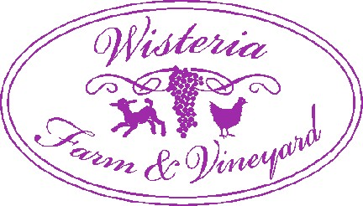
Wisteria Farm & Vineyard
1126 Marksville Road, Stanley, is a local vineyard, where they make wine from grapes that are grown on their property. Owned by husband and wife duo, Sue and Moussa Ishak, they have been running Wisteria since 2009. Along with the grapes and delicious wines they offer, they also are a working farm with Romney sheep and chickens. Sue and Moussa hold events throughout the year, to benefit non-profit organizations in our community. To learn more about all they have going on, visit http://www.wisteriavineyard.com, give them a call at (540) 742-1489, or shoot an email to info@wisteriavineyard.com

