Luray – Page County Chamber of Commerce
18 Campbell Street, Luray, VA 22835 - Tel: 540-743-3915 - Fax: 540-743-3944
www.VisitLurayPage.com

For Immediate Release Contact: 540-743-3915
May 9, 2022 events@luraypage.com

Imagination Station Grand Re-Opening & Ribbon Cutting

Luray, VA – The Luray-Page County Chamber of Commerce had the honor of celebrating the reopening of the Imagination Station, located at Ralph H. Dean Recreation Park, 625 Sixth Street, Luray.

“Our community is lucky to have a place like the Imagination Station where families can bring their little ones. The new playground equipment will give familys a safe and fun place for their kids to enjoy for years to come. We’re excited to have the updates completed and for families to be able to take advantage of such a great park” said Regina Hilliard, President of the Luray-Page County Chamber of Commerce.

The original Imagination Station was opened at Ralph H. Dean Recreation Park in 1993 and is run by the Luray Parks & Recreation Department, which manages nearly 300 acres of park lands. Ralph H. Dean Park features 5 softball/baseball fields, soccer and lacrosse fields, football field, 1-mile fitness trail, skate park, 18-hole disc golf course, picnic shelters and the newly re-build Imagination Station Playground. When asked about Ralph H. Dean Recreation Park and the Imagination Station, Jennifer Jenkins, direct of Luray Parks & Recreation said “The Town’s park system offers year-round recreational opportunities for residents and visitors, including fishing, hiking, fitness and athletic facilities, free community events, summer classes, and outdoor concerts. With its scenic views, vibrant downtown area, and dynamic park system, Luray offers activities for the whole family.”

During the celebration, The Chamber staff joined members of the community to celebrate the re-opening of the Imagination Staiton. In attendance were Mayor Jerry Dofflemyer, Councilwoman Stephanie Lillard, Luray Town Councilman Jerry Shiro, Luray Town Councilman Leigon Webb, Luray Town Councilman Jason Pettit, Luray Town Councilman Joey Sours, Luray Town Manager Steve Burke, Luray Parks & Recreation Director Jennifer Jenkins, Assistant Director of Luray Parks & Recreation Morgan Housden, Project Manager from All Recreation Eric White, President of the Luray-Page County Chamebr of Commerce Regina Hilliard, Chamber staff Clancey Arnold and Edison Emmons and families from the community.

For more on the parks throughout Luray make sure to visit townofluray.com/parks---recreation.html or their facebook page at facebook.com/townofluray, call (540) 743-5511, or email them at jenjenkins@townofluray.com,

For more details on the ribbon-cutting, contact the Luray-Page County Chamber of Commerce at events@luraypage.com.

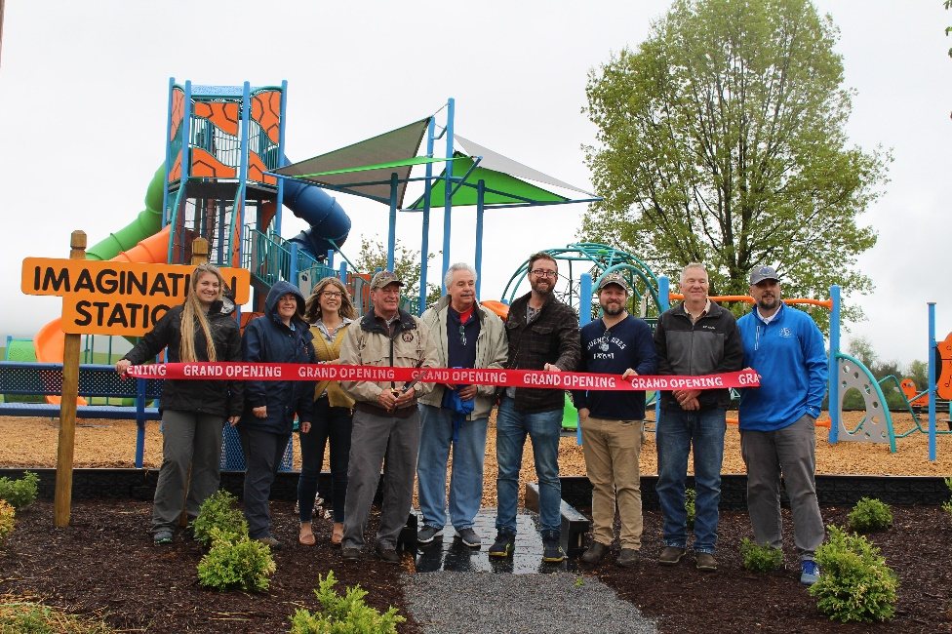

To see more pictures from the Imagination Station Grand Re-Opening & Ribbon Cutting, you can visit our Facebook page.

