Luray – Page County Chamber of Commerce
18 Campbell Street, Luray, VA 22835 - Tel: 540-743-3915 - Fax: 540-743-3944
www.VisitLurayPage.com

For Immediate Release Contact: 540-743-3915
May 9, 2022 events@luraypage.com

HenHouse Shoppe Grand Re-Opening & Ribbon Cutting

Luray, VA – The Luray-Page County Chamber of Commerce celebrated the re-opening of HenHouse Shoppe at their new location, 12 East Main Street, Luray.

“Having a business like HenHouse Shoppe on main street is a great addition. The options they offer for women’s clothing, especially with the sizes they offer, is a way to not only bring new styles to our community, but to be more inclusive and empowering to the women of our community” said the President of the Luray-Page County Chamber of Commerce, Regina Hilliard.

HenHouse Shoppe was a dream that started in 2008 while Emily Dennis, owner, was a single mom raising her daughter. The name began as just a hope that one day she could give back to other women going through the same journey. HenHouse Shoppe was officially launched as a facebook boutique in 2018. A year later in June 2019, they open their brick and mortar store in Elkton. After great success, they decided to open a location in Luray in 2021. With a steady customer base, they were able to move their Luray location onto East Main Street. HenHouse Shoppe offers trend and size inclusive fashion for women of all ages, shapes, and sizes. When asked about her business, Emilly Dennis, owner of HenHouse Shoppe, said “HenHouse Shoppe is a place for women to not only find fun and trendy fashion for their life but a community of friends that encourages one another to chase their dreams and grow their confidence.”

On Friday, May 6, 2022, many members of the community turned out in celebrating this anniversary. Joining Regina Hlliard, President of Luray-Page County Chamber of Commerce was Luray Town Councilman Jerry Shiro, Luray Town Councilman Jason Pettit, Luray Town Manager Steve Burke, Luray Downtown Iniative Director Jackie Elliot, Luray Chief of Police Bow Cook, Treasurer for Town of Luray Danielle Babb, and Chamber Ambassador Amanda Petty.

HenHouse Shoppe is located at 12 East Main Street, Luray. Store hours are from 11 a.m. to 6 p.m. on Tuesday, Wednesday, Thursday and Friday, and from 10 a.m. to 4 p.m. on Saturdays. The store is closed on Sundays and Mondays. For more on all of the services that they offer, make sure to visit henhouseshoppe.com or their facebook page at facebook.com/HenhouseShoppe. Contact them by phone at (540) 908-9307, or email them at emilydennis.henhouse@gmail.com.

For more details on the ribbon-cutting, contact the Luray-Page County Chamber of Commerce at events@luraypage.com.
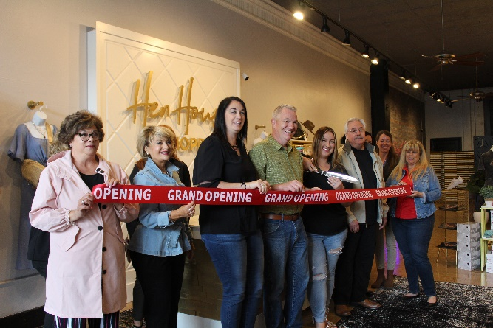

To see more pictures from the HenHouse Shoppe Grand Re-Opening & Ribbon Cutting, you can visit our Facebook page.

