Luray – Page County Chamber of Commerce
18 Campbell Street, Luray, VA 22835 - Tel: 540-743-3915 - Fax: 540-743-3944
www.VisitLurayPage.com

For Immediate Release Contact: 540-743-3915
May 26, 2022 events@luraypage.com

Hawksbill Brewing Company 5th Anniversary Ribbon Cutting

Luray, VA – The Luray-Page County Chamber of Commerce was honored to celebrate the Hawksbill Brewing Company’s 5th Anniversary with a special ribbon cutting ceremony.

“Luray-Page County is extremely lucky to have a place like the Hawksbill Brewing Company. The environment that they have worked hard to create gives locals and visitors a place to unwind, enjoy the company of friends, and try locally brewed beer without having to leave the community. It’s been an honor to watch them grow over the last five years, and we’re excited to see where the future takes them”, said Regina Hilliard, President of the Luray-Page County Chamber of Commerce.

The Hawksbill Brewing Company got its start in 2016, but officially opened their doors in May of 2017. Luray’s original Craft Brewery, the Hawksbill Brewing Company brews their beers right on the premises, allowing them to keep the brewing portion local. Once the beers are created and ready to enjoy, they are served in their taproom, which also has indoor and outdoor seating. When asked about the reasoning behind opening HBC, owner Jim Turner said “When we started Hawksbill Brewing we wanted to do something that promoted the local economy’s two strengths – tourism and agriculture. While there have been some ups and downs for us along the way, here we are five years later – a local enterprise, a great team, creating high quality craft products that represent our community!”
Yesterday, we were joined by members of the community to join us in celebrating this momentus anniversary. In attendance were owners of the Hawksbill Brewing Company Jim Turner and David Sours, Bar Manager Deanne Good, Mayor of Luray Jerry Dofflemyer, Luray Downtown Initative Director Jackie Elliot, Chamber Board Members Amy Judd and Mark Dofflemyer, Chamber Ambassador Christine Caldwell, Chamber President Regina Hilliard, as well as Chamber staff members Clancey Arnold and Edison Emmons, as well as visitors to the area and members of the community.

Hawksbill Brewing Company is located at 22 Zerkel Street, Luray. Their hours of operation are Wednesday and Thursday 4:00-8:00 pm, Friday and Saturday 12:00-8:00 PM, and Sunday 12:00-6:00 PM. For more on all of the everything they have to offer, be sure to visit their Facebook page at https://www.facebook.com/HawksbillBrewingCompany, call (540) 860-5608, or email them at hawksbillhops@gmail.com. For more details on the ribbon-cutting, contact the Luray-Page County Chamber of Commerce at events@luraypage.com.

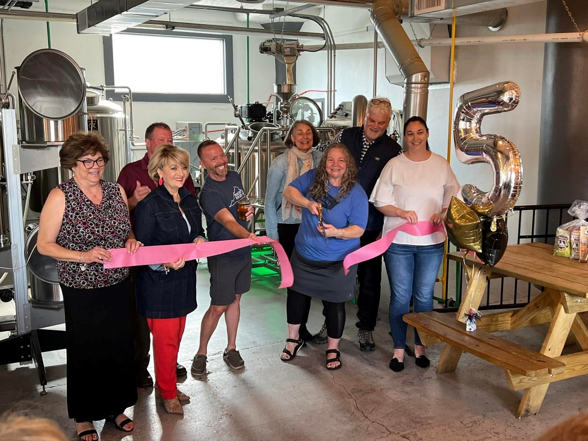

To see more pictures from the Hawksbill Brewing Company 5th Anniversary Ribbon Cutting, visit our Facebook page.

