Staff:  Gina Hilliard, President  Edison Emmons, Social Media & Marketing Assistant  Clancey Arnold, Membership Development &  Investment Administrator  Courtney Stoneberger, Chamber & Tourism Assistant  Board of Directors:  Executive Officers:  Chris Jenkins, Chair – Faithbrooke Barn and Vineyards  DezaRae Beers, Secretary – Yogi Bear's Jellystone Park  Miranda Cave, Treasurer – Blue Ridge Bank  Bill Huffman, Chair of the Tourism Division –  Luray Caverns  Board Members:  Travis Clark – Valley Health Page Memorial Hospital  Mitch Lovinger – Appexnetwork Physical Therapy  Sable Ponn – Funkhouser Real Estate Group  Bart Patton - Patton Gunsmith Works  David Thomas - Valley Star Farm  Mark Dofflemyer – Pioneer Bank  Amy Judd – Lord Fairfax Community College  Pam Wightman – Delaware North  Follow Us on Social Media  Facebook  LurayPageCountyChamber  VisitLurayPageVA  Instagram  LurayPageCountyChamber  VisitLurayPageVA  Twitter  VisitLurayPage  You Tube  LurayPageCountyChamber  VisitLurayPageVA | Ambassadors:  Clancey Arnold, Chair – Luray-Page County Chamber of Commerce  Sable Ponn, Vice-Chair – Sable Ponn, Funkhouser Real Estate Group  Amanda Petty – Amanda Petty Homes with Re/Max Gateway  Zory Glaser – Cardinal Cottage Vacation Cabin Rental  Nancy Boyer – Page County Public Forum  Christine Caldwell – Studio 31.13  Tourism Council:  Restaurants:  Helen Morton – Delaware North  Romeo Pugliese - Mamma Mia Italian Restaurant  Lodging:  Nancy Sottosanti, Treasurer – Shenandoah River Outfitters  DezaRae Beer – Yogi Bear Jellystone Park  Jim Sims – The Mimslyn Inn  Attractions:  Bill Schumacher, Vice-Chair – Fort Valley Ranch  Bill Huffman, Chair – Luray Caverns  Services:  Chris Jenkins – Faithbrooke Barn and Vineyards  CeCe Castle, Secretary – Brookside Restaurant

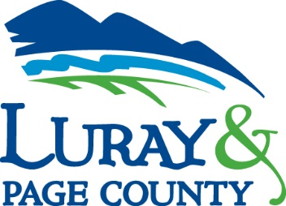
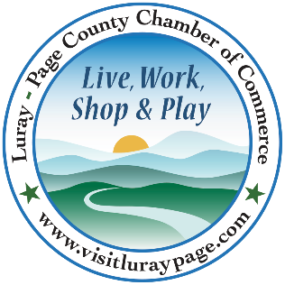

Luray-Page County Chamber of Commerce & Visitor Center
18 Campbell Street, Luray, VA 22835
Phone: (540) 743-3915 • Fax: (540) 743-3944
www.visitluraypage.com

February 2022 Newsletter

The Luray-Page County Chamber of Commerce's mission is to serve our members by promoting and supporting business and tourism throughout Page County. The Luray-Page County Chamber of Commerce's vision is to be the organization where our business community turns for leadership and resources.

Chamber Events

Tuesday, February 1st, 9:00-10:00 AM
LeadShare.
This is an active, structured program for providing and receiving business referrals. It is designed to assist Chamber members in expanding their business network through the Luray-Page County Chamber of Commerce. Clancey Arnold, Membership Development & Investment Coordinator, and on the first Tuesday of every and receive direct leads from other Chamber members. This month’s meeting will be held in the Chamber & Visitor Center Board Room, 18 Campbell Street, Luray. No registration is required. Chamber Members are invited to attend whenever their schedule allows.

Tuesday, February 9th, 12:30-1:00 PM
Valley Business Today Radio Show – People Inc.
Bryan Phipps, president and CEO of People Inc., is joining Edie Emmons to share information on this local non-profit organization. Listen in to The River 95.3 or https://theriver953.com/podcasts/the-valley-today/ to learn about what People Inc. does to help people in our community. To be a future guest on the Valley Business Today Radio Show, contact Edie at edie.emmons@luraypage.com.

Thursday, February 10th, 2:00-3:00 PM
Business Seminar – 5 Tips to Keep Your Facebook Secure
Back by popular demand! If you missed it in October, join us on the Zoom screen from 2pm – 3pm on Thursday, February 10, 2022 for a free webinar to learn 5 things you can do RIGHT NOW to protect your Facebook from hackers. Don’t lose your personal information, potential access to your business page or, all your Facebook memories because of a hack you could have easily prevented. In this webinar, Janet Michael from Java Media will give you 5 tips to protect your Facebook account – personal and professional – so that you don’t fall victim to a hack attack. These are easy, simple steps that take less than 3 minutes in most cases. Don’t think it can’t happen to you … it CAN! Attendance is free but registration is REQUIRED. Register here: https://bit.ly/FBSecureLPCCC. Janet Michael is the owner of Java Media, a social media and marketing firm, with over 20 years’ experience developing successful marketing & advertising campaigns. Java Media provides social media training and workshops for small business owners as well as social media management, oversight & evaluation services. She produces podcasts for small business owners, non-profits, and local leaders. Janet also hosts a daily award-winning talk show, The Valley Today, on local radio station, The River 95.3FM.

Tuesday, February 15th, 12:30-1:00 PM
Tourism Tuesday Radio Show – Performing Arts Luray.
Bonnie Anthony of Performing Arts Luray is joining Edie Emmons to share information on one of Luray’s live performing arts venues. Listen in to The River 95.3 or https://theriver953.com/podcasts/the-valley-today/ to learn about what Performing Arts Luray has to offer. To be a future guest on the Tourism Tuesday Radio Show, contact Edie at edie.emmons@luraypage.com.

Wednesday, February 16th, 10:00 AM-12:00 PM
Ribbon Cutting - ALCOVA Mortgage
Come help us celebrate the opening of ALCOVA Mortgage’s new location, 134 West Main Street Suite A. We will be holding a special ribbon cutting starting at 10:00 AM to help commemorate the expansion of their Luray branch, run by Leslie Currle. After the ribbon cutting, until 12:00 pm, guests are invited to stay and enjoy the open house, get a chance to learn about what ALCOVA Mortgage does, and enjoy refreshments.
Thursday, February 17th, 5:30-7pm
Business After Hours - Hawksbill Brewery
Join us for this month’s Business After Hours at Hawksbill Brewing Company, 22 Zerkle Street, Luray. This month’s Business After Hours is also being Co-Hosted by Rich Hostelley Architecture, LLC / RH+ARC. This event is designed for Chamber members to meet and build relationships with other local business members. It is time to get together and enjoy each other’s company. Bring business cards for networking and to be entered in door prize raffles. Please remember to wear a mask.

Member Spotlight

Page County Public Forum
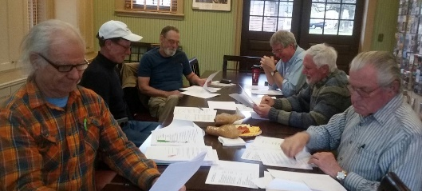
Page County Public Forums, Page County, is a local non-profit organization that works to bring information to the people of Page County. Made up of a group of individuals that want to help the community grow in their knowledge, they put on various free forums throughout the year. With topics that range from internet access, healthcare, social topics, and more, they partner with local experts in each field to bring the most information possible. The individuals that make up the group work to come up with topics and speakers that will help unite neighbors, families and friends through understanding basic common needs and concerns.
If you want to learn more or become part of the group, you can visit their Facebook page, https://www.facebook.com/Page-County-Public-Forum-160331827964252/ or email nlboyer46@gmail.com.

Chamber Announcements

* Any advertising inserted and printed in this newsletter and the content of those inserts and print ads are not sponsored or endorsed by the Luray-Page County Chamber of Commerce & Visitor Center. *

As we move into a new year, please make sure to check your listing on our website, visitluraypage.com. When looking through your listing, please make sure that your company website, social media links, contact information, photos, and description are correct. If you have changes that you would like to have made, please be sure to email them to Edison, at edison.emmons@luraypage.com.

In an attempt to keep all of the information in our office up-to-date for visitors, please make sure to bring your updated rack cards, brochures, and/or business cards to put in the Chamber/Visitor Center. Having our member’s updated information is just another way that we can help promote your business within our community.

To keep up with everything going on at the Chamber, make sure to follow our Social Media Accounts. Here you’ll find information on events, what’s going on in the community, and information on our members.
Facebook: LurayPageCountyChamber & VisitLurayPageVA
Instagram: LurayPageCountyChamber & VisitLurayPageVA
Twitter: VisitLurayPage
You Tube: LurayPageCountyChamber & VisitLurayPageVA

Our weekly In the Loop emails aren’t just for the primary representative in your business. Any employee within your business can receive our weekly e-newsletter. If you have employees that would like to receive these weekly e-newsletter, send their information to Edison at edison.emmons@luraypage.com.

If you have events happening, please send them to Edison at edison.emmons@luraypage.com. We will put all member events on our Community Calendar, as well as promoting them on our social media pages.

If you have a business in mind that you think would benefit from a Chamber membership, make sure to refer them to us. If a new member signs up and mentions your business as who referred them, you’ll receive $50 of your next set of membership dues.

The Luray-Page County Chamber of Commerce & Visitor Center has reinstated our indoor mask requirement. Until further notice, face coverings will be required for everyone while in the Chamber, Visitor Center lobby, train museum, and board room. We are also requiring all who join us for our indoor events to wear a mask, as well.

Throughout the year, the Luray-Page County Chamber of Commerce & Visitor Center offers a variety of events for our members and the community. For our events that involve catering and limited seating, we ask that everyone interested in attending send us an RSVP. For those who RSVP to our paid events, if you do not show up, you will still be charged. This covers the cost of food that has already been ordered.

