Staff  Gina Hilliard, President  Edison Emmons, Social Media & Marketing Assistant  Clancey Arnold, Membership Development &  Investment Administrator  Courtney Stoneberger, Chamber & Tourism Assistant  Mary Dykes, Chamber & Tourism Assistant  Board of Directors  Executive Officers:  Chris Jenkins, Chair  Faithbrooke Barn and Vineyards  Travis Clark, Vice-Chair  Valley Health Page Memorial Hospital  DezaRae Beers, Secretary  Yogi Bear's Jellystone Park  Miranda Cave, Treasurer  Blue Ridge Bank  Bill Huffman, Chair of the Tourism Division  Luray Caverns  Board Members:  Mitch Lovinger – Appexnetwork Physical Therapy  Amy Judd – Laurel Ridge Community College  Sable Ponn – Funkhouser Real Estate Group  Pam Wightman – Delaware North at SNP  Megan Newberry - Andersen Corporation  Mark Dofflemyer – Pioneer Bank  Tony Villa – Madeline Farms  Follow Us on Social Media  Facebook  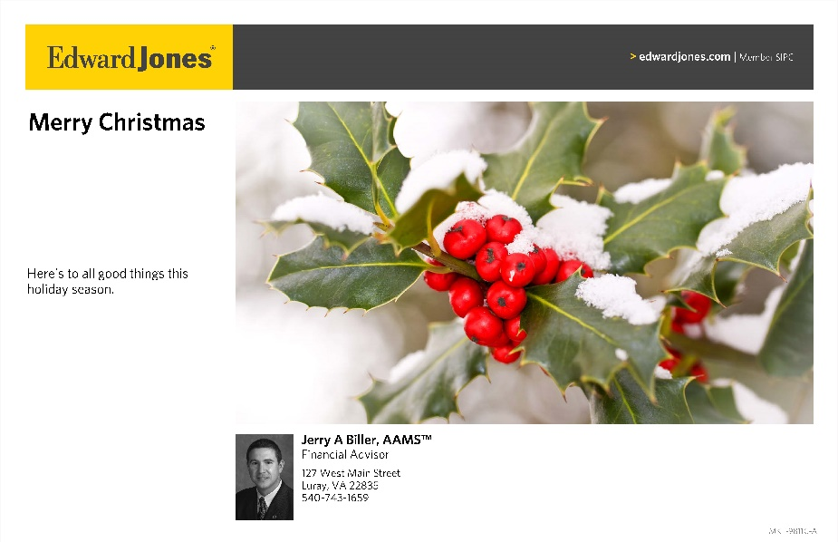  LurayPageCountyChamber  VisitLurayPageVA  Instagram  LurayPageCountyChamber  VisitLurayPageVA  Twitter  VisitLurayPage  You Tube  LurayPageCountyChamber  VisitLurayPageVA | Ambassadors  Clancey Arnold, Chair – Luray-Page County Chamber of Commerce  Sable Ponn, Vice-Chair – Sable Ponn, Funkhouser Real Estate Group  Amanda Petty – Amanda Petty Homes with Re/Max Gateway  Zory Glaser – Cardinal Cottage Vacation Cabin Rental  Nancy Boyer – Page County Public Forum  Christine Caldwell – Andersen Corporation  Marlise Lee - Cameo Galleries  Tourism Council  Restaurants:  Helen Morton – Delaware North  Romeo Pugliese - Mamma Mia Italian Restaurant  Lodging:  Nancy Sottosanti, Treasurer – Shenandoah River Outfitters  DezaRae Beer – Yogi Bear Jellystone Park  Jim Sims – The Mimslyn Inn  Attractions:  Bill Schumacher, Vice-Chair – Fort Valley Ranch  Bill Huffman, Chair – Luray Caverns  Services:  Chris Jenkins – Faithbrooke Barn and Vineyards  CeCe Castle, Secretary – Brookside Restaurant

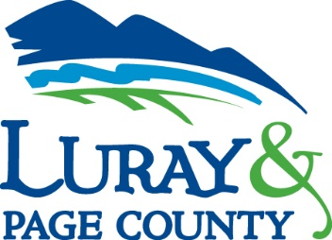

Luray-Page County Chamber of Commerce & Visitor Center
18 Campbell Street, Luray, VA 22835
Phone: (540) 743-3915 • Fax: (540) 743-3944
www.visitluraypage.com

December 2022 Newsletter

The Luray-Page County Chamber of Commerce's mission is to serve our members by promoting and supporting business and tourism throughout Page County. The Luray-Page County Chamber of Commerce's vision is to be the organization where our business community turns for leadership and resources.

Chamber Events

Saturday, November 26th – Sunday, December 18th
Shop Small for the Holidays
Page County Shops for the Holidays. Kick off your holiday season on Saturday, November 26th by shopping locally at all the wonderful shops located throughout Page County. Shop Small for the Holidays! From November 26th through December 18th shop small at local shops and restaurants for a chance to win a $500 shopping spree! When you shop or dine local, send a picture of your receipt by email to events@lurayapage.com, or drop it off in person at 18 Campbell Street, Luray, to be entered into our $500 shopping spree. For each receipt you bring or send to us, you will receive one entry, even if it’s for an online order. Just make sure your entry has your name, phone number, and copy of receipt. Receipts are due to by December 18th, at 5:00 PM, and the drawing will take place Live on our Facebook on Monday, December 19th. For more information visit @LurayPageChamber on Facebook or contact the Chamber at events@luraypage.com or 540-743-3915.

December
Supply Drive to Benefit Choices-Council on Domestic Violence
During the month of December, our Women in Business group and Andersen Corporation will be hosting a supply drive for Choices-Council on Domestic Violence. Choices is a local non-profit that houses women and children that have been the victims of sexual and domestic abuse. Over the month of December, we are accepting donations of Comfort & Healing Care Packages to benefit Choices Survivors. They are in need of bedroom slippers (all sizes), sports bras or brash without underwire (all sizes, larger sizes preferred), underwear (all sizes), cozy socks, yoga pants, leggings, lounge pants (all sizes, larger sizes preferred), gift cards (Wal-Mart, gas cards). If you are interested in donating supplies, you can drop them off at the Luray-Page County Chamber of Commerce & Visitor Center located at 18 Campbell Street, Luray, every day from 9:00 AM-5:00 PM or at Andersen Corporation, 31 Stoney Brook Lane, Luray, on Mondays-Fridays, 6:00 AM-3:00 PM.

Friday, December 2nd, 4:00-9:00 PM
7th Annual Chamber Holiday Festival.
Help us kick off the Holiday season with our 7th Annual Chamber Holiday Festival at the Chamber & Visitor Center, 18 Campbell Street, Luray. This is a FREE event for all to attend! Families can come and enjoy Santa’s workshop with lots of crafts the kid can take home, write a letter to Santa, and leave it in the mailbox, make a Christmas card, take home some reindeer food. Enjoy festive cookies, popcorn, hot cocoa, holiday punch, and s’mores by the firepit. Take the family on a wagon ride or a barrel train ride or enjoy the live Holiday music performed by the local schools and local artists. Take your picture with one of our Christmas characters or by the love letters or stop by the train display. Bring the whole family and get your picture taken with Santa. We do ask for a $5 cash donation or canned food donations in exchange for a picture with Santa. The proceeds will benefit Page One and Page Paws. Get a head start on your holiday shopping by visiting our local craft vendors and enjoy dinner with Main Street Bakery & Catering or El Amigo Food Truck.

Thursday, December 8th, 11:30am-1pm
Women in Business Lunch
For our Women in Business meeting in December, we will be taking a tour of the facility at Andersen Corporation, 31 Stoney Brook Lane, Luray. This is a great chance for us to thank Andersen for being our generous sponsor for our 2022 Women in Business events. To be part of the facility tour, you will need to wear close-toed shoes. We will also have a presentation by Heather Sours, the new executive director of Choices – Council on Domestic Violence. We’ll learn about all the services that Choices offers to its residents, as well as the overall impact they have on the community. You’ll also get a chance to enjoy lunch from El Amigo Food Truck, which is being generously covered by Andersen. Free to attend. If you are interested in joining, please RSVP by Tuesday, December 6th, to events@luraypage.com or (540) 743-3915.

Wednesday, December 14th, 12:00-12:30 PM
Valley Business Today Radio Show: Shenandoah Valley Small Business Development Center
Joyce Krech, Director of the Shenandoah Valley Small Business Development Center, and Sarah Levinson, the Page County representative of the SBDC will be joining Edison Emmons to share information on how the SBDC can help small businesses in our area. Listen in to the River 95.3 or https://theriver953.com/podcasts/the-valley-today/ to learn about everything they can help you with. To be a future guest on the Valley Business Today Radio Show, contact Edison at edison.emmouns@luraypage.com.

Tuesday, December 20th, 12:00-12:30 PM
Tourism Tuesday Radio Show: Cameo Galleries
Marlise Lee, owner of Cameo Galleries is joining Edison Emmons to share information about her photography and fine arts business. Listen in to the River 95.3 or https://theriver953.com/podcasts/the-valley-today/ to learn about all she has to offer. To be a future guest on the Tourism Tuesday Radio Show, contact Edison at edison.emmouns@luraypage.com.

Member Spotlight

Career Support Systems, Inc.
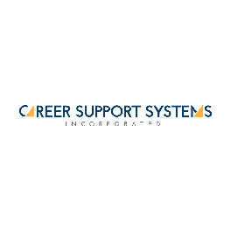
Career Support Systems, Inc., 35 North Bank Street, Luray, is a local employment support system. They are a private, nationally accredited provider of community-based employment and support services for people with disabilities or obstacles finding employment. They were founded in 1993 and has continued to build their reputation by focusing on our under-served populations. They offer their clients an array of highly individualized job placement services and a full range of complementary employment support services. CSS offers workforce services such as job coach training services, school to work transition services, independent living skills training, and much more.
You can learn more at https://careersupport.net/, email joanne@careersupport.net, or call (804) 261-6788.
Chamber Announcements

Our office will be closing at 1 PM on Saturday, December 24th, and closed on Sunday, December 25th for the Christmas holiday. Our staff will be enjoying time spent with our family and close friends. We will reopen for regular hours on Monday, December 26th.
Our office will be closing at 1 PM on Saturday, December 31st, and closed on Sunday, January 1st for the Christmas holiday. Our staff will be enjoying time spent with our family and close friends. We will reopen for regular hours on Monday, January 2nd.
Any advertising inserted and printed in this newsletter and the content of those inserts and print ads are not sponsored or endorsed by the Luray-Page County Chamber of Commerce & Visitor Center.
We’re sure you’ve seen all the flyers that are in our monthly newsletters. Our members have the option of inserting flyers with information on programs, events, and other important things their businesses or organizations are doing each month. When you receive our newsletters, make sure to take a second to look over the flyers so that you’ll know what’s going on in our community. Make sure that you hang them up in your window, make copies for your office, put them up in your employee breakrooms, or even scan them in and email them to your employees. This is a great way to not only help promote the business community, but to let your employees and customers know about what’s going on right here in their own backyards each month.

New Member Spotlight

Mountain View Sheds & Storage
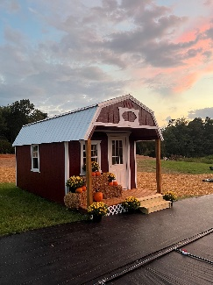
Mountain View Sheds & Storage, 2039 US Highway 211 West, Luray, is an authorized Old Hickory Buildings dealer. Mountain View Sheds & Storage is owned and operated by Gina and Ben Smelser. They took over the business in early September of this year, after purchasing the business from Greg Turner. They sit on a 5-acre lot just off of 211 West in Luray, which overlooks the beautiful Shenandoah Valley mountains. When they first started, they were just selling their beautiful home-grown mums and pumpkins, which was a festive kick-off for the Autumn season. After they got established, they expanded to offering dog kennels, deer stands, gazebos, pergolas, and even chicken coops. In addition, they also sell and offer delivery and installation of Old Hickory Storage Buildings. They are currently in the process of building and offering self-storage units. Their mission is to provide quality and affordable storage options, as well as offering protection of belongings and services related to the storage needs of our community.
If you want to learn more about their options, stop by the lot, visit https://oldhickorybuildings.com/locations/luray-virginia/?fbclid=IwAR1LpHsuPwQCqrDY5M01Vecw6CJCIVn3oj1q-6Ogdirp5PbZaIJV-EVocOM, email ginahikes@gmail.com, or call (540) 244-9674.

