Staff:  Gina Hilliard, President  Clancey Arnold, Membership Development &  Investment Administrator  Danae Alger, Administrative & Events Assistant  Edie Emmons, Social Media & Marketing Assistant  Courtney Stoneberger, Chamber & Tourism Assistant  Board of Directors:  Executive Officers:  Mark Leach, Chair of the Board – Delaware North  Mark Dofflemyer, Vice-Chair of the Board – Pioneer Bank  Stephanie Lillard, Secretary of the Board – Patron  Miranda Cave, Treasurer – Blue Ridge Bank  John Shaffer, Chair of the Tourism Division –  Luray Caverns  Board Members:  Steve Synnott – Syntelligent Analytic Solutions, LLC  Romeo Pugliese – Mamma Mia’s Italian Restaurant  Mitch Lovinger – Appexnetwork Physical Therapy  Chris Jenkins – Faithbrooke Barn and Vineyards  Kim Blosser – Lord Fairfax Community College  DezaRae Beers – Yogi Bear’s Jellystone Park  David Thomas - Valley Star Farm  Darryl Haley – Patron  Volunteers:  Jerry Griffin  Follow Us on Social Media  Facebook  LurayPageCountyChamber  VisitLurayPageVA  CabinCapitalofVirginia  Instagram  LurayPageCountyChamber  VisitLurayPageVA  Twitter  VisitLurayPage  You Tube  LurayPageCountyChamber  VisitLurayPageVA | Ambassadors:  Clancey Arnold, Chair – Luray-Page County Chamber of Commerce & Visitor Center  Helen Phillips-Cockrell – Co-Chair - Certified Health and Wellness Coach, Optimal Health Solutions  Sable Ponn – Sable Ponn, Funkhouser Real Estate Group  Zory Glaser – Cardinal Cottage Vacation Cabin Rental  Garnett Brockman – Page County Farm Bureau Federation/Insurance  Nancy Boyer – Page County Public Forum  Dave Bull – Patron  Tourism Council:  Restaurants:  CeCe Castle, Secretary – Brookside Restaurant  Romeo Pugliese - Mamma Mia Italian Restaurant  Lodging:  Nancy Sottosanti, Treasurer – Shenandoah River Outfitters  John Shaffer, Chairman – Luray Caverns Motels  Jim Sims – The Mimslyn Inn  Attractions:  Bill Schumacher, Vice-Chairman – Fort Valley Ranch  Sue Ishak – Wisteria Farm and Vineyard  Services:  Helen Morton – Delaware North  Chris Jenkins – Faithbrooke Barn and Vineyards  Liz Lewis – County of Page  Sally Hurlbert – Shenandoah National Park

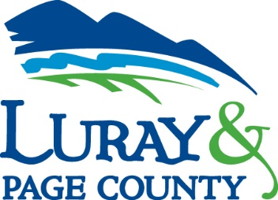
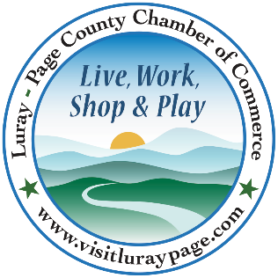

Luray-Page County Chamber of Commerce & Visitor Center
18 Campbell Street, Luray, VA 22835
Phone: (540) 743-3915 • Fax: (540) 743-3944
www.visitluraypage.com

December 2020 Newsletter

The Luray-Page County Chamber of Commerce’s mission is to serve our members by promoting and supporting business and tourism throughout Page County. The Luray-Page County Chamber of Commerce’s vision is to be the organization where our business community turns for leadership and resources.

Chamber Events

December 1st – December 21st, Shop Small Everyday
Page County Shops Small. Throughout the month of December, continue shopping small and supporting our local businesses. Until December 21st, you will have the opportunity to enter into our prize drawing for showing us that you shopped small. Here’s How to Shop Small and Win: 1. Take a photo of you shopping at your favorite businesses in Page County. Online purchases count. 2. Email photo to events@luraypage.com with contact info (name, phone, email, & name of store). 3. Win a prize if photo is picked in drawing on Monday, December 21st. For more information visit www.pagecobuyslocal.com or contact the Chamber at events@luraypage.com or 540-743-3915.

December 1-31st
Young Professional Fundraiser
During the month of December, our Young Professionals group will be hosting a supply drive for ARISE. ARISE is our local Homeless Day Shelter, that helps men and women who are homeless have a place to get a warm meal, a shower and maybe a nap. Over the month of December, we are accepting donations of unopened canned and boxed food, as well as various unopened toiletries and feminine products. If you are interested in donating supplies, you can drop them off at the Luray-Page County Chamber of Commerce & Visitor Center located at 18 Campbell Street, Luray, as well as at the Luray Blue Ridge Bank, 17 West Main Street, Luray and the Shenandoah Blue Ridge Bank, 600 South Third Street, Shenandoah. Cash and check donations are also being accepted. All checks should be made payable to ARISE. Checks and cash can be dropped off at the Luray-Page County Chamber of Commerce, 18 Campbell Street, Luray, Monday-Sunday, from 9:00 AM-4:00 PM.

Tuesday, December 1st; 9:00-10:30 AM
LeadShare. This is an active, structured program for providing and receiving business referrals. It is designed to assist Chamber members in expanding their business network through the Luray-Page County Chamber of Commerce. Join Helen Phillips-Cockrell, Certified and Wellness Coach with Optimal Solutions, and Clancey Arnold, Membership Development & Investment Coordinator, on the first Tuesday of every month and receive direct leads from other Chamber members. This month’s meeting will be held at Alexander’s Restaurant, 410 West Main Street, Luray. No registration is required. Chamber Members are invited to attend whenever their schedule allows.

Thursday, December 1st, 8th, 15th, 22nd & 29th, 10:00-11:00 AM
Chamber Coffee and Conversation. Join Chamber & Visitor Center President, Regina Hillard, along with her guest speakers. To find out information on guest speakers and the topics we are featuring, follow us on our Chamber Facebook page, www.facebook.com/luraypagecountychamber/. This virtual forum will be streamed virtually on Zoom or live on our Chamber Facebook page, allowing the choice of watching it live or recorded.

Wednesday, December 2nd, 11:30-1:00 PM
411 Orientation: New Chamber members from September, October, and November are invited to a pizza lunch in the Chamber/Visitor Center Boardroom, followed by an in-depth review of membership benefits. Come have your membership questions answered, talk about your business, and network with other new members. RSVP to events@luraypage.com by Tuesday, September 1st, to save your seat and guarantee a meal. Please remember to bring a mask.

Wednesday. December 9th, 12:00-12:30 PM
Valley Business Today Radio Show. David Thomas, Valley Star Farm, is joining Edie Emmons to share information on their Christmas tree farm. Listen in to the River 95.3 or https://theriver953.com/podcasts/the-valley-today/ to hear about everything they offer at Valley Star Farm. To be a future guest on the Tourism Tuesday Radio Show, contact Edie Emmons at edie.emmons@luraypage.com.

Thursday, December 10th; 4:00-6:00 PM
Business Seminar: Five Marketing Musts for 2021. Join us on the Zoom screen for a presentation and conversation with Janet Michael from Java Media about the five marketing musts your business should implement (or continue) in 2021. Janet will present each of the marketing goals followed by discussion from attendees where she’ll answer questions and offer suggestions for implementation of each. Marketing is one of the single most important tasks a business owner can do to grow their business. And yet, it is also the most difficult for many to understand and gain success. Janet will talk about the impact the pandemic has had on how you market your business and offer tips for learning how to grow your business in the new normal. Register in advance for this webinar at https://us02web.zoom.us/webinar/register/WN_6ShfR5W5TjOnuvjAXaKLtw. After registering, you will receive a confirmation email containing information about joining the webinar.
Tuesday, December 15th, 12:00-12:30 PM
Tourism Tuesday Radio Show. Christina Grieve, owner of Stover Hall, is joining Edie Emmons to share information on their venue. Listen in to the River 95.3 or https://theriver953.com/podcasts/the-valley-today/ to hear about everything they offer at Stover Hall. To be a future guest on the Tourism Tuesday Radio Show, contact Edie Emmons at edie.emmons@luraypage.com.

*Do your part to slow the spread of the coronavirus and follow all CDC guidelines. Please continue to sanitize/wash hands and social distance. Please remember to bring and wear a face mask at all our in-person meetings and events.

* Any advertising inserted and/or printed in this newsletter as well as the content of those inserts and print ads, are not sponsored or endorsed by the Luray-Page County Chamber of Commerce. *

New Member Highlights

Gochenour’s Woodcrafts
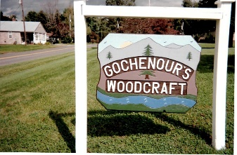
Gochenour’s Woodcrafts, 4495 Ida Road, Stanley is a local wood crafting vendor. Owned and operated by J.H. Gochenour and his wife, Brenda, they offer handcrafted reproduction Pie Safes, jelly cabinets, trash bins, potato and onion boxes, kitchen islands, bookcases, and much more. What started as hobby in 1982, Mr. Gochenour started selling his furniture at Craft Shows, as well as selling his products out of his shop. Aside from what he typically makes, he also makes custom orders, and can even use whatever paint and stain you want. If you would like to learn more about all the things he offers, visit their facebook page at https://www.facebook.com/Gochenours-Woodcraft-112667696747857, give him a call at
(540) 778-3719, send an email to taterbox@embarqmail.com, or visit his shop at 4495 Ida Road, Stanley.

Help Us Welcome Our New Members
Gochenour’s Woodcarfts
4495 Ida Road
Stanley, VA 22851
(540) 778-3719
taterbox@embarqmail.com

Member Spotlight
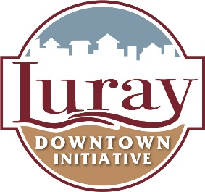
Luray Downtown Initiative
Luray Downtown Initiative, 18 Campbell Street, Luray, is a Main Street America Accredited program. Run by Meredith Dees, Luray Downtown Initiative works with the downtown businesses to help them thrive, while revitalizing such an important part of the Town of Luray. Since 2004, LDI has contributed more than 25,000 volunteer hours. These volunteer hours equate to more than $650,000 in support of downtown revitalization. From hosting events, to painting the signs heading into downtown, LDI works with businesses and community members to help our downtown come to life, by helping the locally owned businesses thrive. To learn more about how they are boosting Luray’s downtown, visit their website, https://downtownluray.com/, call (540) 743-7700, or send an email to luraydowntown@gmail.com.

