Luray – Page County Chamber of Commerce
18 Campbell Street, Luray, VA 22835 - Tel: 540-743-3915 - Fax: 540-743-3944
www.VisitLurayPage.com

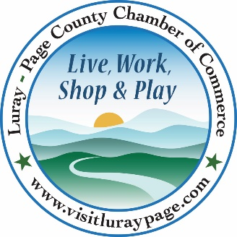

For Immediate Release Contact: 540-743-3915
June 17, 2023 events@luraypage.com

Daughter of the Stars Farmers Market Ribbon Cutting

Luray, VA – The Luray-Page County Chamber of Commerce was excited to celebrate the opening of a Luray Market with the Daughter of the Stars Farmers Market by holding a special ribbon cutting.

“It’s great to see a Farmers Market returning to Luray. Fresh and local produce, locally made crafts and items, and a chance to see what talents are hidden in our community is something we’re glad we can help bring to our community and visitors. We’re ecstatic that Daughter of the Stars Farmers Market decided to expand into Luray, and that we are able to offer them a space right here at the Chamber of Commerce & Visitor Center”, said Regina Hilliard, President of the Luray-Page County Chamber of Commerce.
Daughter of the Stars Farmers Market started in 2022, with their original market at Big Gem Park in Shenandoah (736 Fourth Street, Shenandoah). After seeing the success and knowing of the need for more options like a Farmers Market, they were able to expand to opening a Luray Market once a month. Courtney Nelson, coordinator for DotS Famers Market, said ““We’re excited to be here in Luray. Like our mission states…we’re trying to build health and wellness in Page County.” The Farmers Market had 17 vendors set up for the first Luray market, with plans to accept more vendors that will offer fresh and locally grown produce, eggs, and crafts.
During the ribbon cutting ceremony, we were honored to be joined by Membership Development & Engagement, Clancey Arnold, Social Media & Communications Coordinator Edison Emmons, Mayor of Luray Jerry Dofflemyer, Luray Town Council Members Jason Pettit and Ron Vickers, as well as the new Market Manager Delynda Hendricks.

Daughter of the Stars Farmers Market holds Markets at Big Gem Park (736 Fourth Street, Shenandoah) on the first Saturday of each month, and at the Luray-Page County Chamber of Commerce & Visitor Center (18 Campbell Street, Luray) on the third Saturday of the month. They will be operating through the month of November. You can visit their website, or email them at daughterofthestarsfm@gmail.com. For more details on the ribbon-cutting, contact the Luray-Page County Chamber of Commerce at events@luraypage.com.

