Luray – Page County Chamber of Commerce
18 Campbell Street, Luray, VA 22835 - Tel: 540-743-3915 - Fax: 540-743-3944
www.VisitLurayPage.com

For Immediate Release Contact: 540-743-3915
May 26, 2022 events@luraypage.com

Curated Grand Opening & Ribbon Cutting

Luray, VA – The Luray-Page County Chamber of Commerce had the honor of celebrating the grand opening of Curated, one of Luray-Page County’s newest shops located at 51 West Main Street, Luray.

“There’s nothing that makes us happier than seeing new businesses come to Page County. The opening of Curated has given locals and visitors another great option for shopping. Whether it’s gifts for a loved one, a souvenier to remember your time, or just ideas for what you want to buy down the road, Curated has brought a new and welcoming environment for our community to enjoy” said Regina Hilliard, President of the Luray-Page County Chamber of Commerce.

Curated opened their doors at the end of October 2021. Owned and operated by Leah Pence, Curated is a retail shop that has a little bit of everything, from clothes to kids toys to books. In addition, they also offer a variety of beautiful Luray and Virginia themed products like bumper stickers. When we asked Leah about Curated she said “Curated is a shop for those who have phat taste and slim wallets. Clothing is mostly gently worn resell. There is also new clothing, purses, skin care, fragrance, books, jewelry, cards, totes, custom candles and great gifts!”

Yesterday, we were joined by members of the community to join us in celebrating this momentus anniversary. In attendance were Owner of Curated Leah Pence, Store Manager Fiona Malone, employee Isabelle Redding, Mayor of Luray Jerry Dofflemyer, Luray Councilwoman Stephanie Lillard, Town of Luray Manager Steve Burke, Luray Downtown Initative Director Jackie Elliot, Chamber Board Member Tony Villa, Chamber Ambassador Amanda Petty, Chamber President Regina Hilliard, and Social Media & Marketing Assistant Edison Emmons, as well as members from the community.

Curated is located at 51 West Main Street Luray. Their hours of operation are Monday-Saturday 11:00 AM-6:00 PM, and Sundays 11:00 AM-5:00 PM. For more on all of the services that they offer make sure to visit facebook page at facebook.com/curatedbyleah/, call (374) 461-6350, or email them at curatedbyleah@gmail.com For more details on the ribbon-cutting, contact the Luray-Page County Chamber of Commerce at events@luraypage.com.

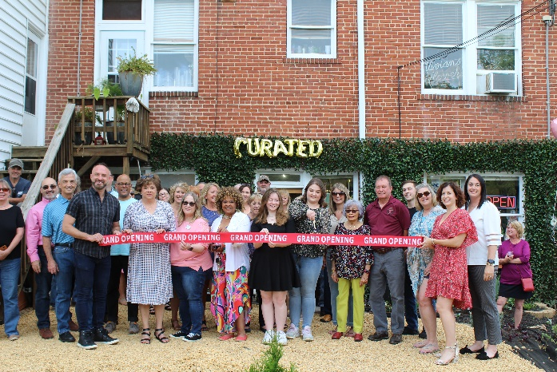
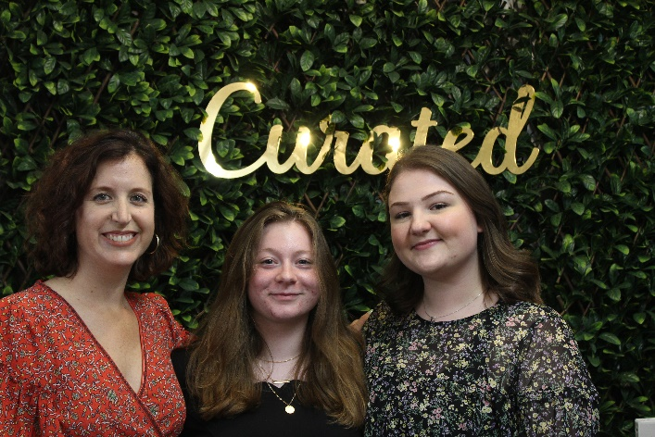

To see more pictures from the Curated Gradn Opening & Ribbon Cutting, you can visit our Facebook page.

