Luray – Page County Chamber of Commerce
18 Campbell Street, Luray, VA 22835 - Tel: 540-743-3915 - Fax: 540-743-3944
www.VisitLurayPage.com

For Immediate Release Contact: 540-743-3915
May 26, 2022 events@luraypage.com

Cooter’s Place in the Valley 5th Anniversary Ribbon Cutting

Luray, VA – The Luray-Page County Chamber of Commerce had the honor of celebrating the 5th anniversary of Cooter’s Place in the Valley with a special Ribbon Cutting.

“Page County is lucky to have such a unique business as a part of the business community. Many people here and throughout the United States grew up watching The Dukes of Hazzard, and Cooter’s gives them a place to kind of relive their childhoods. Having a piece of TV history and a place for people to get a little bit of nostalgia is something you don’t find in most places,” said Regina Hilliard, President of the Luray-Page County Chamber of Commerce.

Anyone that visits Cooter’s will get to checkout classic Dukes of Hazzard memorabilia, a cool garage with great old cars, a museum of things from the show, live music on the weekends, and a chance to meet Ben Jones himself.

Yesterday, we were joined by members of the community to help celebrate the 5th anniversary of Cooter’s. In attendance were the following, Owner Ben Jones and Alma Viator, Cast Members from The Dukes of Hazzard Catherine Bach and Tom Wopat, Cooter’s Staff, Chamber Ambassador Amanda Petty, Chamber President Regina Hilliard, Chamber staff Clancey Arnold and Edison Emmons, members of the community, and people attending the Car Show.

Cooter’s Place in the Valley is located at 4768 US Highway 211 West, Luray. They’re hours of operations are Sunday-Thursday 9:00 am-5:00 pm, and Friday and Saturday 9:00 am-6:00 pm. For more on all of the services that they offer make sure to visit facebook page at facebook.com/CootersLuray, call (540) 843-2515, or email them at katlin@cootersplace.com. For more details on the ribbon-cutting, contact the Luray-Page County Chamber of Commerce at events@luraypage.com.

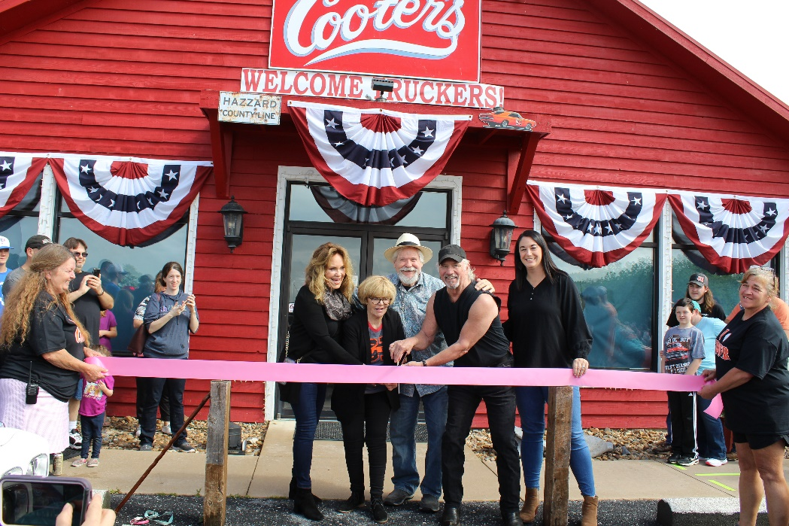

To see more pictures from the Cooter’s 5th Anniversary Ribbon Cutting, you can visit our Facebook page.

