Luray – Page County Chamber of Commerce
18 Campbell Street, Luray, VA 22835 - Tel: 540-743-3915 - Fax: 540-743-3944
www.VisitLurayPage.com

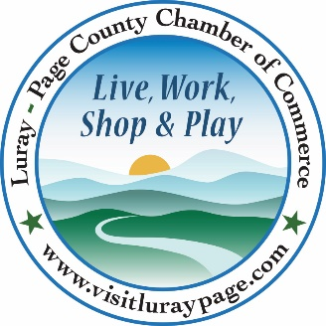

For Immediate Release Contact: 540-743-3915
October 7, 2022 events@luraypage.com

Blue Shepherd Spirits Celebrates Their Grand Opening

Luray, VA – The Luray-Page County Chamber of Commerce had the honor to celebrate grand opening of Blue Sphered Spirits with a special Ribbon Cutting.

“We love nothing more than welcoming new businesses to our community. Alex and Sarah have brought a business that is in high demad and are a welcomed addition to the Page County Businesses Community”, said Regina Hilliard, President of the Luray-Page County Chamber of Commerce.

Blue Shepherd Spirits officially opened their doors on August 26, 2022. They distill their own rum, vodka, and gin on site and offer craft cocktails, bottles, and samples of their products. Alex and his wife Sarah have lived in Luray for the past 5 years and decided to take the leap to open their own distillery after a life of being first responders. “Our mission at Blue Shepherd Spirits is to give the people of Luray and its visitors a place to come and enjoy artesian crafted spirits,” the website states. “All of our spirits are created in house, in extremely small batches. We are a nano distillery that uses local grains and goods to make our spirits and cocktails”, said Alex Colby, co-owner of Blue Shepherd Spirits.
During the ribbon cutting ceremony, we were honored to be joined by President of the Luray-Page County Chamber of Commerce Regina Hilliard, Social Media & Marketing Assistant for the Luray-Page County Chamber of Commerce Edison Emmons, and members of the community, Mayor of Luray Jerry Dofflemyer, Luray Town Council Member Jason Pettit, Luray Downtown Initiative Director Jackie Elliot, Chamber Ambassadors Sable Ponn, Amanda Petty, and Marlise Lee, Chamber Board Member Megan Newberry, and members of the community.

Blue Shepherd Spirits is located at 622 West Main Street, Luray. Their hours are Friday-Sunday from 12:00-5:00 pm.. For more information on their services, you can visit their website, http://blueshepherdspirits.com/, call (540) 316-0056, or email them at alex@blueshepherdspirits.com. For more details on the ribbon-cutting, contact the Luray-Page County Chamber of Commerce at events@luraypage.com.

