Staff  Gina Hilliard, President  Edison Emmons, Social Media & Marketing Assistant  Clancey Arnold, Membership Development &  Investment Administrator  Courtney Stoneberger, Chamber & Tourism Assistant  Board of Directors  Executive Officers:  Chris Jenkins, Chair  Faithbrooke Barn and Vineyards  Travis Clark, Vice-Chair  Valley Health Page Memorial Hospital  DezaRae Beers, Secretary  Yogi Bear's Jellystone Park  Miranda Cave, Treasurer  Blue Ridge Bank  Bill Huffman, Chair of the Tourism Division  Luray Caverns  Board Members:  Mitch Lovinger – Appexnetwork Physical Therapy  Amy Judd – Lord Fairfax Community College  Sable Ponn – Funkhouser Real Estate Group  Pam Wightman – Delaware North at SNP  Bart Patton - Patton Gunsmith Works  David Thomas - Valley Star Farm  Mark Dofflemyer – Pioneer Bank  Tony Villa – Madeline Farms  Follow Us on Social Media  Facebook  LurayPageCountyChamber  VisitLurayPageVA  Instagram  LurayPageCountyChamber  VisitLurayPageVA  Twitter  VisitLurayPage  You Tube  LurayPageCountyChamber  VisitLurayPageVA | Ambassadors  Clancey Arnold, Chair – Luray-Page County Chamber of Commerce  Sable Ponn, Vice-Chair – Sable Ponn, Funkhouser Real Estate Group  Amanda Petty – Amanda Petty Homes with Re/Max Gateway  Zory Glaser – Cardinal Cottage Vacation Cabin Rental  Nancy Boyer – Page County Public Forum  Christine Caldwell – Studio 31.13  Tourism Council  Restaurants:  Helen Morton – Delaware North  Romeo Pugliese - Mamma Mia Italian Restaurant  Lodging:  Nancy Sottosanti, Treasurer – Shenandoah River Outfitters  DezaRae Beer – Yogi Bear Jellystone Park  Jim Sims – The Mimslyn Inn  Attractions:  Bill Schumacher, Vice-Chair – Fort Valley Ranch  Bill Huffman, Chair – Luray Caverns  Services:  Chris Jenkins – Faithbrooke Barn and Vineyards  CeCe Castle, Secretary – Brookside Restaurant

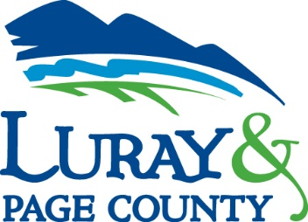
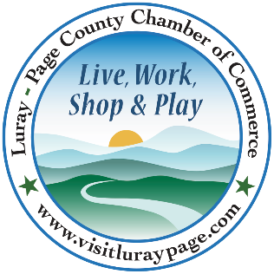

Luray-Page County Chamber of Commerce & Visitor Center
18 Campbell Street, Luray, VA 22835
Phone: (540) 743-3915 • Fax: (540) 743-3944
www.visitluraypage.com

August 2022 Newsletter

The Luray-Page County Chamber of Commerce's mission is to serve our members by promoting and supporting business and tourism throughout Page County. The Luray-Page County Chamber of Commerce's vision is to be the organization where our business community turns for leadership and resources.

Chamber Events

Wednesday, August 10th, 12:00-12:30 PM
Valley Business Today – LD&B Insurance and Financial Services
Danielle Painter, a financial advisor with LD&B Insurance and Financial Services, is joining Edison Emmons to share information on the services LD&B offers. Listen in to The River 95.3 or www.thevalleytodaypodcast.com/ to learn about what LD&B Insurance and Financial Services. has to offer for their visitors. To be a future guest on the Valley Business Today Radio Show, contact Edison at edison.emmons@luraypage.com.

Thursday, August 11th, 2:00-3:00 PM
Business Seminar – Intro to Email Marketing
Join Janet Michael from Java Media for a FREE webinar “Intro to Email Marketing” on Thursday, August 11, 2022, from 2 PM – 3 PM via Zoom. The webinar is free, but registration is required. Janet will explain the pros and cons of e-mail marketing, discuss the various methods to obtain email addresses, and share valuable tips and techniques to get the most out of each campaign. She’ll review a few email marketing services and discuss which one best fits your needs. Open discussion will follow the presentation to get answers to any of your questions. Follow the link to register https://bit.ly/3Pnwpho by Wednesday, August 10th.
Tuesday, August 16th, 12:00-12:30 PM
Tourism Tuesday – Shenandoah River State Park
Davey Allen, Park Interpreter at Shenandoah River State Park, is joining Edison Emmons to share information on Shenandoah River State Park. Listen in to The River 95.3 or www.thevalleytodaypodcast.com/ to learn about what the Shenandoah River State Park has to offer for their visitors. To be a future guest on the Tourism Tuesday Radio Show, contact Edison at edison.emmons@luraypage.com.

Wednesday, August 17th, 12:00-1:00 PM
Smart Business Growth – More Money! – A Solution that Doesn’t Always Work?
Join us for Small Business Growth interactive workshop series in partnership with Shenandoah Valley Small Business Development Center (SDCD) via zoom. Whether you are just starting out or have years of experience, these discussions will challenge your way of thinking and help you avoid common pitfalls as you grow your business. We’ll be discussing Grants, Loans, and Investments! Oh My! Successful growth means using money strategically and understanding its true impact on your business. RSVP to events@luraypage.com or (540) 743-3915 by Tuesday, August 16th, to receive the Zoom link plus session materials.
Thursday, August 18th, 5:30-7:00 PM
Business After Hours – Caverns Country Club Resort
Join us on Thursday, August 18th, from 5:30-7:00 PM for Business After Hours at the Caverns Country Club Resort. You will have the opportunity to introduce yourself to other members, exchange business cards, make new business contacts, win door prizes, and enjoy refreshments. Golf Carts will be available to tour the 18-hole course and a putting contest with a prize to the winner. This event is designed for Chamber members to meet and build relationships with other local business members. It is time to get together and enjoy each other’s company. RSVP to events@luraypage.com or (540) 743-3915 by Tuesday, August 16th.

Thursday, August 25th, 5:30-7:00 PM
Women in Business Social
Join us for this month’s Women in Business Social, on Thursday, August 25th, from 5:30-7:00 PM, at The Valley Cork, 55 East Main Street, Luray. This is the perfect opportunity for the women of the Page County business community to get together, network, and unwind after a day of work. If you are a Chamber Member and would like to attend, it will cost $15 for Chamber Members and $20 for Potential members and will include 2 drinks and charcuterie board samples. For those interested in joining us, please RSVP to events@luraypage.com or by calling (540) 743-3915 by Tuesday, August 23rd.

Thursday, August 26th, 10:00 AM
Racey Engineering 20 Years on Main Street Ribbon Cutting
On Thursday, August 26th at 10:00 AM we will be hosting a special ribbon cutting to celebrate Racey Engineering’s 20th anniversary of being a Main Street Business. We will be cutting the ribbon at 10:00 AM, followed by a chance to learn about their services, network with other members, and enjoy refreshments. If you plan on joining us, please RSVP to events@luraypage.com or (540) 743-3915 by Wednesday, August 24th.

Chamber Announcements

Any advertising inserted and printed in this newsletter and the content of those inserts and print ads are not sponsored or endorsed by the Luray-Page County Chamber of Commerce & Visitor Center.

Member Spotlight
Shenandoah River Adventures, LLC
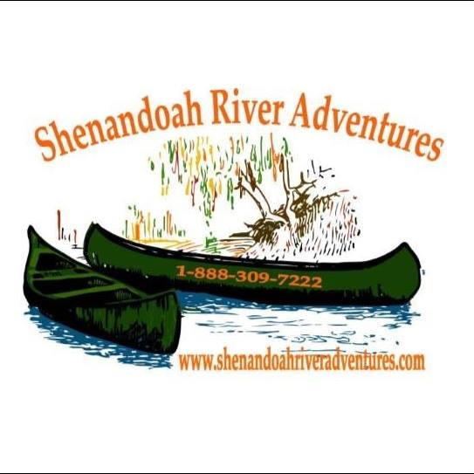
Shenandoah River Adventures, LLC, 415 Long Avenue, Shenandoah, is a local river company that offers their guests kayaking, canoeing, tubing, and more. Owned and operated by Rodney Turner, Shenandoah River Adventures sits on a beautiful section of the Shenandoah River. Even the earliest of beginners can find something to enjoy when they book with them. Visitors get to choose from kayaking, canoeing, tubing, swimming, and even fishing trips for them and their family or friends to enjoy. They are close to other attractions in the area such as Luray Caverns, Shenandoah National Park, and more, making them a great place to cool off and relax after a day out and about.
Find out more and book your river trip at https://www.shenandoahriveradventures.com/, by emailing shenandoahcanoes@aol.com, or by calling (888) 309-7222.
New Member Spotlight
Longview Goldens, LLC
Longview Goldens, LLC, Luray, is a local Golden Retriever Breeder that offers AKC certified puppies. Started by owner Brenda Ellison in December of 2021, Longview Goldens using responsible breeding practices with their dogs. Brenda found an outstanding Breeder of Merit in NOVA to work with after Bella (Brenda’s Golden Retriever) had her first litter of puppies. Bella’s first litter was 11 healthy pups of which they kept two; one for breeding and the other because her husband fell in love. Longview Goldens’ dogs are genetically cleared, and have OFA certified hips, elbows, heart, and eyes. Brenda’s main goal is to sell to clients that want a health and sound Golden Retriever. Longview Goldens is currently accepting applications for the next litter of puppies.
You can find out more about them by visiting https://www.facebook.com/Longview-Goldens-101465212365710, emailing longviewgoldens@gmail.com, or calling (571) 244-9754.
SaVida Health
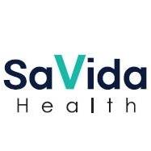
SaVida Health, 700 East Main Street, Luray is a rapidly expanding addiction practice and a leader in outpatient, medication - assisted treatment for opioid & alcohol use disorders. The Luray branch of SaVida Health is run by Phil Floyd. Phil has a history of working in the mental health field after Majoring in Psychology. During his undergraduate days he became more interested in the field after his first field placement/internship at the Rockbridge Area Community Mental Health Center back in 1981. He quickly developed a passion for the work and recognized quickly that people struggling with a mental illness and/or addiction at times simply needed someone to listen to them. SaVida offers evidence-based, integrated treatment including counseling, case management, medical care, and toxicology testing. Driven by the recognition that addiction is a disease, not a personal failure, SaVida Health delivers respectful, compassionate, and confidential care. Today SaVida Health, headquartered in Nashville, TN, has outpatient treatment centers in Massachusetts, Vermont, Delaware, and Virginia.
To learn more about the treatment and other services that SaVida Health offers, visit http://SaVidaHealth.com, email p.floyd@savidahealth.com, or call (540) 742-7330.
What’s Next? Xolo Creative Projects
What’s Next? Xolo Creative Projects, 308 First Street Ste 5, Shenandoah, is a retired business women’s network. Created in 2022 by Monica Lesko What’s Next offers retired women a chance to build warm friendships, talk about issues that interest you, address the problems you’re facing, and discuss ideas that excited you. They also offer help with free-lance projects that are intriguing and could possibly generate a modest cash flow. The women that are part of What’s Next will use resources that Page County offers, coordinate with existing organizations, explore grant opportunities, and have a chance to support each other. Monica Lesko, founder of What’s Next?, has a history of running businesses, including Avio Galleries, which provided art, prints, and framing for the Corporate, Government, and Health Care communities of the Washing DC, Baltimore, and Richmond areas. Monica also has leadership experience, which included being part of he International Facility Manager’s Association, (IFMA), the Professional Picture Framers Association, (PPFA), Global Alliance for Arts & Health, and the Rotary Club of Luray. In addition to Monica, Frank DiSerio brings experience and knowledge of bringing ideas to fruition. A graduate of Dartmouth College and Harvard Graduate School of Design, he has written a number of papers on the Art Selection Process for Corporate, Government and Health Care Institutions; guidelines on Interior Designer Art Program Management and is author of a forthcoming books “How to Establish an Institutional Art Program – An Executive Guide” and “Insights of Savvy Artists”.
Find out more about What’s Next? Xolo Creative Projects by emailing chatcircle3@gmail.com or calling (202) 289-1112.

