Staff  Gina Hilliard, President  Edison Emmons,  Communications and Marketing Coordinator  Clancey Arnold,  Membership Development and Engagement  Mary Dykes, Chamber & Tourism Assistant  Courtney Stoneberger, Chamber & Tourism Assistant  Board of Directors  Executive Officers:  Travis Clark, Chair  Valley Health Page Memorial Hospital  Amy Judd, Vice Chair  Laurel Ridge Community College  DezaRae Beers, Secretary  Yogi Bear's Jellystone Park  Miranda Cave, Treasurer  Blue Ridge Bank  Bill Huffman, Chair of the Tourism Division  Luray Caverns  Board Members:  David Reed - Reed & Reed, P.C. Attorneys & Counsellors at Law  Mitch Lovinger – Appexnetwork Physical Therapy  Sable Ponn – Funkhouser Real Estate Group  Megan Gordan - Page Alliance for Community Action  Michael Darrow– Delaware North at SNP  Tony Villa – Madeline Farms  Ian Rudolph – Rudy’s Diner  Follow Us on Social Media  Facebook  LurayPageCountyChamber  VisitLurayPageVA  Instagram  LurayPageCountyChamber  VisitLurayPageVA  Twitter  VisitLurayPage  You Tube  LurayPageCountyChamber  VisitLurayPageVA | Ambassadors  Clancey Arnold, Chair – Luray-Page County Chamber of Commerce  Sable Ponn, Vice-Chair – Sable Ponn, Funkhouser Real Estate Group  Amanda Petty – Amanda Petty Homes with Re/Max Gateway  Zory Glaser – Cardinal Cottage Vacation Cabin Rental  Nancy Boyer – Page County Public Forum  Christine Caldwell – Andersen Corporation  Marlise Lee - Cameo Galleries  Tourism Council  Attractions:  Bill Huffman, Chair – Luray Caverns  Bill Schumacher, Vice-Chair – Fort Valley Ranch  Lodging:  Nancy Sottosanti, Treasurer – Shenandoah River Outfitters  DezaRae Beer – Yogi Bear Jellystone Park  Jim Sims – The Mimslyn Inn  Restaurants:  Helen Morton – Delaware North  Romeo Pugliese - Mamma Mia Italian Restaurant  Services:  Chris Jenkins – Faithbrooke Barn and Vineyards  CeCe Castle, Secretary – Brookside Restaurant
 | 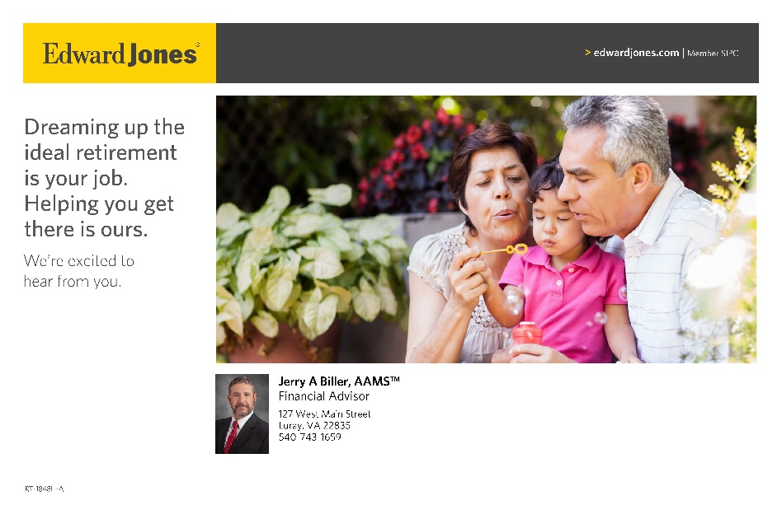

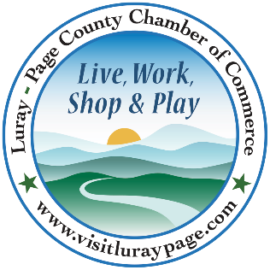

Luray-Page County Chamber of Commerce & Visitor Center
18 Campbell Street, Luray, VA 22835
Phone: (540) 743-3915 • Fax: (540) 743-3944
www.visitluraypage.com

April 2023 Newsletter

The Luray-Page County Chamber of Commerce's mission is to serve our members by promoting and supporting business and tourism throughout Page County. The Luray-Page County Chamber of Commerce's vision is to be the organization where our business community turns for leadership and resources.

Chamber Events

Wednesday, April 12th, 8:00-9:30 AM
LPCCC Chamber Membership Orientation
Make Sure You are Getting the MOST Out of Your Chamber Membership! If you are a new member, long-time member, or even future members, find out how to get the most out of a Chamber membership. We will walk you through all the basics, in-depth review of membership benefits, how to get involved, our events, how to sponsor events, give you an opportunity to meet Chamber members, and provide you with coffee and breakfast pastries. Come have your membership questions answered, talk about your business and network with other new members. Hosed at the Chamber/Visitor Center boardroom, 18 Campbell Street, Luray. RSVP to events@luraypage.com or (540) 743-3915 by Monday, April 10th to save your seat.

Wednesday, April 12th, 12:00-12:30 PM
Valley Business Today Radio Show – Becoming a Member of the Chamber
Clancey Arnold, Luray-Page County Chamber of Commerce’s Membership Development & Engagement, is joining Edison Emmons to share information on the benefits of joining the Luray-Page County Chamber of Commerce. Listen in to The River 95.3 or https://theriver953.com/podcasts/the-valley-today/ to learn about membership. To be a future guest on the Valley Business Today Radio Show, contact Edison at edison.emmons@luraypage.com.

Wednesday, April 12th, 5:30-7:30 PM
Wedding Forum
Join us for our annual Wedding Forum on Wednesday, April 12th from 5:30-7:30 PM! We’ll be hosting a round table discussion on the local wedding industry at Stoneyman Valley Ranch, 283 Pollock Road, Stanley. This is the perfect time for all businesses in the wedding industry to get together and discussion hot-button topics, network with other businesses, enjoy drinks and light refreshments, and get new ideas for the upcoming wedding season. This is a free event that will be open to all wedding businesses that service the Page County area. If you are interested in attending, please RSVP to events@luraypage.com or (540) 743-3915 by Monday, April 10th.

Thursday, April 13th, 11:30 AM-1:00 PM,
Lunch N Learn – Healthy and Productive Conversations at Work
Join us on Thursday, April 13th, from 11:30 AM-1:00 PM, at Laurel Ridge Community College, 200 College Drive, for a discussion on healthy and productive conversations at work. We’ll be joined by Elisabeth Alger, Therapist at Choices Council on Domestic Violence. We’ll go over appropriate conversations, what’s taboo, and how to respond and give criticism. Lunch will be provided by Main Street Bakery & Catering, and will be Chamber Members $15, Potential Members $20. If you wish attend, RSVP by Monday, April 11th to events@luraypage.com or (540) 743-3915.

Tuesday, April 18th, 12:00-12:30 PM
Tourism Tuesday Radio Show – Page County Equine Connections, LLC
Kris Garrett and Abigail Bullock of Page County Equine Connection, LLC, is joining Edison Emmons to share information on their upcoming Spring Fun Horse Show. Listen in to The River 95.3 or https://theriver953.com/podcasts/the-valley-today/ to learn about this exciting event. To be a future guest on the Tourism Tuesday Radio Show, contact Edison at edison.emmons@luraypage.com.

Wednesday, April 19th, 10:00 AM
Daisy’s Country Cravings and Deli Grand Opening & Ribbon Cutting
Join us on Wednesday, April 19th, at 10:00 AM to celebrate the grand opening of Daisy’s Country Cravings and Deli, 822 East Main Street, Luray. Come and celebrate with us as we hold a special ribbon cutting ceremony to welcome Daisy’s Country Cravings and Deli to the Page County Business Community. After the ribbon is cut, stick around and learn about all that they offer. If you plan on attending, please RSVP to (540) 743-3915 or events@luraypage.com by Monday, April 17th.

Thursday, April 20th, 5:30-7:00 PM
Business After Hours - Blue Shepherd Spirits
Join us on Thursday, April 20th, from 5:30-7:00 PM, for this month’s Business After Hours at Blue Shepherd Spirits, 622 West Main Street, Luray. All members who attend is entered into the drawing for great door prizes. You’ll also be able to enjoy tasty refreshments and craft cocktails with their vodka, gin, or rum. This event is designed for Chamber members to meet and build relationships with other local business members. It is time to get together and enjoy each other’s company. Bring business cards for networking and to be entered in door prize raffles. If you would like to attend, please RSVP to events@luraypage.com or (540) 743-3915 by Tuesday, April 18th.

Friday, April 21^{st,} 10:00 AM-4:00 PM
Page County Chamber Volunteer Day
Give back to the community and connect with local nonprofit organizations as part of Page County Chamber Volunteer Day. This pairs members of the business community with rewarding half-day service projects throughout Page County. Page County Chamber Volunteer Day connects Page County businesses to Chamber member nonprofits. This is a great opportunity for nonprofits to develop relationships with Page County businesses, and for businesses to have an afternoon of team building while giving back to the community.

Wednesday, April 26th, 5:30-7:00 PM
Women in Business Wine & Paint Class
Join us on Wednesday, April 26th, from 5:30-7:00 PM for a Wine & Paint Class at The Valley Cork, 55 East Main Street, Luray. The Wine & Paint class will be led by local artist Marlise Lee, who will walk participants through the steps of creating their own piece of art. Each participant will leave with their own unique 11x14 acrylic painting and will be fun for all experience levels. All supplies are included, and refreshments provided by The Valley Cork. The price for this class will be $50 for Chamber members and $55 for Potential members. If you are interested in attending, RSVP to events@luraypage.com or (540) 743-3915 by Monday, April 24th

Member Spotlight
Blue Ridge Hospice
Blue Ridge Hospice, Luray, is a non-profit organization that’s philosophy of care focuses on medical and personal comfort in the last days of life. Care is centered on comfort, pain management and quality of life.Services include the Blue Ridge Hospice Inpatient Care Center, a comfortable, home-like environment with 24-hour nursing care, and private rooms, with round the clock visiting hours. Respite Care is short term care, providing relief care for in-home caregivers, who require a break from caring for loved ones. Patients can receive 24-hour facility care for up to 5 consecutive days, fully covered as a Medicare Hospice Benefit. Music Therapy is provided by board-certified music therapists, providing relaxation, improving sleep, alleviating pain, reducing anxiety, and elevating mood. Bereavement Counselors provide Grief Support services, including individual grief counseling, educational workshops, telephone outreach, resource materials and support groups. Spiritual Support is offered and has been scientifically proven to lower levels of pain and increase comfort and quality of life. Blue Ridge Hospice has partnered with We Honor Veterans to provide veteran focused end of life care. Pet Therapy rounds out the list of services. Pets provide patients with companionship; reduce anxiety and stress and increase joy and relaxation. For more information, on Blue Ridge Hospice, located at 333 W. Cork Street, Unit 405, Winchester, VA, visit https://brhospice.org/ or https://www.facebook.com/brhospice/, or contact (540)313-9278 or jtaucci@blueridgehospic.org.

New Members Spotlight
Daisy’s Country Cravings Market & Deli
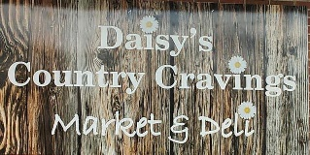
Daisy’s Country Cravings Market & Deli, 822 East Main Street, Luray, is a local market and deli in the town of Luray. Owned by Daisy Jones, Daisy’s Country Cravings Market & Deli opened their doors on January 9, 2023. The Market & Deli offers general market selections like snack foods and drinks, but also fresh homemade food. Daisy grew up and still lives in Page County, and wanted to open her own market and deli because she has a love of people and food. She takes pride in the southern comfort foods that she cooks up and wanted to share these dishes with everyone around her. Daisy’s is also a gas station and convenience store, but has a grill area, making it perfect for Daisy to serve up delicious food for her guests all day, everyday. You can learn more by visiting her Facebook Page, emailing daisypainter@ymail.com, or calling (540) 669-5965.

Daughter of the Stars Farmer’s Market
Daughter of the Stars Farmers Market, Shenandoah, is a local non-profit organization that puts on a local farmers market in the Town of Shenandoah. Daughter of the Stars translates to “Shenandoah”, the nonprofit corporation, Daughter of the Stars Farmers Market, is a tribute to the entire valley. They’ve been operating for one year and are expanding within the Town of Shenandoah and to the Town of Luray. Operating hours will be between 10am-2pm on the first and third Saturdays of the month from May through November 2023. On the first Saturdays of the month the market will be held at Big Gem Park (736 Fourth St., Shenandoah, VA 2249). On the third Saturdays of the month the market will be held at the Luray-Page County Chamber of Commerce (18 Campbell St., Luray, VA 22835). Not only will there be sales of local goods, but there will also be engaging, family-friendly activities such as reading events with the Massanutten Regional Library, occasional live music, and yoga sessions. Each location is central to the county, with nearby streams and walking trails. This year Daughter of the Stars Farmers Market is looking to showcase more local producers of food and art to highlight the beauty and skill the region has to offer. You can learn more about their mission and becoming a vendor by visiting https://www.facebook.com/DaughteroftheStarsFM or emailing daughterofthestarsfm@gmail.com.

Chamber Announcements

Any advertising inserted and printed in this newsletter and the content of those inserts and print ads are not sponsored or endorsed by the Luray-Page County Chamber of Commerce & Visitor Center.
We have a variety of events throughout the year. While some of them are free, we do host events that we require an RSVP for. Our Lunch N’ Learn’s, Women in Business, Annual Banquet, and other events that we require an RSVP for are ones where we must charge for food that is provided. RSVPing for these events is how we can let our hosts know how much food to prepare. If you RSVP to an event, but do not let us know before the RSVP date that you will not be able to attend, we will still have to charge for your spot, as our hosts and caterers will have already purchased and prepared the food for the events.
When RSVP’ing for an event, please make sure to call our office at (540) 743-3915 or email your name, business, and event you’re planning on attending to events@luraypage.com. After coming up with our monthly events, we create Facebook event pages. While we appreciate everyone interacting and sharing our event pages, we will no longer accept them as the RSVP for our events. To properly invoice for each person attending, and to keep track of everyone that is planning on attending, we need confirmation via phone or email if you are attending our events.
We’re sure you’ve seen all the flyers that are in our monthly newsletters. Our members have the option of inserting flyers with information on programs, events, and other important things their businesses or organizations are doing each month. When you receive our newsletters, make sure to take a second to look over the flyers so that you’ll know what’s going on in our community. Make sure that you hang them up in your window, make copies for your office, put them up in your employee breakrooms, or even scan them in and email them to your employees. This is a great way to not only help promote the business community, but to let your employees and customers know about what’s going on right here in their own backyards each month.

