Luray – Page County Chamber of Commerce
18 Campbell Street, Luray, VA 22835 - Tel: 540-743-3915 - Fax: 540-743-3944
www.VisitLurayPage.com

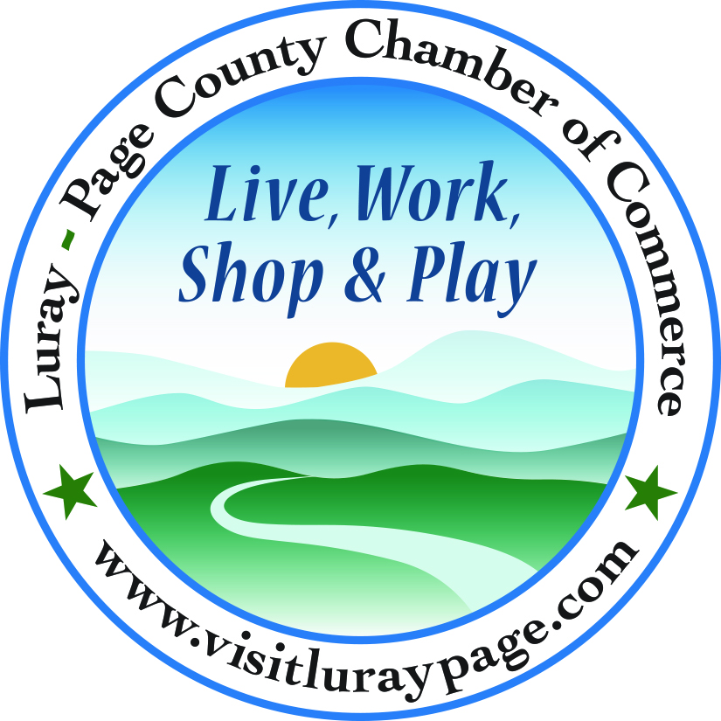

For Immediate Release Contact: 540-743-3915
February 18, 2022 events@luraypage.com

ALCOVA Mortgage Ribbon Cutting

Luray, VA – The Luray-Page County Chamber of Commerce had the honor of celebrating the opening of the new branch location for ALCOVA Mortgage, at 134 West Main Street Suite A, Luray, on Wednesday, February 16th, at 10:00 AM.

“In Luray-Page County, we are lucky to have businesses such as ALCOVA Mortgage that go above and beyond to not only run their business, but that also work to help make the community better. Leslie and her team have worked with countless individuals to make the homebuying and refinancing process easy and as stress-free as possible”, said Gina Hilliard, President of the Luray-Page County Chamber of Commerce. “We are excited for the opening of their new location where they will be able to grow their business and help even more people in our community.”

The Page County branch of ALCOVA Mortgage is run by Leslie Currle. When Leslie opened the local branch in 2018, they were in a small building just outside of downtown. Over the past four years, as she has grown her clientele and the branch, she was able to move into a much larger building in the downtown district of Luray. This year, Leslie was able to add Kelly Currle to her team, giving them more opportunity to further help their clients. After the Ribbon Cutting, all who attended were put into a drawing for gift cards from various businesses in the town of Luray. In addition, Jason Helmintoller, a Branch Partner for ALCOVA offered a grand prize drawing of $500 to be donated to the local charity or non-profit of the winner’s choice.

Yesterday, many members of the community turned out to celebrate the success of Leslie and ALCOVA Mortgage. Joining Regina Hlliard, President of Luray-Page County Chamber of Commerce from the Town of Luray, Mayor Jerry Dofflemyer, Councilwoman Stephanie Lillard, Town Manager Steve Burke, Police Chief Bow Cook, Luray Downtown Initiative Director Jackie Elliot, and Director of Economic Development & Tourism for Page County, Nina Fox, joined professionals from the real estate business, as well as people who have worked with ALCOVA and other community members to wish them luck on their new adventure.

When asked about ALCOVA and her mission in the community, Leslie said “At Alcova, we believe in giving back to the communities we serve and I am proud to live in this wonderful community and I look forward to "showing you the way home".

For more information or to set up an appointment with them, you can visit their website, https://alcovamortgage.com/va/luray, call (540) 244-4540, or email them at LCURRLE@alcovamortgage.com, For more details on the ribbon-cutting, contact the Luray-Page County Chamber of Commerce at events@luraypage.com.
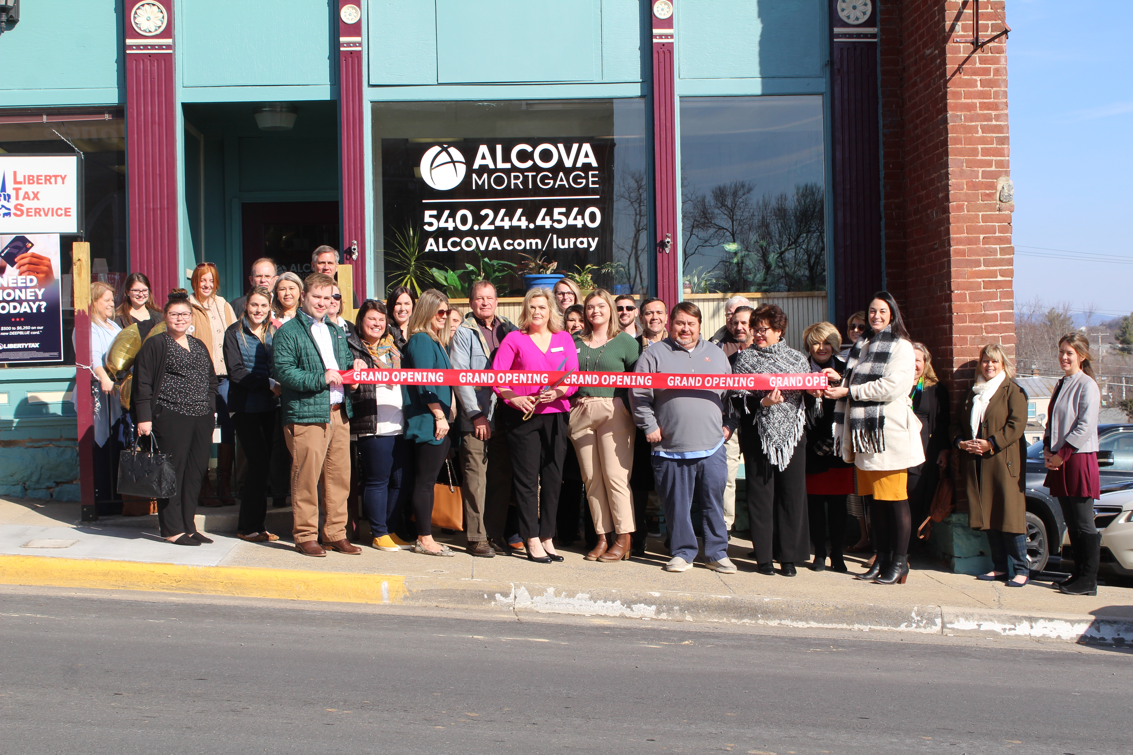
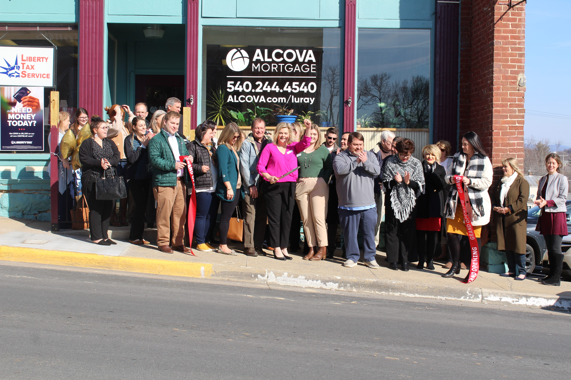
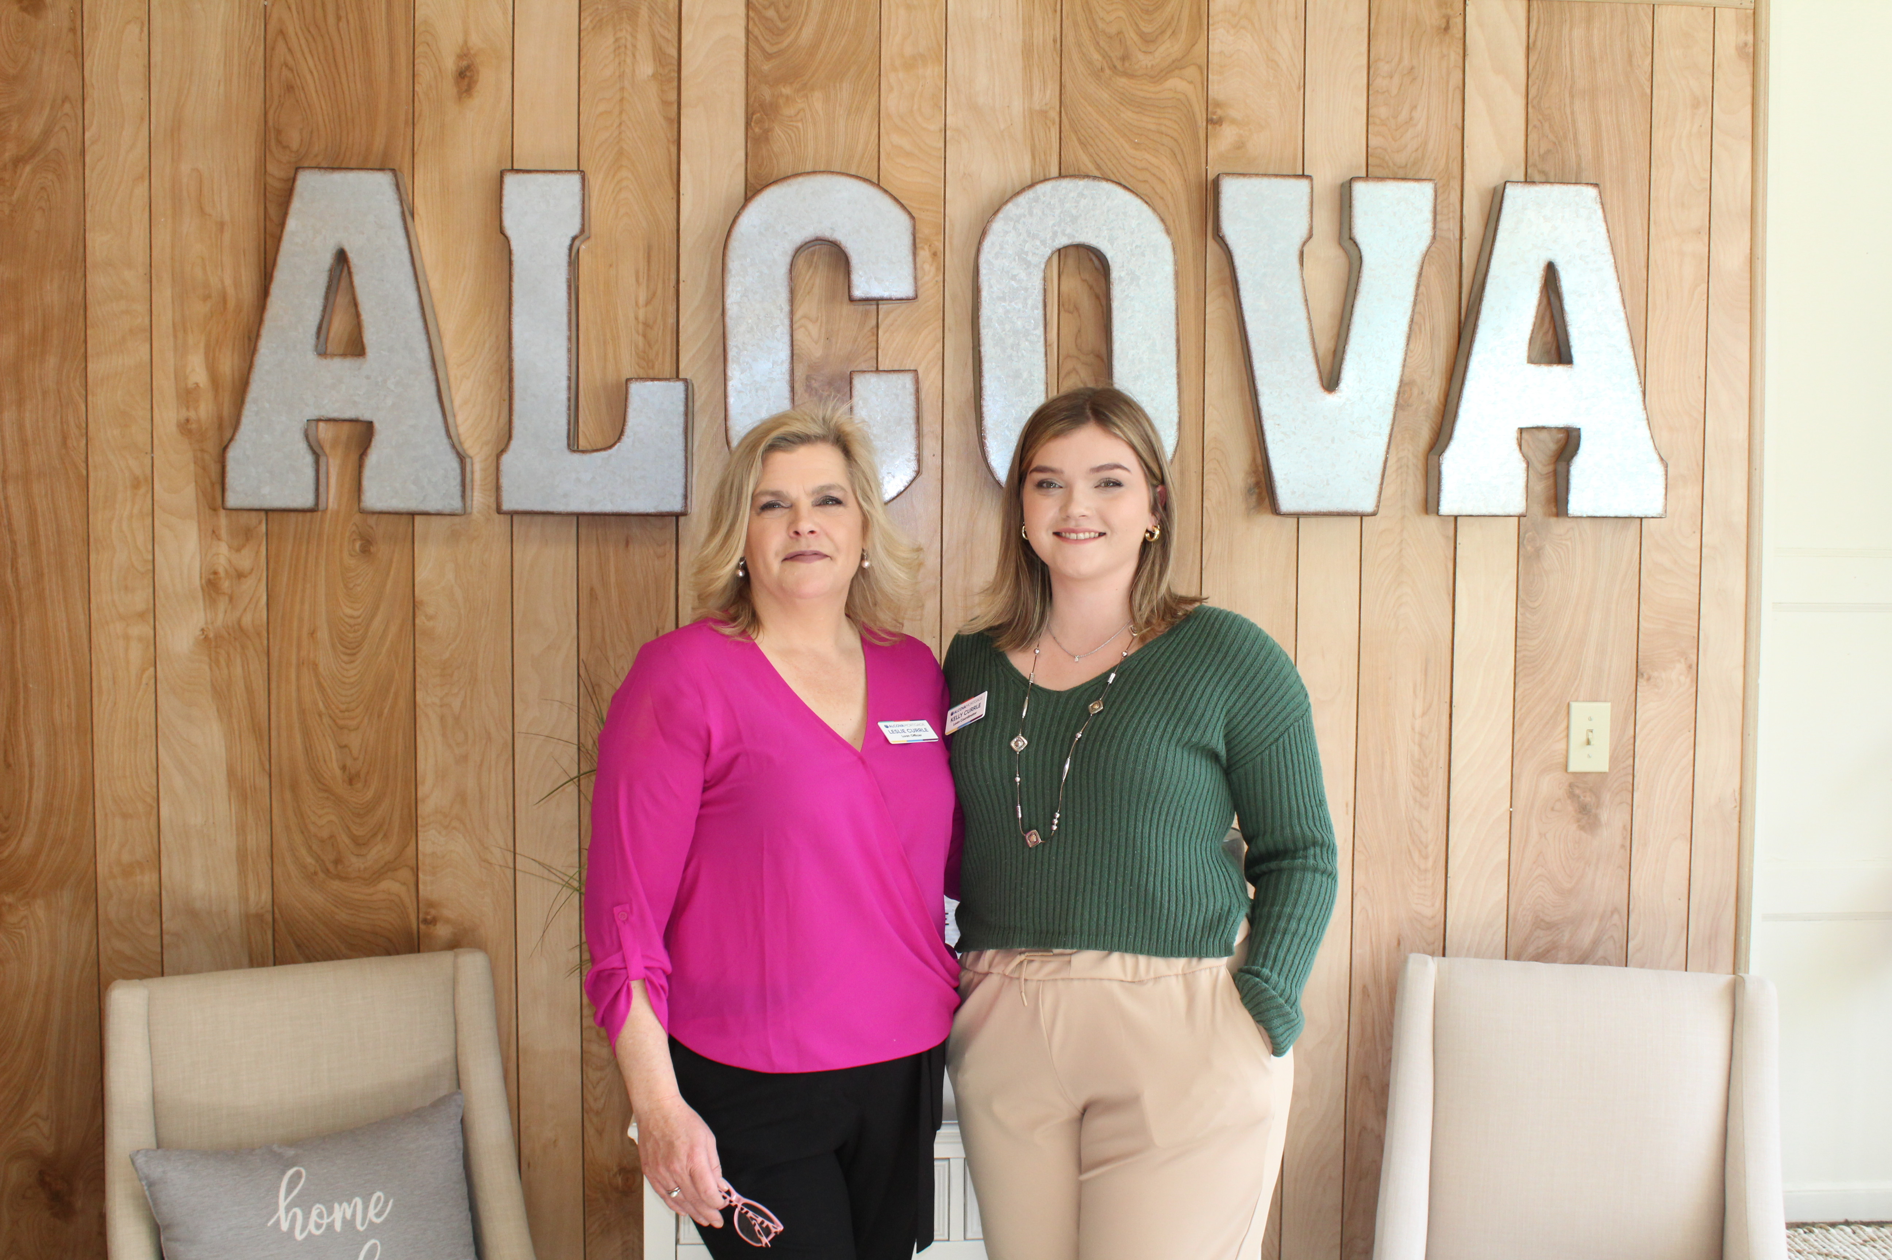

To see more pictures from the ALCOVA Mortgage Ribbon Cutting, you can visit our Facebook page.

